Press release 2/September/2005:

Ras Al Hamra, 1st and 2nd of September.

Prequalification rounds were held for the 2nd Sultanate of Oman Audi Hobie 16 National Championship in which the members of the PDO Recreation Club competed for 10 places in the championship finals next week. The Hobie 16 is the most popular sailing catamaran class in the world. It is a very fast and exciting sailing boat which is sailed by a team of two called helm and crew. Excellent weather conditions with strong winds saw some spectacular sailing for 20 teams that had entered the event. After 13 races sailed off the beach of Ras Al Hamra, Frank van Beek and Sabine Vahrenkamp had taken the first position in the qualifying rounds, closely followed by Bob and Judy Gardham. Last years champion, Victoria Grainger, now sailing with Susanne Solberg, took third. At the same time as the qualifying rounds, five youth teams were competing for the 2nd Oman Youth Trophy which was won by Safia Al Habsi, the first Omani national to take the helm in a Hobie 16 sailing championship. Overall she finished in 14 position, a very impressive performance after only one year of sailing experience. She will be sponsored by the Ministry of Sports Affairs to follow professional sailing training abroad. Next weekend, the 8th and 9th of September, the championship finals will be held from the beach in front of the Intercon Hotel. These finals are promising to become a spectacular display, accessible to the general public.
Press release 9/September/2005:

2nd Sultanate of Oman Audi Hobie 16 2005 National Sailing Championship

The second phase of the Audi Hobie 16 National Sailing Championship took place at the Intercontinental Beach this weekend. This prestigious event was held under the auspices of the Ministry of Sport, HE Eng Ali Bin Masoud Al Sinadi. This Championship has been officially recognised by the International Hobie sailing association as an Major Regatta in the Middle East and is open to interested sailors of this craft from all over the world. The exclusive sponsors of the event were Wattayah Motors, on behalf of their Audi division.

The event attracted participation from 24 teams each consisting of a helm [captain] and 1 crew. Due to the overwhelming demand for places in the competition a prequalification round was held during the previous weekend at the PDO Ras Al Hamra Recreation Club to determine club boat allocations for the championship. The ten successful teams joined the 4 independent owners to form the racing fleet of 14 Hobie 16 boats that are named after the length of the craft [16 feet].

The finals held over the weekend consisted of 9 races [5 on Thursday and 4 on Friday]. Racing conditions were very predictable for this time of year with the winds kicking in late morning and dieing down in the afternoon. This produced a variety of racing conditions from a stiff 14 knot wind on Friday afternoon to a mild 5 knot breeze of late on Thursday afternoon. The variable conditions really test the sailing skills of the teams and this was very apparent as the sailing progressed.

The sailing was dominated by Klaus Mueller and Jane Nicolson with a string of victories and place finishes that ensured they won the overall championship. In second place was the ladies team of Victoria Grainger [the reigning National Champion] and Susanne Solberg. Third place went to Bob and Judy Gardham after a tightly fought duel with Victoria and Susanne that went down to the last race. Nothing could deter Klaus and Jane. If they made a good start they romped away with the race and if they had a poor start they simply ploughed their way back up the field with their lowest result being a third place.

Typical of most racing events, battles were taking place throughout the fleet and every race held a variety of surprises as the conditions varied. What worked one minute could and did change on a regular basis on both days and for those knowledgeable about the finer points of sailing it was indeed a real feast of sailing.

The organisers were also proud to watch the youth sailors taking part last week. The involvement of the Youth to participate with the more experienced teams during the prequalification provides an excellent platform for the Youth learn while they compete.

The best placed Youth in this prequalification round will attain the title National Youth Champion. The winner of this years event was the young and up and coming new Omani sailor Safia Al Habsi and her crew Stephen Mackay.

The event concluded with a presentation ceremony attended by his Excellency the Under Secretary of Sports and Affairs HE Rashid Ahmed Mohd Al Hinai and Audi’s Brand Manager Mr Ibrahim Al Zadjali the exclusive sponsors.
Oman Tribune: 11/Sept/2005:

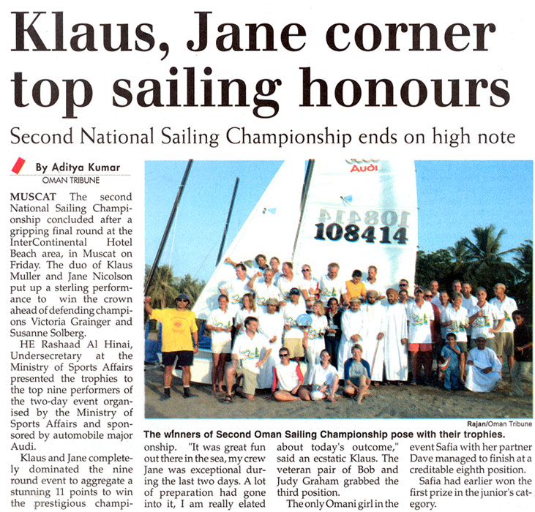
Times of Oman 10/Sept/2005:

Klaus-Jane supreme
By Our Sports Reporter
MUSCAT — Klaus Muller and Jane Nicolson proved a perfect combo as the duo put up an excellent show to clinch the overall honours of the second Oman Audi Hobie 16 National Sailing Championship, which climaxed yesterday at the InterContinental beach.
Klaus and Jane were in full control right through the day and their collection of low penalties proved good enough to dethrone defending champions Victoria Graigner and Susanne Solberg.
The two-day event was organised by the Ministry of Sports Affairs and sponsored by Audi and gracing the prize giving ceremony yesterday evening was Rashad Al Hinai, the undersecretary at the ministry.
Klaus and Jane was simply superb in all the nine stages and they sailed to perfection gathering only 11 penalty points to win the coveted title.
Second placed Victoria and Susanne aggregated 26 penalty points on the conclusion of the nine rounds conducted over the two days.
Later in a remark to the media, jubilant Klaus said: “It was great fun and I am really happy. My crew Jane too was superb.”
The veteran pair of Bob and Judy Graham grabbed the third position with 28 penalty points.
The only Omani girl in the event Safia Al Habsi, who had won the National Youth Trophy last weekend, too proved competitive.
Partnering Dave, Safia managed to finish at a creditable eighth position.
Finishing fourth were Frank and Sabine (39pp) and in the fifth position was the pair of Joe and Kristine (45pp).

Oman Observer 10/Sept/2005

Audi Hobie-16 National Championship ends
Al Habsi lifts youth title
MUSCAT — The second Audi Hobie-16 National Sailing Championship concluded at the Shatti al Qurum yesterday. Rashad bin Ahmed al Hinai, Under-Secretary at the Ministry of Sports Affairs, presided over the final proceedings of the two-day event, which was attended by several ministry officials and the fans.
Oman's Saffiyah al Habsi won the under-18 championship and she also finished eighth in the overall championship.
The overall championship was won by Klauson Mald, who was assisted by Jane Nicholson. The top prize, besides a trophy, includes a two-day stay at the Nizwa Hotel. Second place won by Victoria and Suzzane. Third place won by Bob Gatham and Judie Gatham.

