

Press Release Oman Laser Association - 06 February 2006

Frank van Beek new National Laser Sailing Champion
Rashid Khalfan best Omani Sailor

The 2005 Oman Open National championship for Lasers (one man Olympic class sailing dinghies) was sailed last weekend from the beach off the Ras al Hamra Boat Club. 25 Sailors competed in the event organised by the Oman Laser Association with participants from Royal Oman Navy, RAHBC and Castaways – Civil Aviation Recreation Club.

Sailing conditions were excellent over both days. Frank van Beek came out on top with very consistent sailing over 7 races (6 first places and 1 second). Second place was for Tony van Thiel only 5 points behind the leader. Rashid Khalfan from RNO-Wudum was the best Omani sailor with a 4th place overall, an excellent performance.

Thursday saw light steady North-Westerly winds good for 4 races. Frank quickly set the pace in the first race which he later continued in the series. It is only in the third race when he made a less than perfect start that Tony managed to beat him. Last year’s champion Douwe Sickler was in sub-optimal form coming third in 3 of the days races. There was fierce competition for the sub-top positions with typically 10 sailors crossing the line within less than a minute.

Friday was “for the big boys” with strong Easterly winds providing near perfect sailing conditions. 3 races were sailed with the pattern set on the first day continuing. Several capsizes were seen throughout the day but most sailors recovered quickly to continue their course.

RNO’s Rashid Khalfan sailed very well with a third and two 4th places easily gaining him the title of Best Omani Sailor. Mahfood Mohammed, also from RNO-Wudum, came second with Abdulhakeem Al-Keyumi of the Castaways third Best Omani Sailor. Considering the fact that Abdulhakeem started sailing only 2 years ago a very good performance indeed.

Prizes, kindly sponsored by ULO, were awarded to all participants. The chairman of the Oman Laser Association, Peter Searle congratulated Tony van Thiel with the excellent organisation of the championship. Volker Vahrenkamp, Chuck Heller, Liesbeth de Wit, Fred Rourke and Paul-Henri van Thiel were thanked for their strong management of the races.

The Laser is a small single sail boat sailed by one person. It is an Olympic class which is very popular around the world. Laser sailing is a fantastic sport which can be practiced in Oman throughout the year. In strong winds the sailing is very physical, the boat gives you a great workout. With Oman’s strong history of sailing, good winds, beautiful beaches and deep blue sea, Laser sailing has the prospective to become a true national sport with the potential of Omani participation in world class events such as the Asean and Olympic games.

For full details and pictures of the event see: http://www.pdo.co.om/hseforcontractors/rahbc/Sailing/Sailraces/2005-OLA-Nationals.htm
Final results:

Place | Name | Points | Comment
1 | Frank van Beek | 6 | Overall 1st Place
2 | Tony van Thiel | 11 | Overall 2nd Place
3 | Douwe Sickler | 18 | Overall 3rd Place
4 | Rashid Khalfan S. (RNO) | 27 | Best Omani 1st Place
5 | Peter Searle | 28
6 | Bob Gardham | 48
7 | Stephen Rice | 54
8 | Iain Hudson | 54
9 | Rodger Martin | 55
10 | Rob Nieuwenhuis | 59
11 | Trine Nathan | 63 | Best Lady
12 | Torstein Smensen | 63
13 | Cees van Eden | 64
14 | Barrie Wiltshire | 75
15 | Mahfood Mohammed (RNO) | 83 | Best Omani 2nd Place
16 | Paul Harrison | 89
17 | Abdulhakeem Al-Keyumi | 94 | Best Omani 3rd Place
18 | Yacoob Masood (RNO) | 97
19 | Sabah Saif Salim (RNO) | 98
20 | Abdullah al Said (RNO) | 117
21 | Saleem Rashid (RNO) | 119
22 | Amor Mubarik (RNO) | 129
23 | Bob Gloyn | 130
24 | Doug Taylor | 141
25 | Maritte Brongersma | 153

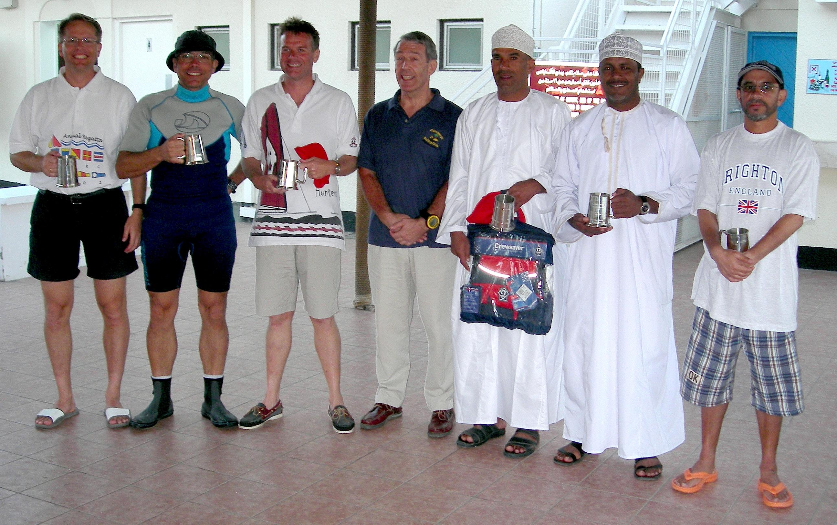

The winners (best Overall 3/2/1 on the left and best Omani 1/2/3 on the right) with Peter Searle (OLA-Chairman) in the middle
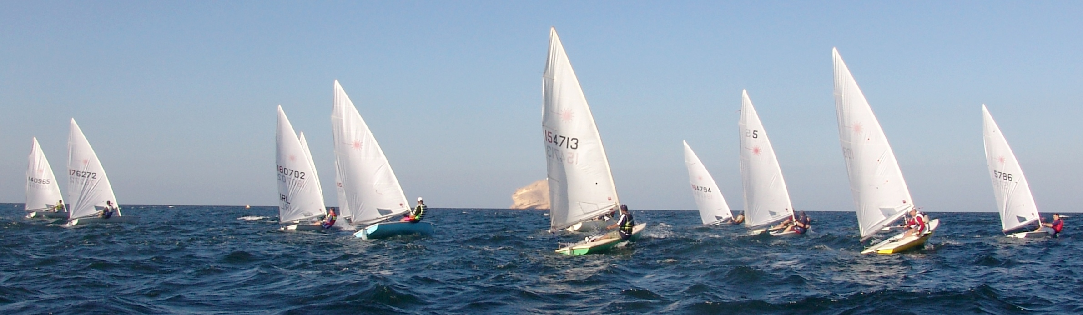

The fleet just after the start of the last race in strong winds

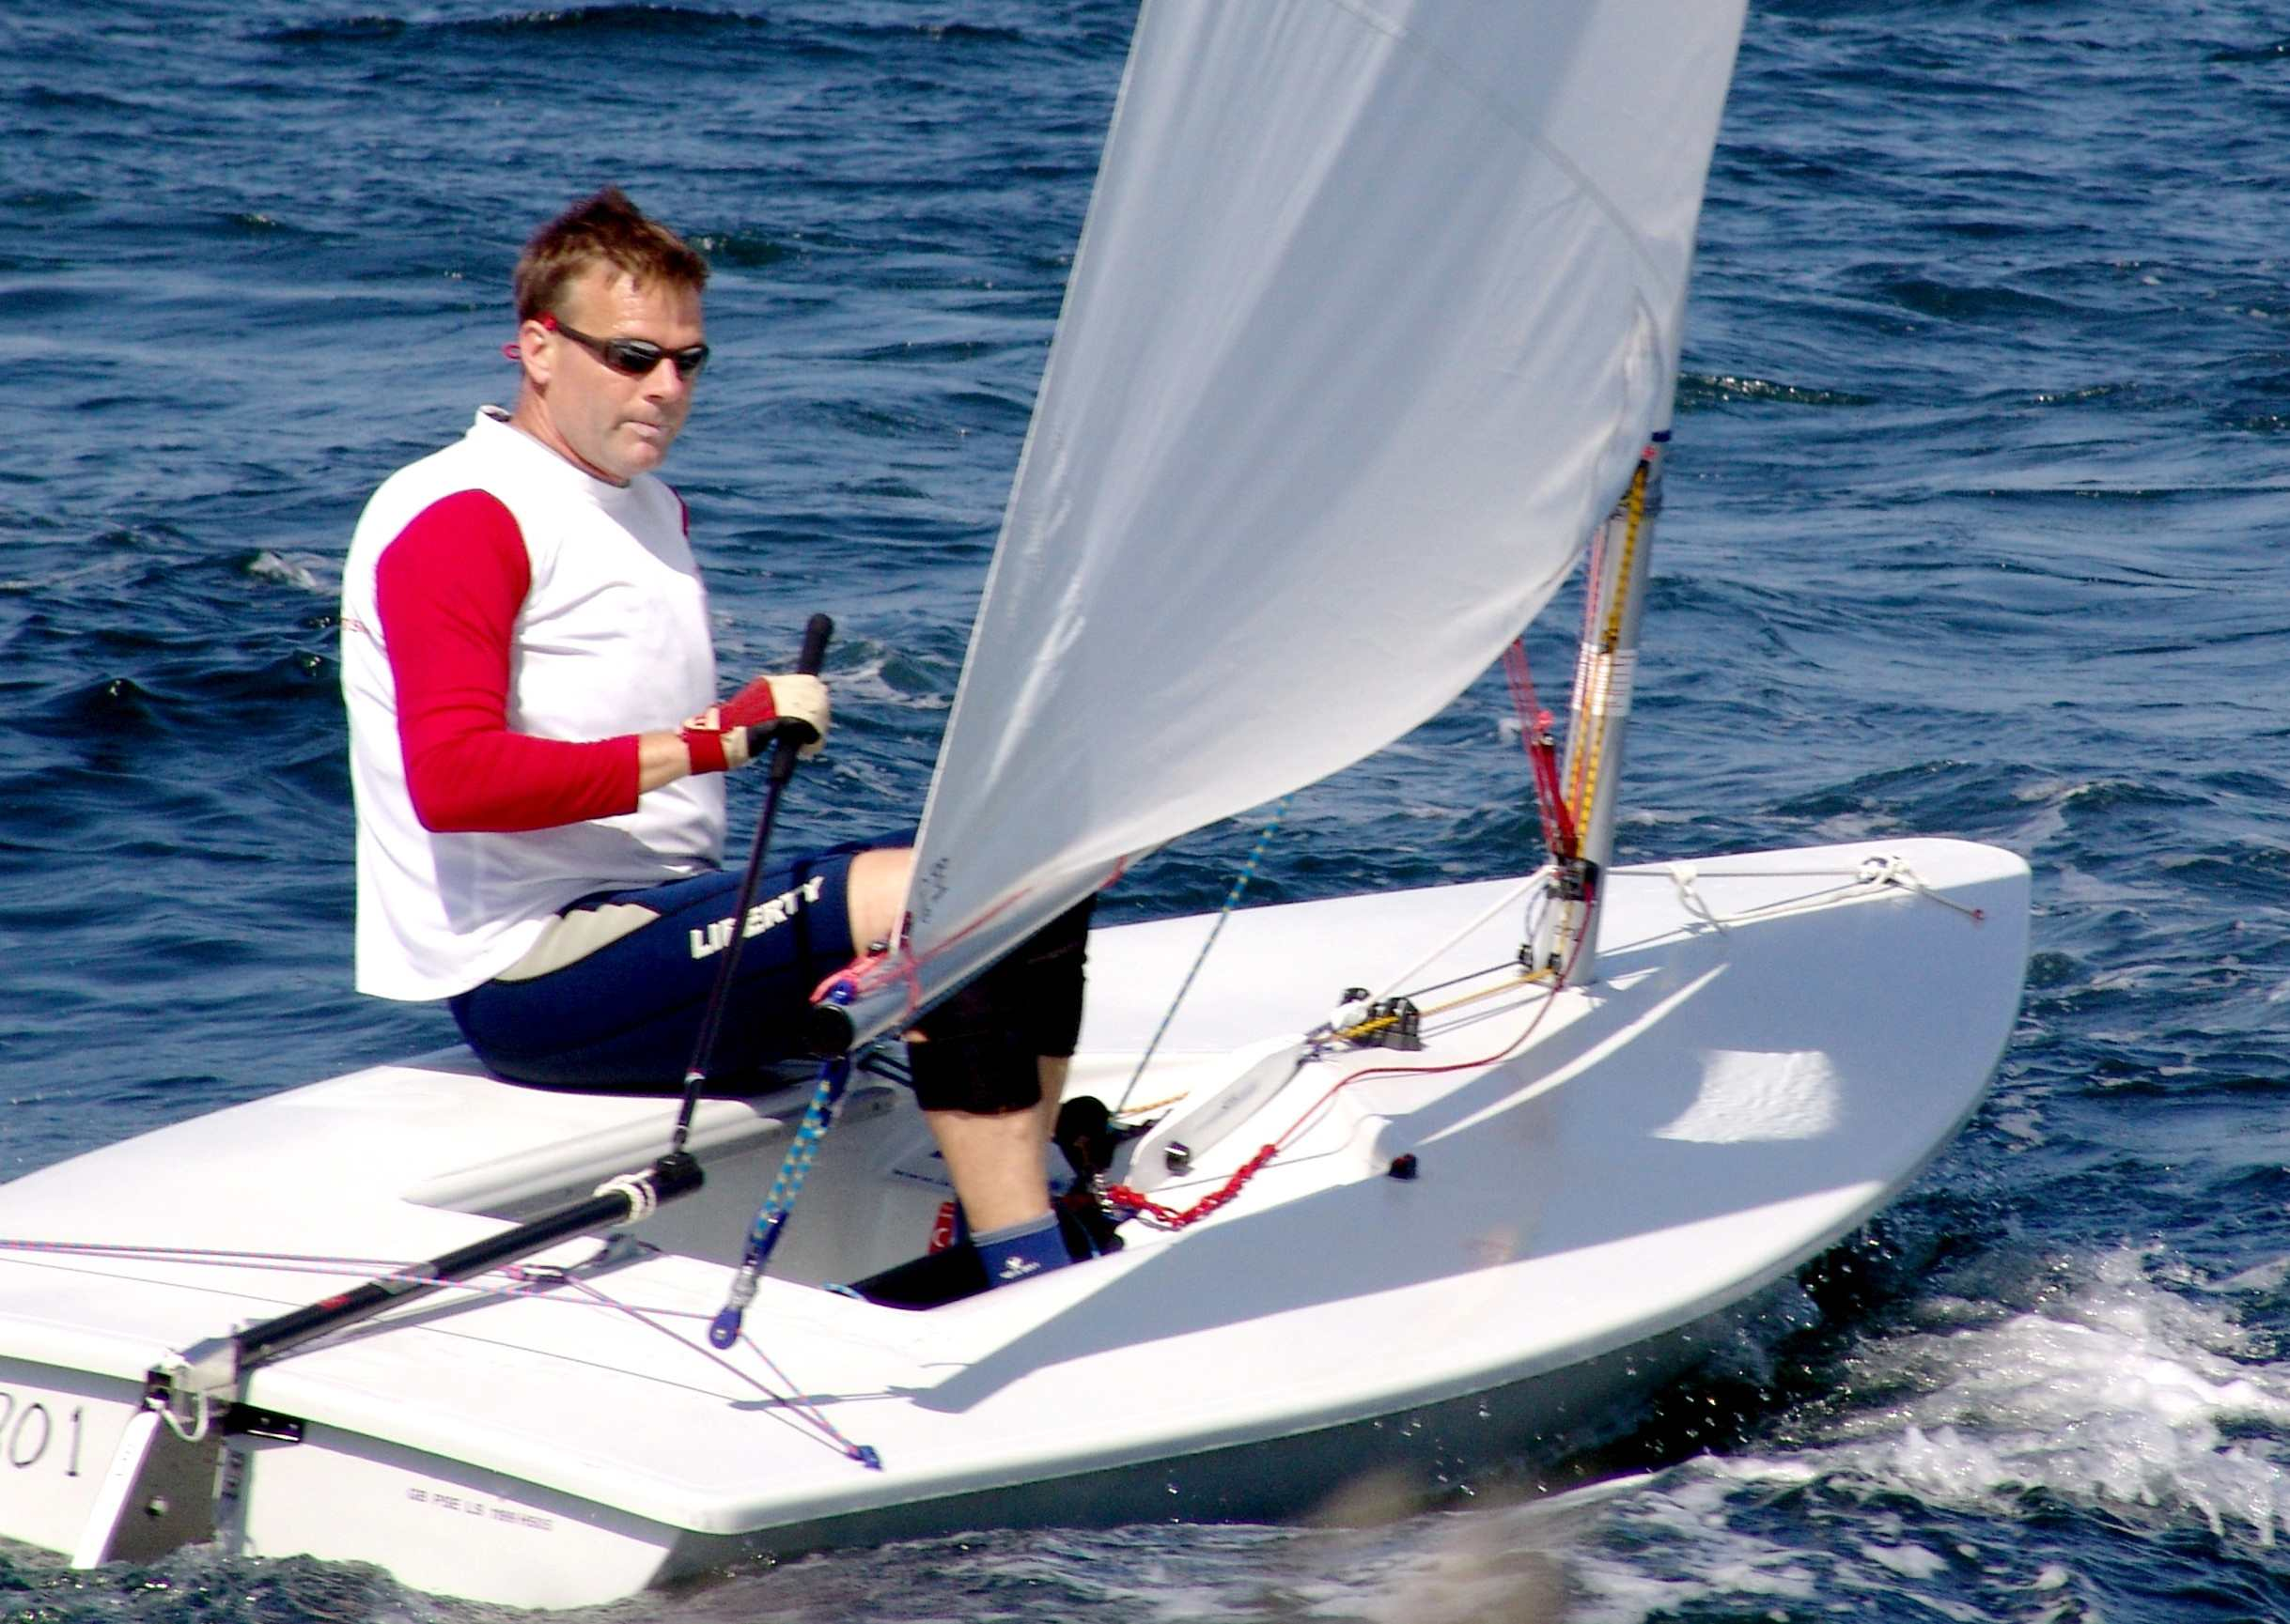

Frank van Beek (the new National Champion) sailing closed haul.

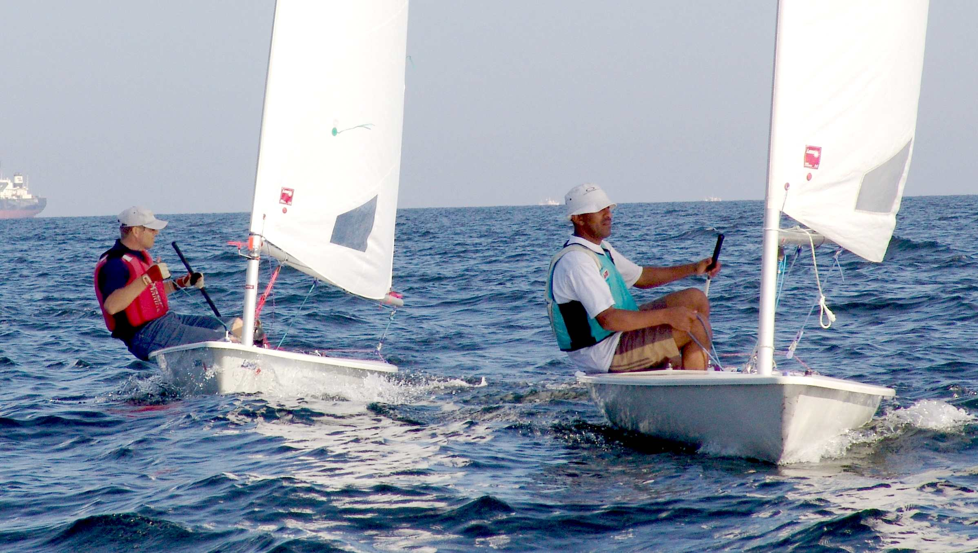

Rashid Khalfan (Best Omani Sailor) closely followed by Douwe Sickler (3rd over all)

