Introduction to

Boat Terms

General Sailing Terms

Port Tack

Starboard Tack

The Points of Sailing

Manoeuvres

Basic Rules

Reference books

Sailing Musts

Index of Sailing terms

Introduction

This guideline has been produced to provide the basic terminologies used when sailing 2 man dinghies (like the Laser 2000).

This guideline does not attempt to explain all the subtle differences between different models of boats or advanced techniques in sailing styles.

Listed under the general section of “Reference Books” you will find suitable books to expand your knowledge further at your own pace.

This guide is also intended to be used in parallel with on the beach rigging / sailing instruction.

The last section of this guideline includes the terms used in this document.

Enjoy, and Do it for Fun!

Happy Sailing

The Instructors

Boat Terms

Hull: Everything on the underside of the boat

Cockpit: The sitting area where all the action happens

Toe straps: The canvas straps that run along insides of the cockpit which can be used to stop you from falling out!

Bow: The front of the boat

Stern: The back of the boat

Jib: The small sail

Main: The large sail

Spinnaker: The large colourful sail used for reaching

Tell Tales: The ribbon strings on the main and jib

Jib sheet: The rope that controls the jib in and out, similarly the Spinnaker sheet controls the spinnaker.

Car: The fitting that guides / positions the jib sheet in respect of the sail

Main sheet: The rope that controls the main sail in and out

Main traveller: The fitting that guides / positions the main sheet

Kicking Strap (Vang): The fittings that control the boom and provide a downward force to allow the main sail shape to be adjusted.

Outhaul: The rope that adjusts the foot of the main

Blocks & Cleats: The rotating fittings that guide / control the sheets to the sails

Halyard: The rope that hoists / lowers sails

Boom: The aluminium tube at the bottom of the main sail

Gooseneck: The fitting at the front of the boom / mast connection

Cunningham sheet: The rope that tensions the main at the gooseneck fitting

Tiller: The stick that we use to steer the boat

Rudder: The steering blade that is attached to the stern

Centre-Board: The large plate which can be raised and lowered to prevent the boat from drifting side-ways

Shrouds: The metal wires that hold the mast up on each side of the boat

Jib Forestay: The metal wire at the front of the boat holding the mast

Bung: The sealing plug in the stern (Transom)
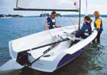
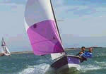
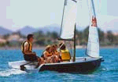

General Sailing Terms

Port (Colour code Red): Left as you look forward when sitting on the boat

Starboard (Colour code Green): Right as you look forward when sitting on the
boat

Ahead: Looking towards the front

Fore: The front area of a boat

Astern: Looking behind

Aft: The rear area of a boat

Tacking: Turning the boat so that the bow travels completely through the wind and
the sails fill on the opposite side

Gybing: Turning the boat so that the stern travels completely through the wind and
the sails fill on the opposite side

Going About: Turning the boat on to a new course

Windward: The side of the boat where the wind is coming from

Leeward: The side of the boat where the wind is leaving the boat

Bear Away: To steer the boat away from the wind

Harden Up: To steer the boat towards the wind

Pinching: Sailing too close to the direction of the wind

Luffing: The sails lift towards you as though they are being patted

Helm to Lee: The command stated by the helm as a tack manoeuvre is executed

Bearing Away & Gybing: The command stated by the helm as a gybe manoeuvre
is executed

Sheet: The command to pull in the main / jib sheet

Ease: The command to let out the main / jib sheet

Dump: The command to immediately release the main / jib sheet

Are you ready?: The advice given to the crew when tacking / gybing

From: Wind direction is described as where it is coming from

Gust: A sudden change of wind strength (the surface of the water changes to a
darker shade)

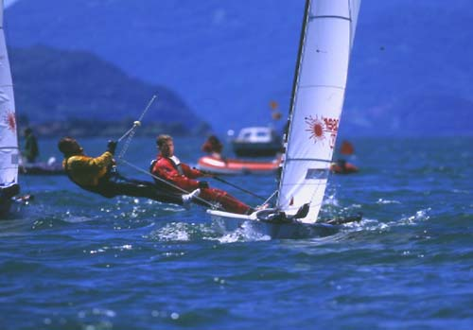
On the beat, pushing hard, boat flat

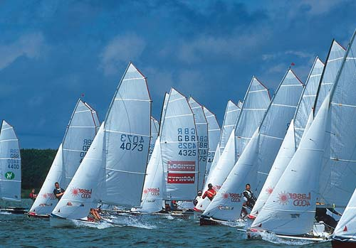
The Start

On the trapeze, power on and away

Laser 4000’s Racing

Port Tack (Red Code colour)

The wind is coming from the left

Your left shoulder is facing forward

Helm: The tiller is in your right hand

You are the give way boat



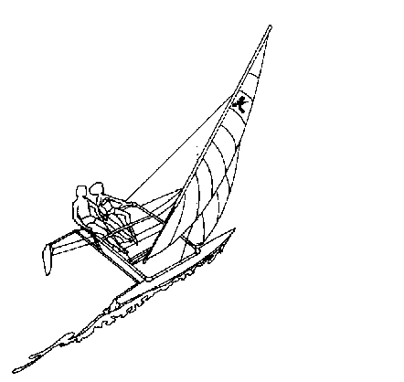

Starboard Tack (Green Code colour)

The wind is coming from the right

Your right shoulder is facing forward

Helm: The tiller is in your left hand

You are the right of way boat

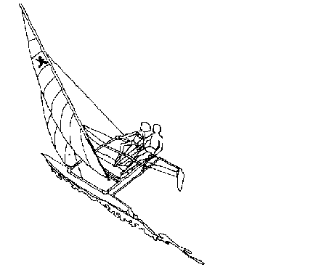

Points of Sail

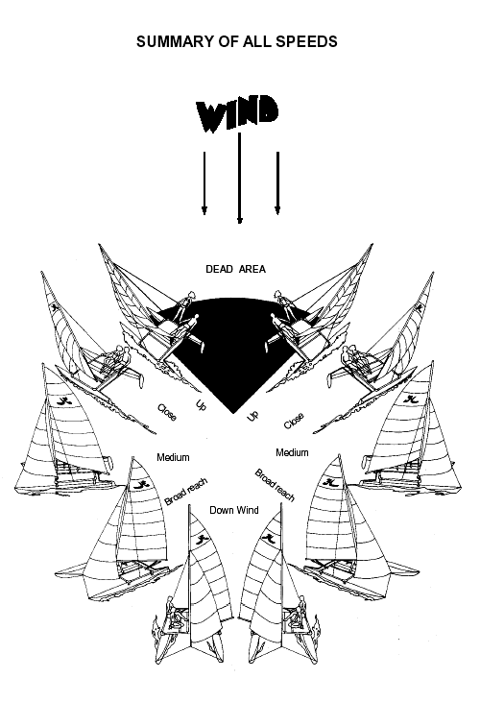
Up = Beating

Close = Fetching

Medium = Reaching

Downwind = Running

Basic Manoeuvres

Tacking

Gybing

Beating

Reaching

Running

Capsizing

Tacking

The boat is sailing as close to the wind as possible, (on a beat) the helm pushes the tiller away positively, but no further than to create a 45 degree rudder angle.

The Crew comes in to towards the centre of the boat and prepares to move across to the new windward side, trying, at all times to keep the boat reasonably well balanced.

The helm draws in the last few cm of main sheet as the boat approaches head to wind. As the boat passes through the wind both the crew and the helm move towards the new windward side of the boat.

The helm passes the tiller around the back of the main sheet block, changes tiller hands and sheets in the main sheet, all whilst settling in on the new course, do not sheet the main on any faster than the crew can sheet in the jib.

As the boat is approaching a head to wind position, the crew moves on to their knees in the centre of the boat as far aft as practically possible and picks up the jib sheets one in each hand and watches the jib reverse it self as the boat turns through the wind.

As soon as the boat has passed through the wind the crew releases the jib and sheets back in on the new tack.

Helm Key Points

Only attempt a tack when you have: Boat Speed

Turn the boat through the turn: Positively

Wait until you are on the new tack: Before straightening the rudder

Crew Key Points

The jib should be: Slow to cut, quick to pull

Only sheet in the jib: As fast as the tell tales will allow you

Gybing

The boat is sailing with the wind indicator ribbon flying at 90 degrees to the boat, (on a run) the helm pulls the tiller positively, but no further than to create a 45 degree rudder angle.

At the point that the wind indictor ribbon is flying completely away (dead down wind) from the helm, the helm rolls on to their knees to the centre of the boat and gathers in his non tiller hand the middle of the main sheet. He then and assists the main over to the new side.

The helm passes the tiller around the back of the main sheet block, changes tiller hands and sets the main sheet / traveller sheet in conjunction with the tell tales.

As the boat is approaching a dead down to wind position, the crew moves on to their knees in the centre of the and picks up the jib sheets, one in each hand and watches the jib reverse it self as the boat turns through the wind.

As soon as the jib reverses to the new side, the crew releases the traveller sheet and jib sheet, and slides across the boat and sets the new traveller sheet and jib sheet in conjunction with the tell tales.

Gybing with the Spinnaker.

This process is the same as for gybing with the Jib except that, with the Spinnaker there is a lot more sail to bring through the wind. The key to success is fluidity, make it a smooth as possible as this will also give you control of the boat. The Spinnaker will fly with the wind and will cross from one side to the other, but to make sure that nothing gets tangled it is important to try to control the sail by keeping hold of the sheets throughout the manoeuvre.

Helm Key Points

Only attempt a gybe when you have: Boat Speed

Wait until you are on the new reach: Before straightening the rudder

Crew Key Points

The jib should only be: Released when it has reversed

Setting/ Resetting the jib: The tell tales must fly on both sides of the sail

Beating

The boat is sailing as close to the wind as possible.

To achieve an upwind course we have to sail either side of the apparent wind direction.

Typically a mono-hull will up to 35 to 40 degrees either side of the direction of the apparent wind.

The beat requires a zig- zag approach to achieve a passage to windward.

The apparent wind you create is significantly higher than the actual wind strength.

Use the wind indicator ribbon tied to the front of the boat to show you where the apparent wind direction is coming from.

Make sure that the centre board is as far down as possible

Helm Key Points

Keep the sails / travellers in as tight as the wind flow will allow you to:

Maintain flowing tell tales at all times

Keep full power on: No Luffing

Crew Key Points

The jib should be set to: Maintain flowing tell tales at all times

Use their weight to balance the boat fore and aft as well windward to leeward to:

Maintain a properly trimmed flat boat

Reaching

The boat is sailing off the wind.

The reach is the fastest point of sail.

Hiking out is very common on the reach.

The apparent wind you create is significantly higher than the actual wind strength.

Use the wind indicator ribbon tied to the front of the boat to show you where the apparent wind direction is coming from.

Reaching with the Spinnaker

The reach is the fastest point of sail, where the wind is coming in to the boat from the side. The Laser 2000 has an asymmetric spinnaker with the lower front corner (the Tack) fixed to a gaff pole. The boat is designed so that the whole sail and pole assembly can launch and be stowed by pulling on one rope. To make things even faster, the boat has a self-furling assembly which will roll the jib up to improve the performance of the sail.

The Spinnaker is launched by pulling on the Halyard. The Sail is stowed in a bag fixed to the deck and comes out as the halyard is pulled up. The Gaff pole also launches from the bow of the boat.

Once the Spinnaker is up it is controlled the Spinnaker sheet. The sheet should be eased until the back edge of the sail is just beginning to curl.

The Spinnaker will fill quickly and so you need to be ready to hike (lean) out.

Getting the Spinnaker down simply the reverse of launching, but this needs to be done carefully to make sure that the sail stows back into the bag.

Helm Key Points

Keep the sails / travellers adjusted with the wind flow to allow you to:

Maintain flowing tell tales at all times

Keep full power on: No Luffing

Keep the bows up: Nose Diving is very possible on this point of sail

Crew Key Points

The jib should be set to: Maintain flowing tell tales at all times

The centreboard needs to be raised a tad.

Nose Diving is very possible on this point of sail

Use their weight to balance the boat fore and aft as well windward to leeward to:

Maintain a properly trimmed flat boat

Trim the Spinnaker to keep the rear edge at the point where it just curls.

Running

The boat is sailing off the wind with sails set as far out as practically possible, maintaining flowing tell tales.

You limit the setting by sailing no deeper than with the apparent wind direction setting at 90 degrees to the boat’s heading.

The run is very tactical, like beating you have to zig zag down the course.

The helm / crew position could be balanced on either side of the cockpit, to maintain a flat boat .

Use the wind indicator ribbon tied to the front of the boat to show you where the apparent wind direction is coming from.

Setting the main sail on one side and the jib on the other (Goose Winging) is only used in very light conditions or for a very short distance to sail.

Helm Key Points

Keep the sails / travellers adjusted with the wind flow to allow you to:

Maintain flowing tell tales at all times

Keep full power on: No Luffing

Speed and direction is achieved by:

Riding the surf and bearing away with gusts

Crew Key Points

The jib should be set to: Maintain flowing tell tales at all times

Use their weight to balance the boat fore and aft as well windward to leeward to:

Maintain a properly trimmed flat boat

Capsizing

The classic capsize occurs in several circumstances:

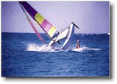

When the boat gets knocked over sideways by the wind, typically going upwind.

When the boat falls over going down wind, a classic broach with the spinnaker,

Or simply when something happens to cause the boat’s weight distribution to change suddenly, perhaps if someone fall off!! Fortunately the Laser 2000 is a very stable boat and it takes real effort to tip it over.

But, a boat can be righted almost immediately with the right technique.

Once you have that feeling that you have gone beyond the point of no return, hold on to the sheet in your hand.

You will be thrown forward and clear of the boat.

But you are still in contact with the boat via the sheet in your hand.

You may be able to step over the upturned hull and stand straight onto the centre board…on the other hand you may already be in the water.

The helm and crew respectively immediately swim back to the boat to release the sheets and travellers from their cleats.

The crew then swims to, and holds on to, the centreboard while still in the water. This action depresses the hull into the water to create a rudder effect and the wind action on the hull acts as a sail. The boat will then pivot around to achieve the desired position of the mast of approximately 45 degrees to the wind.

When the mast has been rotated around to approximately 45 degrees to the wind, the crew or the helm pull themselves up on to the centreboard and lean back, whilst holding the righting ropes which are just under the lip of the hull.

The boat will initially be slow to rise as the water is slowly displaced from the main sail.

Once the boat is upright it is important to settle back down, get your bearings and make sure that you are in calm state of mind before flying off again.

If the boat turns turtle (completely upside down), both the Crew and the Helm stand on one edge of the hull and lean back, holding on to the righting rope. This will bring the boat up to the half capsize position (on its side).

Helm Key Points

Immediate reaction at the point of no return:

First part of the recovery: Release all Sheets and cleats

Righting position: Get a steady footing on the centreboard and make sure that you have something to hold on to.

Entry on to the boat: Stay calm and make sure that all ropes are loose, (you may have to pull the Spinnaker down)

Crew Key Points

Immediate reaction at the point of no return: Mutter under your breath about the Helm

First part of the recovery: Release all Sheets and cleats

Righting position:
Keep in contact with the boat, hold on to something

Basic Rules

Fundamental rule, collisions shall be avoided

Preventive reaction is mandatory

A Starboard boat has right of way over a Port boat

A boat to windward shall keep clear of a boat to leeward

An overtaking boat shall keep clear

A boat clear astern shall keep clear of a boat clear ahead

If you are racing a penalty exoneration for breaking a rule is achieved by executing as soon as possible a 720 degree turn clear of the fleet and before rounding the next mark

If you are racing a penalty exoneration for hitting a mark is achieved by executing as soon as possible a 360 degree turn clear of the fleet and before rounding the next mark

Good references

The following books / links are recommended for further reference:

International Sailing Federation:

The Racing Rules of Sailing 2001 to 2004

Bryan Willis: Fernhurst:

2001 – 2004 The Rules in Practice

Lawrie Smith: Fernhurst:

Dingy Helming

John Caig: Fernhurst:

Racing for Beginners

Frank Bethwaite: Waterline: (a very technical book but full of stuff…)

High Performance Sailing

Hyper link to: The Laser Association sales Laser 2000 site:

http://www.lasersailing.com/2000/splash.asp

The Royal Yachting Association (RYA)

http://www.rya.org.uk/

Basic Sailing Musts

Keep the boat level from stern to bow

Keep the boat flat as possible,

Crew moves in and out of the boat continuously to trim the boat fore and aft as well as in the stern to bow plane

Keep the tell tales streaming, stalling of the tell tales slows the boat down considerably

Avoid stalling the sails by luffing

If in doubt, “let the sheets out” and pull back in to accelerate

Enjoy the thrill of asymmetric dinghy sailing

Terms in the order that they appear in this guideline

Term | Descriptions or Action |  | Sailing Term
1 | The underside / base of the boat |  | Hull
2 | The sitting area |  | Cock-pit
3 | The canvas straps that run along the trampoline |  | Toe straps
4 | The front of the boat |  | Bow
5 | The back of the boat |  | Stern
6 | The small sail |  | Jib
7 | The large sail |  | Main
8 | The ribbon strings on the main and jib |  | Tell Tales
9 | The rope that controls the jib in and out |  | Jib sheet
10 | The rope that allows the jib sail to slide inboard and outboard |  | Jib traveller sheet
11 | The fitting that guides / positions the jib traveller sheet |  | Car
12 | The rope that controls the main sail in and out |  | Main sheet
13 | The rope that allows the main sail to slide inboard and outboard |  | Main traveller sheet
14 | The fitting that guides / positions the main traveller sheet |  | Main traveller
15 | The rope that adjusts the foot of the main |  | Outhaul
16 | The rotating fittings that guide / control the sheets to the sails |  | Blocks &Cleats
17 | The rope that hoists / lowers sails |  | Halyard
18 | The aluminium tube at the bottom of the main sail |  | Boom
19 | The fitting at the front of the boom / mast connection |  | Gooseneck
20 | The rope that tensions the main at the gooseneck fitting |  | Cunningham sheet
21 | The stick that we use to steer the boat |  | Tiller
22 | The aluminium tube that the tiller is connected to |  | Cross bar
23 | The steering blade that is attached to the stern |  | Rudder
24 | The metal wires that hold the mast up on each side of the boat |  | Shrouds
25 | The metal wire at the front of the boat holding the mast |  | Jib Forestay
26 | The blade in the centre of the boat |  | Centre-board
27 | The Ginormous colourful sail in a bag at the front of the boat |  | Spinnaker
28 | The ropes under the hull just outside the cock-pit |  | Righting Ropes
29 | The sealing corks in the stern |  | Bung
30 | Left as you look forward when sitting on the boat |  | Port (Colour code Red)
31 | Right as you look forward when sitting on the boat |  | Starboard (Colour code Green)
32 | Looking towards the front |  | Ahead
33 | The front area of a boat |  | Fore
34 | Looking behind |  | Astern
35 | The rear area of a boat |  | Aft
36 | Turning the boat so that the bow travel completely through the wind and the sails fill on the opposite side |  | Tacking
37 | Turning the boat so that the stern travel completely through the wind and the sails fill on the opposite side |  | Gybing
38 | Turning the boat on to a new course |  | Going About
39 | The side of the boat where the wind is coming from |  | Windward
40 | The side of the boat where the wind is leaving the boat |  | Leeward
41 | To steer the boat away from the wind |  | Bear Away
42 | To steer the boat towards the wind |  | Harden Up
43 | Sailing too close to the direction of the wind |  | Pinching
44 | The sails flutter towards you as though they are patted from the opposite side |  | Luffing
45 | The command stated by the helm as a tack manoeuvre is executed |  | Helm to Lee
46 | The command stated by the helm as a gybe manoeuvre is executed |  | Bearing Away & Gybing (or oooohhhhhh…)
47 | The command to pull in the main / jib sheet |  | Sheet
48 | The command to let out the main / jib sheet |  | Ease
49 | The command to immediately release the main / jib sheet |  | Dump
50 | The advice given to the crew when tacking / gybing |  | Are you ready?
51 | Wind direction is described as where it is coming from |  | From
52 | A sudden change of wind strength (the surface of the water changes to a darker shade) |  | Gust

Notes

