GREAT WINDS MAKE FOR EXCITING RACING AT CASTAWAYS REGATTA
11th April 2002

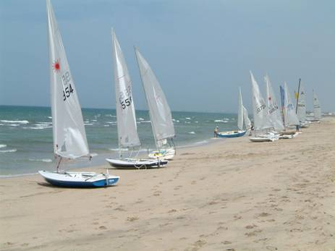

The Castaways Sailing Club organised an Open Sailing Regatta at the Civil Aviation Recreation Centre on Thursday 11th April. Seventeen boats enjoyed some fantastic winds and some really exciting racing. Five Lasers, 2 Laser 2s, Damian's Wanderer and Reinhardt's large cruising catamaran came from Castaways, and 4 Hobie 16 catamarans and 4 Lasers joined us from PDO. The PDO Lasers came by trailer and car roof-rack but the Hobie 16s came by sea, two on the previous Wednesday afternoon and two early on Thursday. The sail down was great with good wind, and the first boats even found themselves surrounded by dolphins on the way to add to the excitement… "if they'd have been any closer, they'd have been on the cat with us!" the crew reported. The Hobies sailed back safely to PDO on Friday morning and the Lasers returned by road.

Four challenging, windy races were sailed around a course marked by large distinctive orange pillar-shaped buoys for the monohulls, and a slightly longer triangle that included the Seeb Wreck north cardinal buoy for the catamarans. The best 3 places from the 4 races were to count towards the final result. The conduct of the races was strictly controlled by Steve, the Race Officer for the day, and ably assisted in the committee/rescue boat by David, the boat skipper.

There was some tough sailing at the head of the Laser fleet, with Douwe Sickler and Jan Wind battling it out for honours in each race. Tony Van Thiel gained strength throughout the day as others were beginning to feel the effects of the weather, and, with some smart tacking, picked up some places to finish second in the last race. Peter Searle survived without capsizing but suffered gear failure that impeded his performance - at least, that's his excuse! Eric van Thiel, the youngest competitor, was unfortunate to have to abandon two races with gear problems.

The Hobies also had some great racing, with some exciting long reaches. The battle for first place was fierce. Bob and Steph were in contention to the end - if only they hadn't capsized to give Dave and Jane the edge!

It is rare that a sailing regatta can be arranged to coincide with such consistent and perfect sailing weather. This made for a tough day but a challenging one that left all competitors tired, aching, feeling much older but exhilarated. "Let's do it again soon!!" was often heard as the competitors headed home.

Thanks go to the staff of the Civil Aviation Recreation Centre, to Ernest the boatman, and to Peter Searle and John Coates for organising the event.

Anyone who is interested in joining the Castaways Sailing Club can contact Peter Searle on 594751 for details.

Results:

Laser

1st Douwe Sickler
2nd Jan Wind
3rd Tony Van Thiel
4th Peter Searle (3 races)
5th John Coates
6th John Murray
7th Ken Alderman (3 races)
8th Eric van Thiel (2 races)
9th Graham Jackson (1 race)

Winner of the Stan White Trophy (for 1st place Castaways) was Peter Searle.

Hobie Catamaran

1st Dave and Jane
2nd Bob and Steph
3rd Jean-Marie and Judy
4th Volker and Sabine

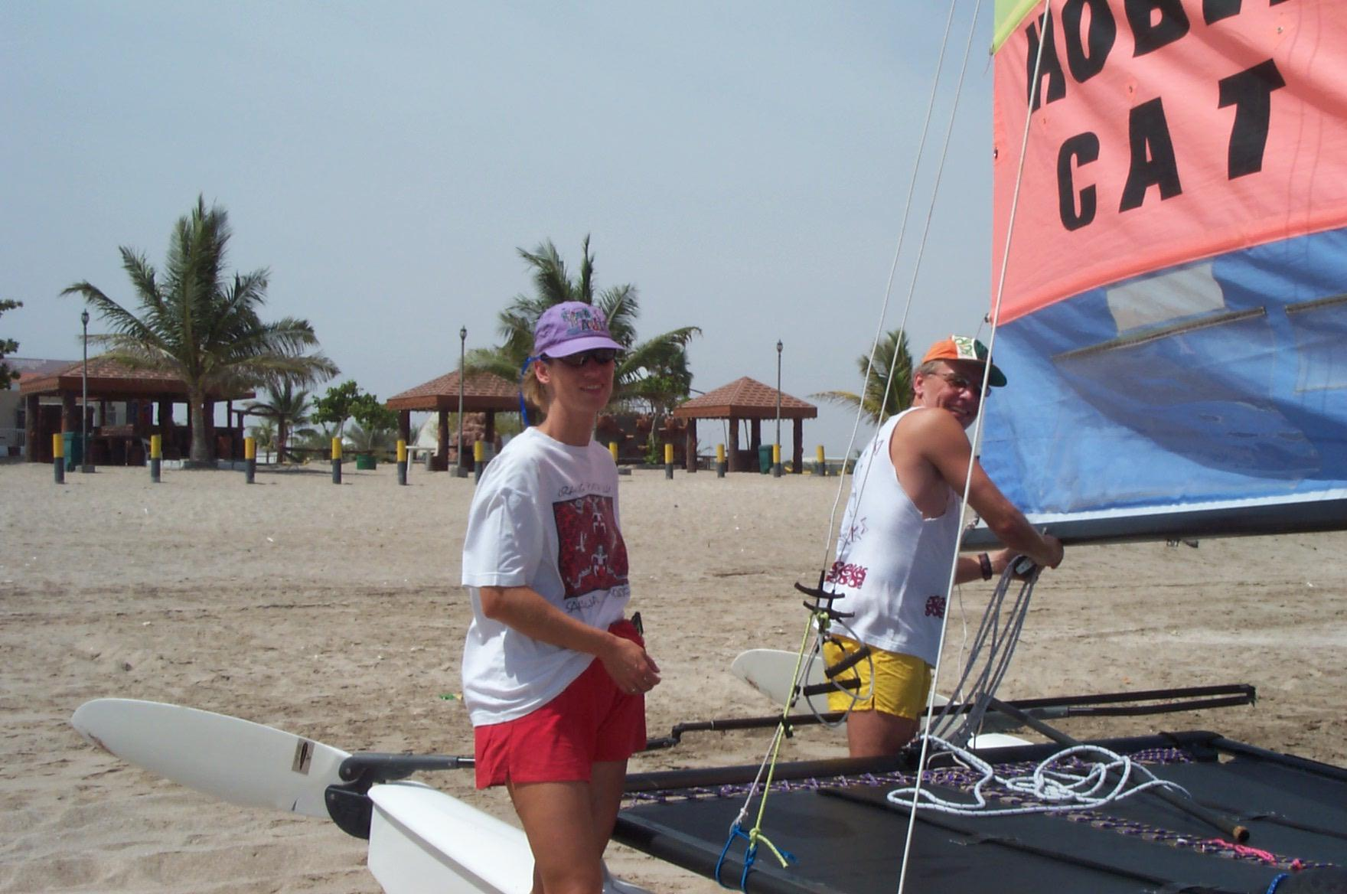 | 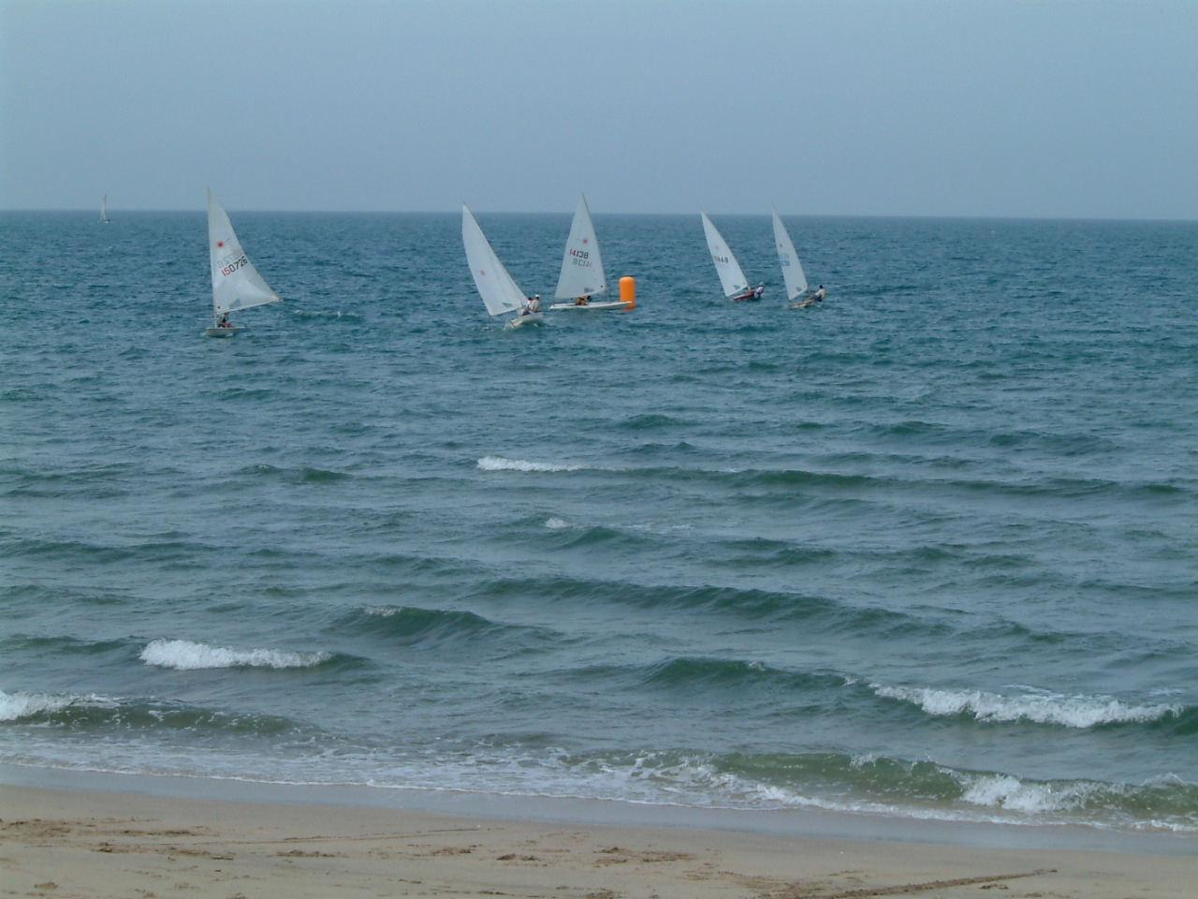
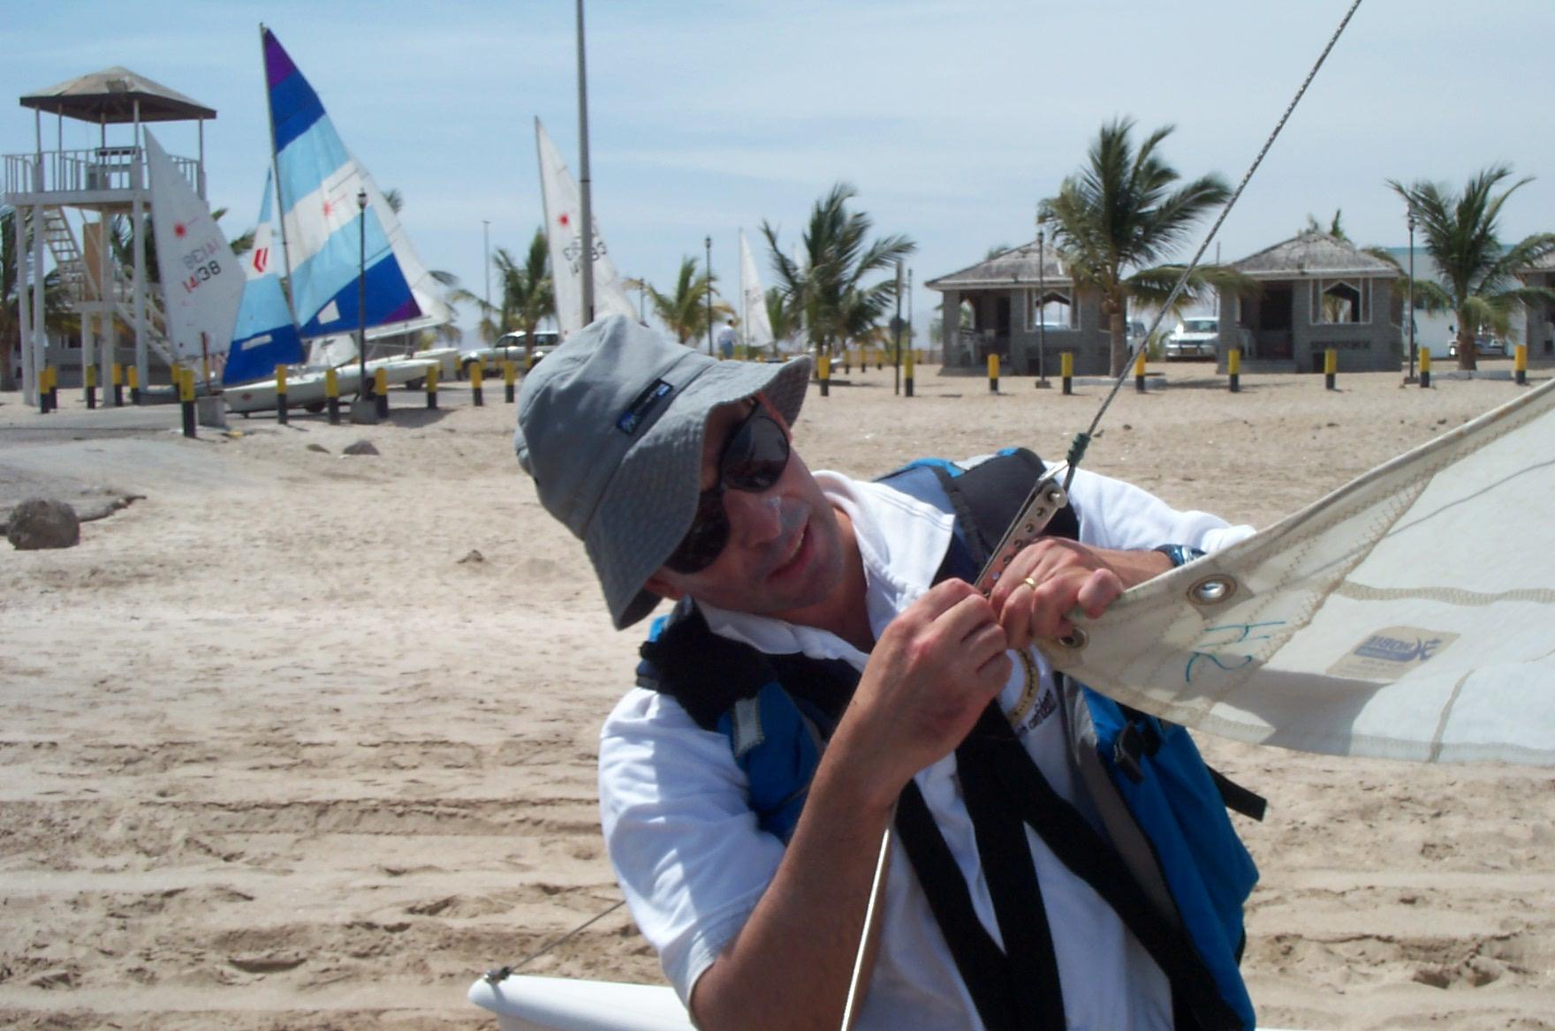 | 