Royal Navy of Oman - Open Laser Regatta: July 2000 Wudam

Neil Dunkley wins
Last weekend 13-14 July, 16 Laser dinghies participated in the Laser Open Regatta organised by the Sailing Association of the Royal Navy of Oman and the Oman Laser Association. The event was a great success due to the good weather, the excellent facilities and the capable organisation provided by the Royal Navy of Oman. Neil Dunkley won the two-day regatta ahead of Dutchman Bart van Reij. The event was attended by sailors from the PDO club, Civil Aviation Recreation Club and the Sailing Association of the Royal Navy of Oman.
Races were held from the facilities of the Sailing Club in Wudam. Races were held both inside the breakwaters and out at sea, which made for interesting sailing for competitors and spectators. Reliable wind and a choppy sea provided exciting racing conditions. Race officer was Cdr. Robin Hodson who with the assistance of support boats of the Navy ran a tight racing programme.
The closest racing took place for 3rd to 6th position overall between Chris Waite, Said Ibrahim, Sam Eddings and Rashid. Omani sailors Said Ibrahim and Rashid managed 4th and 6th position respectively in the strong fleet of sailors. Rashid won the third race, the second time ever for an Omani sailor to win a heat in an OLA regatta.
Commander Hamed Al Farsi, acting Commander of the Base and president of the Mess Committee handed out the prices. He said he enjoyed watching the races, he was pleased with the results and he extended an offer to host the race again next year.
Chairman of the Oman Laser Organisation Neil Dunkley thanked the Royal Navy for their hospitality and commended John Simpson and Chris Waite for the organisation of the event. He congratulated Omani Sailors Said and Rashid on their progress over the past 4 years and he hoped that events such as this would further stimulate them to reach an international level of sailing.
Results Regatta:
1) Neil Dunkley 9) Volker Vahrenkamp
2) Bart van Reij 10) John Simpson
3) Chris Waite 11) John Coates
4) Said Ibrahim 12) David Nam
5) Sam Eddings 13) Robert Black
6) Rashid 14) Salim
7) Dave Clark 15) Yaqoob
8) Jan Wind 16) Abdul Karim
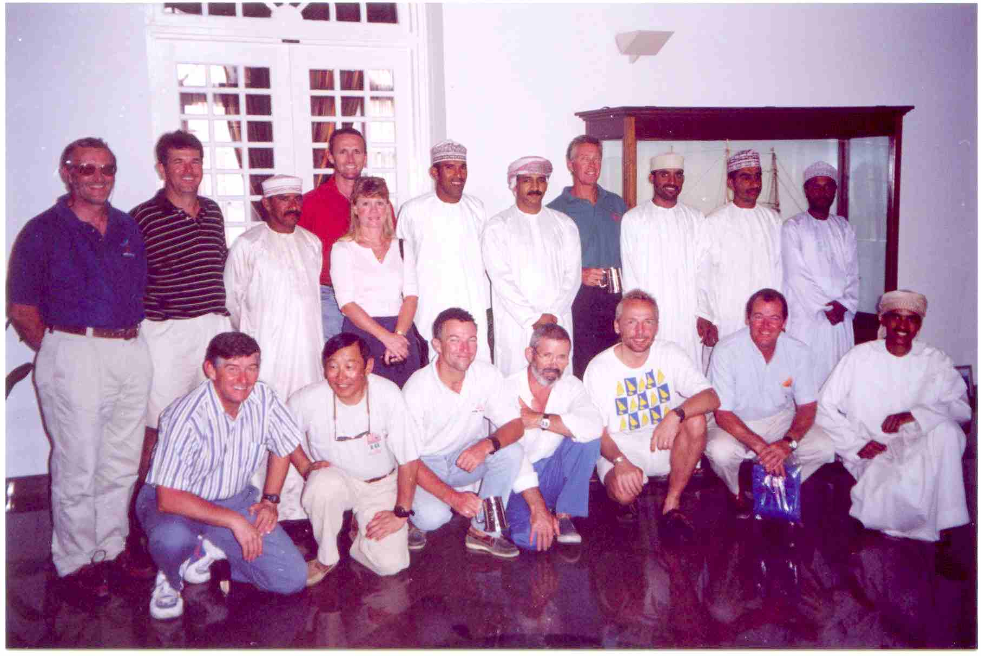
Participants after the prize giving.

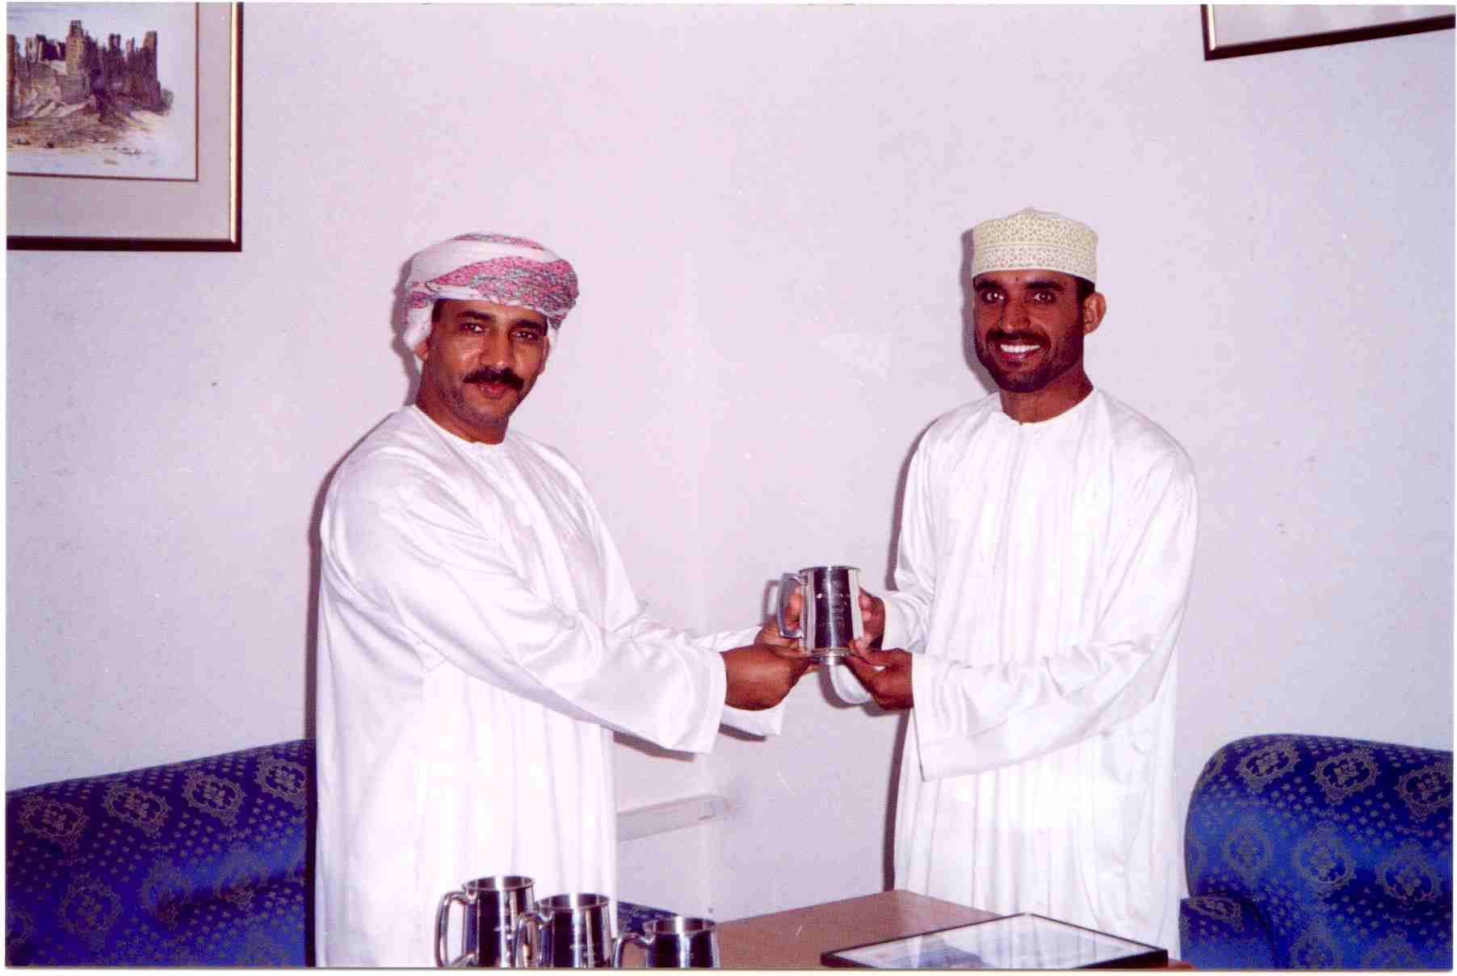
Said Ibrahim 4th prize

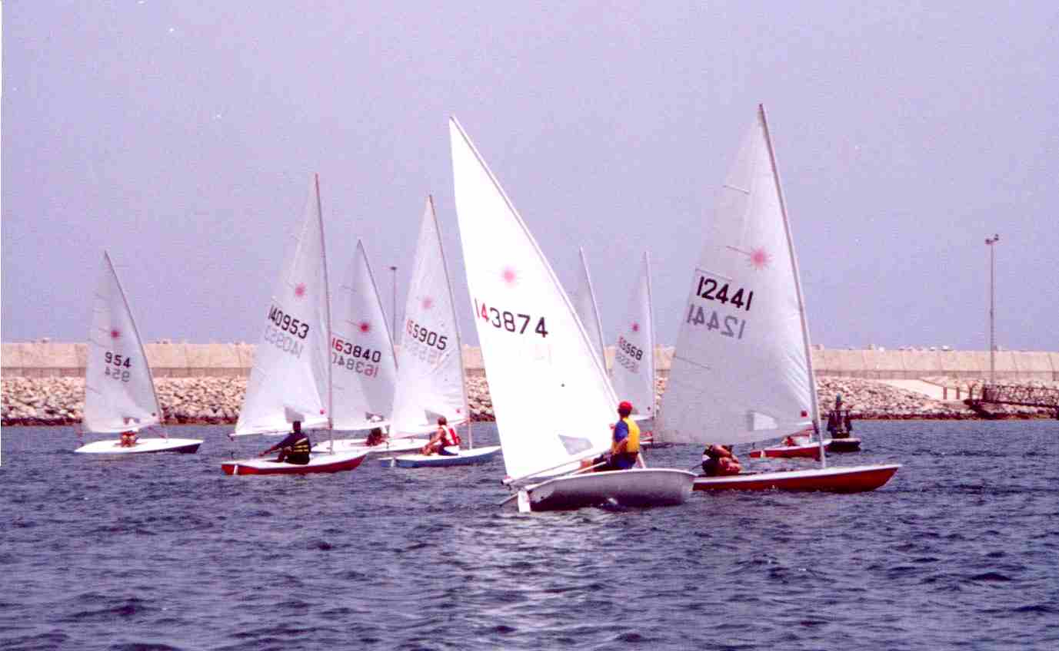
Start of race 3

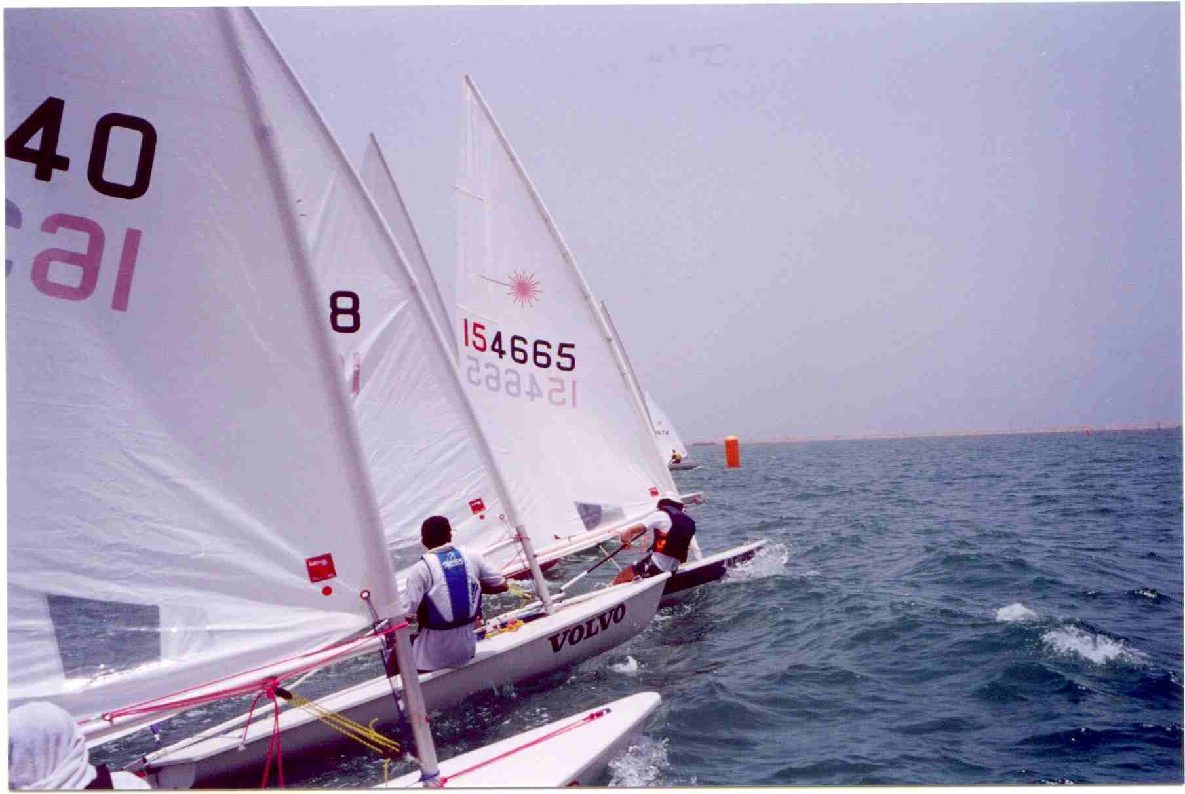
Start of race 4

