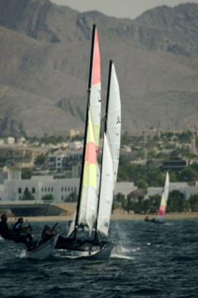
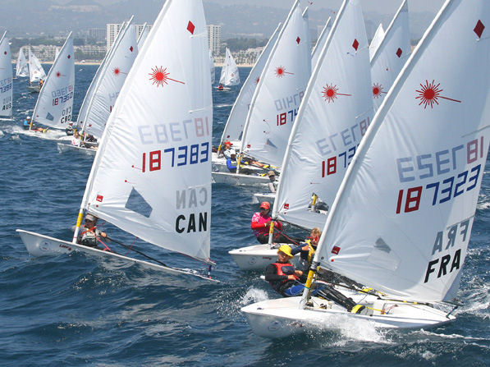

Muscat Festival
Open Regatta
Muscat
Oman
Notice of Race
Laser Dinghy & Beach Catamarans
2008 Muscat Festival Open Sailing Regatta

- Organising Authority

This Sailing Regatta will be organised by QMTC and Muscat Festival committee and the appointed Race Committee.

- Dates & Venue

31st January 2008 & 1st February 2008

All racing will be held just offshore Azaiba Muscat Festival Beach area, near the “Wave” development, Muscat, The Sultanate of Oman.

For further details please contact the Event Organiser, David Clark – daveclarkoman@gmail.com

- Rules

The event will be governed by the ISAF RRS 2005-2008, this Notice of Race (except any changes made by the Sailing Instructions), the Sailing Instructions, the relevant International Class Rules and any posted amendments on the Event Notice Board, This event is designated Category C as stated in Appendix 1 of the RRS 2005 – 2008.

- Eligibility & Entry Fees / Reimbursement Fees for International entries

All entries are to be in accordance with their relevant class rules.

The latest SCRHS shall be used for the assignment of catamaran handicaps, important note, an age allowance and subsequent adjustment of handicap may be granted to 5 years and older Hobie 16s / Prindle 16s / Prindle 18s / Dart 18s at the sole discretion of the race committee. Such adjustments will be posted at least 60 minutes before the official start.

No Entry fees will be levied.

Special Note for International entries:

For Non Oman located Catamaran Teams entries (i.e. International teams that bring their own boats to the event): A one off total expense reimbursement of RO 105 (One hundred and Five Omani Rials) shall be payable to each team (irrespective of the number of people in the team) that competes in the regatta.

For Non Oman located Laser entries (i.e. International teams that bring their own boats to the event): A one off total expense reimbursement of RO 20 (Twenty Omani Rials) shall be payable to each Laser entry that competes in the regatta.

Documentary assistance will be given with custom / border cooperation and general assistance however all costs to temporarily freight - import boats / equipment etc are to the competitors - importers sole account.

This cash reimbursement will be given to qualifying teams / competitors at the prize giving on Friday 1st February 2008.

- Competing Classes

Class A: Laser Dinghies

Class B: All beach catamaran classes up to and including 21ft LOA, with or without spi/gen-nakers

- Registration

All teams shall complete their registration between 07:30 & 08:45 on Thursday 31st January 2008.

- Pre-advice participation

All entries are to pre-register with the name of the helm, Laser type / catamaran type, declaration of with or without spinnaker, proof of age of boat. (Photo of the name plate for example)

Email details to, David Clark daveclarkoman@gmail.com no later than 11th January 2008.

- Sailing Instructions

Sailing Instructions will be posted on the Event notice board.

- Schedule of Events

The Muscat Festival Open Sailing Regatta will take place on Thursday 31st January 2008 & Friday 1st February 2008.

Thursday

07:30 – 08:45 Registration

09:00 Briefing

First Start not before 10:00

5 races are scheduled for each class

Friday

First Start not before 10:00

4 races are scheduled for each class

No racing will start after 1700 each day

10. Prizes

Prize giving will be at Azaiba Beach Festival area at 1700 on Friday 1st February 2008

Cash prizes will be awarded for:

Overall catamaran Handicap Team first, second, third places, RO 350, RO 270, RO 170 respectively

Overall Laser first, second, third places, RO 150, RO 120, RO 60 respectively

Omani Laser first, second, third places, RO 150, RO 120, RO 60 respectively

At the sole discretion of organisers additional trophies or prizes may be awarded

