Oman National Laser Championships 1999 held at Al Sawadi

Dunkley National Laser Champion

Reigning champion Neil Dunkley held onto his title of National Champion at the 1999 Oman Open Laser Championship last weekend. 20 Laser sailors attended the successful races off the beach of the Crowne Plaza Al Sawadi Hotel organised by the Oman Laser Association on 21st and 22nd of October.

The cream of the Laser sailors in Oman attended the event, and the championship was definitely not a walkover for Neil Dunkley who found himself in the middle of the fleet on several occasions. Runner up was Bart van Reij and 3rd place was for Chris Waite.

Sailors from the Royal Navy of Oman put in an excellent performance with a 4th place for Rashid Khalfan and an 8th place for Said Ibrahim. The two new boats of the Navy made these two sailors finally sail to their true potential. During the prize giving, the chairman of OLA commended Rashid for being the first Omani sailor to ever win a race in an OLA championship. He expressed the hope that further acquisitions of new boats would allow more Omani sailors to sail at this competitive level.

The races were held in moderate wind conditions around the Al Sawadi Islands. Race officer was Trevor Horsley who, assisted by his wife Angie, laid some excellent courses and kept tight control over the races. The Royal Navy of Oman provided a start boat and a rescue boat for the event.

Incoming manager of the hotel Didier Coelm handed out the prizes that were kindly sponsored by ULO Leisure Marine from Dubai and the Crown Plaza Al Sawadi Hotel.

Final results:
1. Neil Dunkley 11. Iain Rae
2. Bart van Reij 12. Cees de Bruin
3. Chris Waite 13. John Simpson
4. Rashid Khalfan 14. Rodger Martin
5. Jan Wind 15 John Murray
6. David Lee 16. Simon Lees
7. Sam Eddings 17. Mariette Frits
8. Said Ibrahim 18 Chris Bukton
9. Tony van Thiel 19. Hussain
10. Peter Searl 20. Dave Nam
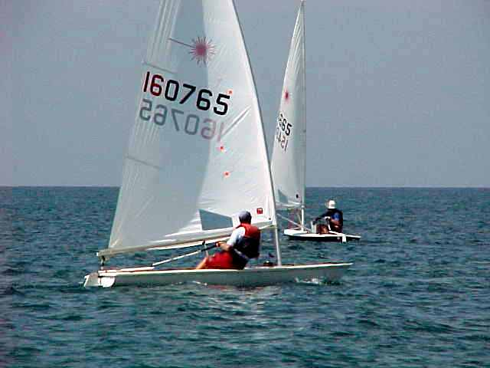
Oman champion Neil Dunkley in pursuit of runner up Bart van Reij

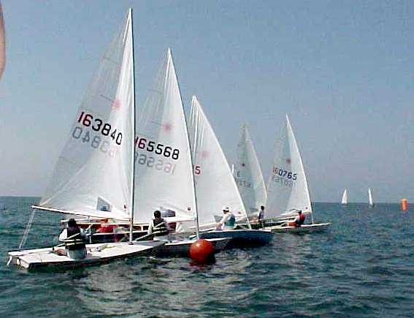
Lasers crowding around the startline of the third race
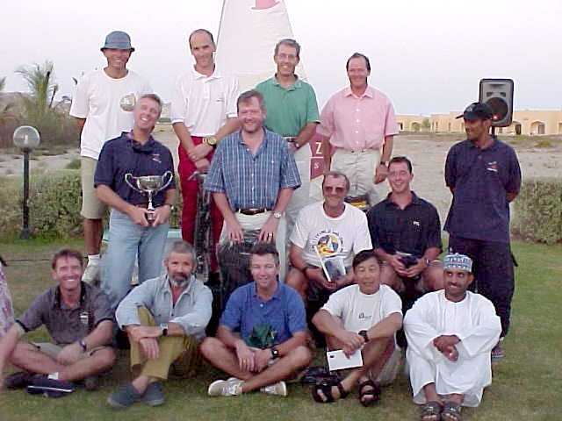
Prize winners

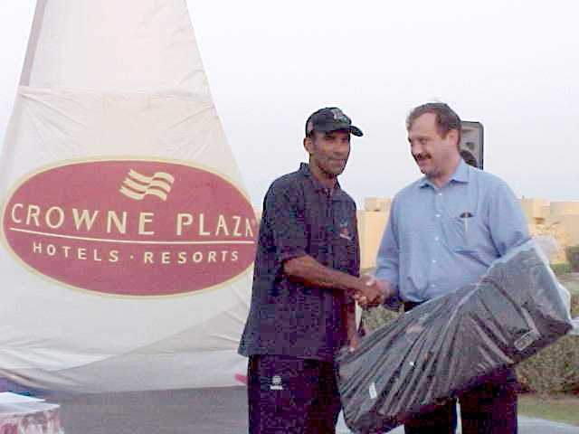
Rashid Khalfan receiving his 4th prize from Hotel manager Didier Coelm
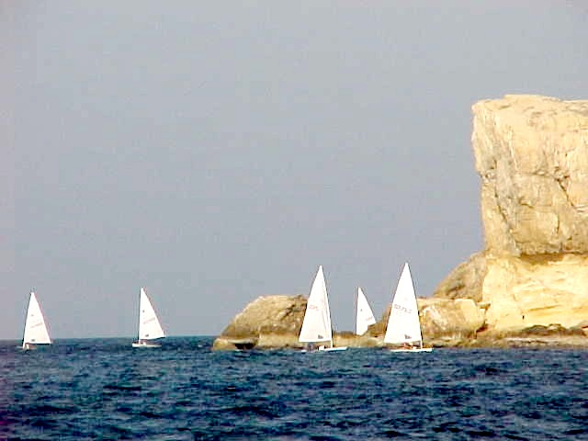
Lasers near the Al Sawadi Islands

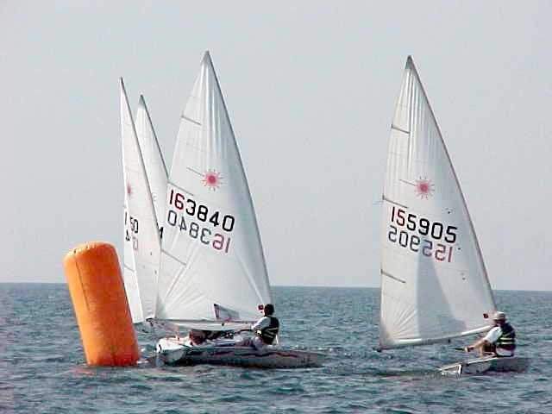
Rounding the windward buouy.

