

Guide to Prindle-16 catamaran sailing
at the Ras al Hamra Boat Centre

May 2000, Muscat, Oman

originally compiled in 1994 by
Jan Hartsink

endorsed by
Adrian Drewett (Commodore)
Gjalt van der Zee (Sailing Captain)

updated in 1999/2000 by
Dirk Kramers (Sailing Captain)
Robin Hamersma (Team Captain)

Contents
1) Introduction
2) Pre-rigging
3) Rigging
4) Launching
5) Sailing
6) Returning
7) De-rigging
8) Parking
9) Signing out

Appendices
A) Required Competencies & Basic Rules - Sailing Craft
B) RAHBC Prindle Helms Ticket Exam skills
C) Helmsticket Statement RAHBC
D) Glossary of Terms / knots (from the Prindle owners manual*)

*Please note that this manual does not appear to be copyright protected, so feel free make your own complete copy.
1) Introduction

This guide has been compiled following the acquisition by the Ras al Hamra Boat Centre of eight brand new Prindle-16 catamarans, and has to be read in conjunction with the ‘Required Competencies & Basic Rules - Sailing Craft’ (Appendix A). The notes take you around basic RAH Boat Centre rules regarding rigging, launching, sailing, returning, de-rigging and parking of the club cats. The guide has been written very much from a (novice) helm's perspective. However, crews are very much encouraged to read through all this as well. Keep in mind that champion sailing teams often comprise two experienced helms ! With respect to the sailing of the boats, a few performance tips have been included. Last, but certainly not least, safety aspects have been highlighted bold where appropriate.

Prindle-16 boats were chosen as the RAH club catamaran, partly because of their name (and experience of some of the RAH cat sailors) as being most durable. Despite this, it's very easy to wreck any boat - the P-16 included-, in no time. Proper usage, maintenance, and in particular a timely recognition of wear are prerequisites to guarantee a lifetime of the boats that the club can afford. You are encouraged to report anything you don't trust or like about the state of a boat to any of the following persons: the boatman, bosun, cat member, sailing captain, or commodore.

Please do help to keep the Prindle-16 fleet of eight in good shape. A fleet lifetime of at least 6 to 8 years should really be no problem (in this case the total annual depreciation of the eight boat fleet, would be some RO 3000), if we are all thoughtful, gentle and caring with the boat club's major asset. Treat them as if they were your own most precious toy !

You are assumed as a RAHBC cat helm to have read this document A to Z and to have active knowledge of the contents. Please do adhere to the rules. Don't think this is to be childish, to cover backsides, or worse, put you off sailing club equipment. It is deemed a necessary measure, to make sure things will go in a safe manner and to guarantee many club members after you will enjoy a fleet that's in good shape. Please do pass on any constructive suggestions/changes you may have to the boat club, so that we can judge whether it can be included in an updated edition of this document.

Have lots of fun and see you out there !
2) Pre-rigging

Put your helm's ticket (and that of your crew in marginal weather conditions) in the board located outside the sailing. Without a helm's ticket or without a crew you are not allowed to sail a club catamaran. Put your name, boat number, time out/in and contact number in the log book. Now it's time to pick up the bungs, sails, harnesses and life vest from the sailing room and bring this to the boat. Untie the boat and remove the cover. Put in the bungs (hand-tight will be fine !). Make a quick check of the hulls (no cracks outside ?, no water inside ?), the inspection ports (are they all hand-tight ?), the stays (are all the locking rings in and intact ?), the rudders (in up position ?, are the rudder pintails locked by a split pen ?), the forestay shackle, the shackles of the jib sheet and main blocks and the tension of the dolphin striker. Put the sails and your gear onto the trampoline. Put the boat onto the beach trolley and tie the ropes to the stays. Do check that the wheels do not make contact with the hulls, as the rotating wheels can give irremovable burn marks and even cause dents in the hulls. Move the boat to the beach with at least two people. Do watch the rudder blades and the hulls when moving the boat. Put the boat on the beach above the waterline and with the bow in the wind.

3) Rigging

Remove the main sail and jib from the sailbag. Undo/untangle the jib halyard and put the S-hook through the top eye (the open end of the hook to the mast side), close the zip around the steel forestay, the jib halyard and gently hoist the jib, whilst closing the zip. When the jib is completely up keep the zip 1/2 meter open, hold on to the halyard, pull the jib sideways and slightly down whilst releasing the halyard. The hook should lock in the ring. If it doesn't work, try and repeat the exercise with the jib moved sideways towards the opposite hull. When the jib is locked in the upper ring undo the halyard extension cord and put it back in the sailbag. Now tension the jib with the thin line, and put the jib sheet shackle on. Tension the jib sheet a bit such that it is in back position, because a luffing jib will be damaged in no time. Just as an example the small battens can come out, because of wear on the sail material and the stitches.

Unroll the main sail and make sure the main sheet is not entangled/hooked up in the battens. Check the batten pockets whether all pop nails/bolts are intact, and that no one batten pierces through the sail. Also, do check the batten tension lines on the rear side and see to it that they are all knotted. If any of this is wrong, do not take the boat out with this sail until it has been corrected. Sails are like the engine of a car: you wouldn't like to start your engine without a lube oil fill, would you ? Untangle the main halyard and put the shackle through the top eye hand tight. Make sure that the end with which you will hoist is not hooked behind the sidestays or trapeze wires and go stand right in front of the mast. Pulling side-ways will damage the sheaves in the top of the mast ! Gently guide the sail through the mast groove whilst hoisting. Keep this groove "downwind" (i.e. the mast profile parallel to the wind direction), because it reduces the friction. Also pay extra attention on guiding the batten pockets past the groove. When the sail is almost completely up rotate the rear end of the mast to starboard and hoist further until you hear that clear click. Another way is to hoist completely, then rotate the mast and pull the down eye until the sail is locked. Downhauling can be done two ways: with a separate line and with the end of the main halyard. Guide the bottom part of the sail through the groove and attach the downhaul line to the eye. Down through the block on port, back through the eye, through the eye on starboard, back through the eye and finally through the clamp. How tight should it be ? Well it's a matter of trimming but in a good wind the bottom of the sail should be some +/- 10 cm (one hand) above the boom. Put the main halyard behind the sidestays and trapeze wires and attach it firmly to the black cleat. Then sheet the main halyard in, and put it in the pocket on the trampoline. Attach the outhaul shackle on the boom to the main sail and tighten to your taste. Lots of wind = flat sail = tight. Check whether the main sheet is completely out (first on the traveler, then through the main blocks): it wouldn't be the first time that a catamaran capsizes on the beach in a gust ! Keep the black tiller extension away from the traveler, such that it can freely run.

Well, are you ready ? Sorry to write it, but there's a high chance you are not. Store the sail bag. Check the boat once more and convince yourself that you will step on to a seaworthy machine. Are the bungs in and is the life line properly tied with a bowline knot around the pivot and an eight knot above the eye in the trampoline ? Are all the trapeze wires at the correct height for you ? Catch a bit of wind in the main sail and look up to the mast top: does the sail profile look smooth ? Are all stays properly attached ?

Enough now, put on the harnesses, life vests, shoes and gloves if you like them.

4) Launching

Open the jib and make sure both jib and main sail can freely luff. Make sure the rudders are up. If wind and sea state allows reverse the boat towards the sea and away from the windward and downwind ramps (i.e. somewhere in the middle). If a hull at water touches hard concrete, there's almost without exception immediate damage ! The helm can stand behind the boat and pulls on the rope through the trampoline (not on the tiller crossbar !), the crew pushes from the front (bow). Wait for a suitable moment with not too many awkward waves to put the boat in the water (still reversing !). This is the point where you have to be extra careful: make sure to keep the boat in the wind. It's quite easy as long as your crew holds onto the boat near the front. Put the boat in waist deep water. The helm goes onto the trampoline and puts the rudders down: hold onto both lines one in each hand, release the one with aluminum pipe whilst giving the black ball one a gentle but continuous pull. Do not lock the rudder blades until you are in deep water. If a locked ruder touches the ground due to the action of the waves, there will be serious damage ! Make sure that you look seaward before sailing out: can you freely go or are there boats or swimmers in your way (the latter shouldn't !) ? Put the jib a little back and when the helm is happy the crew can come aboard. Do watch the ramps, raft and traffic whilst sailing out.

You may have seen some sailors putting their private cat out in a rough and windy sea with the bow pointing towards the sea. It looks impressive and a bit like the start of bob sledding. This technique is great for a regatta with a Le Mans type start, but you better believe it, only a few club caters can do this successfully without getting damage to themselves, others and/or the boat. We have already seen unmanned club boats sailing off (with a pregnant woman swimming on it's course) to the raft (with children on), because of failed attempts of this sort. In other words, don't do any bravado trials like this with club property if you are not experienced. An exception to this are very, and we mean very light wind conditions (i.e. 0-1 Beaufort = 1-3 knots = 0 - 5 km/hour = 0 - 1.5 m/sec) or in marginal weather with the assistance of at least one other person in addition 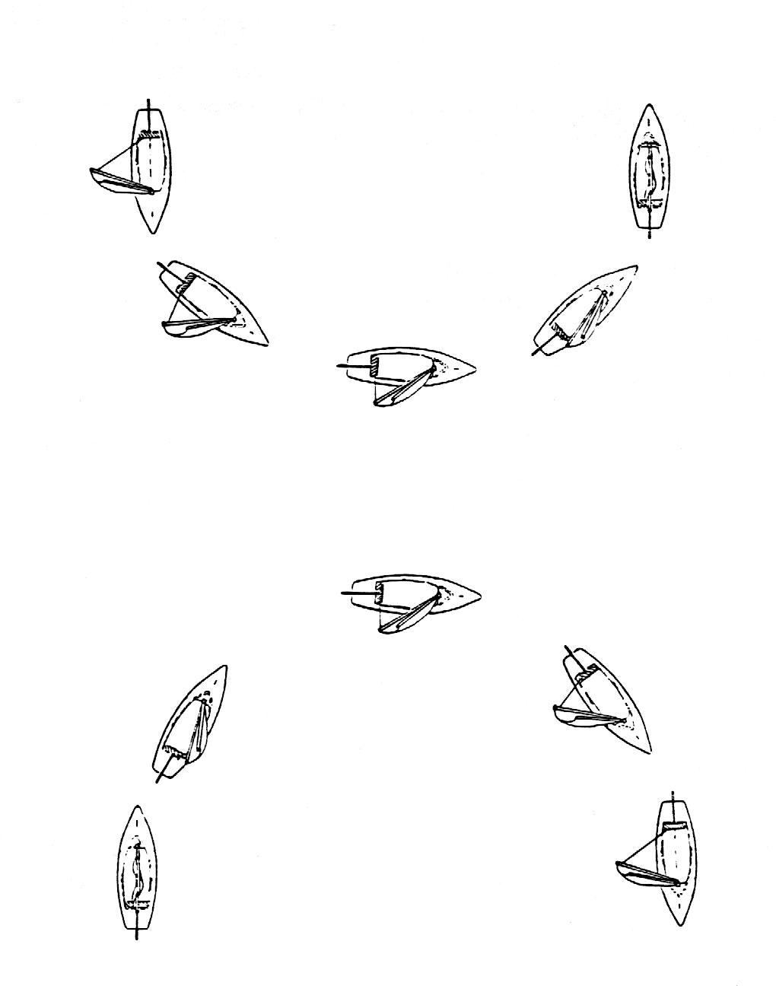to the helm and crew.
WIND
Down wind
Voor
Broad reach
Ruim
Reach
Half
Beat
Aan
In
Broad reach
Ruim
Down wind
Voor
Reach
Half
Beat
Aan
In

5) Sailing

Although this is what it is all about, the guide will be brief on sailing. For obvious reasons one cannot disclose too many cat sailor's secrets ! You are a qualified helm and so you know about sailing this P-16 machine. If you really want to know about cat sailing and improve your skills a useful book is that of Brath & Enzmann (Dutch translation: Catamaran zeilen ISBN 90 228 1249 9). A few basic traffic/racing rules will be outlined here and a few Prindle-16 specific tips be given. To become really skilled on a catamaran one needs to practice a lot. By all means do so: that's the whole idea about club catamarans. Let there be many skilled helms in the forthcoming races !

The following sketch shows common course terminology:
A few basic rules
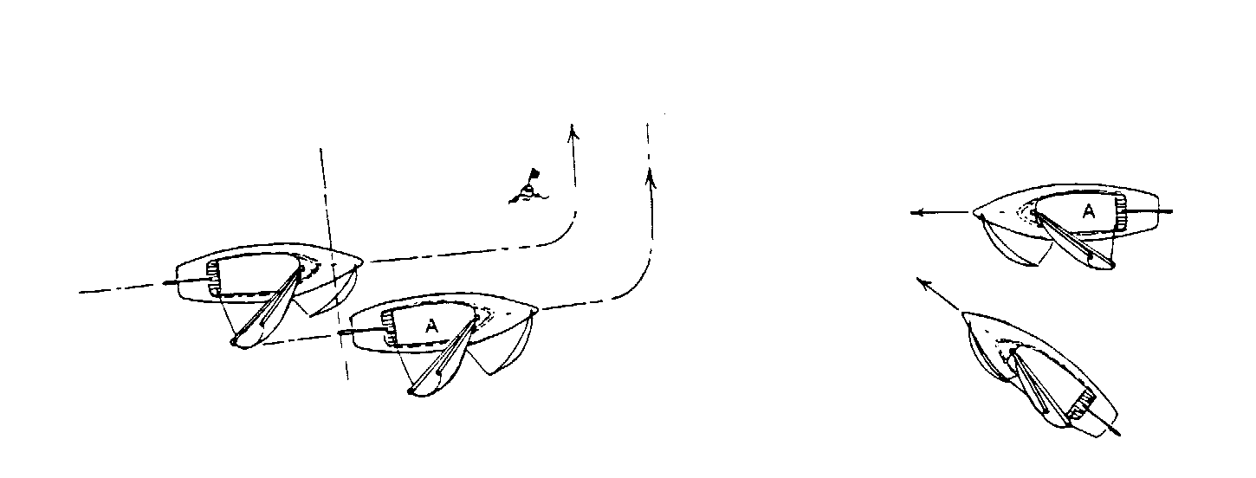Try and comprehend the next four figures. Boat A has to give way to the other boat in all cases (with boat we mean any sailing device):

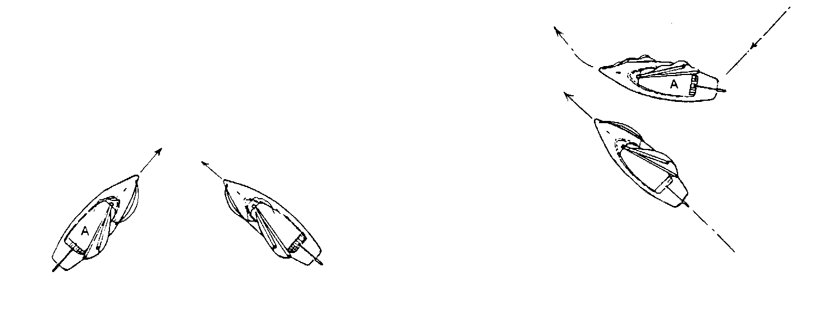The inner boat must be given space to round the buoy by boat ‘A’. | The leeward boat has the right of way. Boat ‘A’ needs to give way.

The boat with the sails on the starboard side has to give way to the boat with the sails on the port side. | A maneuvering boat (gibing/tacking) has to give way to any other boat.

Another pertinent rule in Oman waters is to stay clear of fishermen boats, oil tankers and other professional traffic. Do realize that the first group may be dragging long nets and fishing lines along, so think carefully where you go. It wouldn't be the first time that a club boat is being chased away from a fisherman, because of potential or actual damage to nets or lines.

A few sailing tips

Make sure the hulls are correctly in the water. If the deck of the bow is 10-15 cm above the waterline the boat is properly balanced in the direction of sailing. How much should the hull that you're sitting or standing on be out of the water ? As a rough indication when the hull is just touching the water or some 10 cm in, you're doing fine.

What to do if the boat makes it's classical nose-dive. As a crew in the trapeze try to avoid that you're being catapulted to the bow or even further (it can hurt !). Easier said then done, but if you keep an eye on what the leeward bow is doing, very often you can anticipate the nose-dive. When it does happen, keep contact with the hull by making small jumps even though physics dictate you to the front. This way you're breaking your own speed. As a helm, keep the boat on course in a nose-dive, but sheet the main sail out very quickly, and keep your position on the boat. Very often you can prevent the nose-dive evolving into a full blown capsize, just by this very last thing.

To gain speed on a broad reach, you could try opening the outhaul of the main sail (on the boom). This way, you give the sail more of a belly. The other broad reach tip is the use of the traveler. Put this out some 3/4 or even fully, and sheet the main block in. You will notice the change in curvature of the sail. In fact if on any stiff wind you think there's too much sail on the boat compared to the weight of helm and crew (e.g. constantly close to capsizing), you could try to put the traveler out a bit. This will normally make life easier for the helm (less work on the main sheet) and the boat speed will increase.

If you're being overtaken by another P-16 at anomalous speed, you'll realize there is something wrong. Are the sails (especially the jib) not too tight and/or has the boat made water in the hulls ? It's for you to find out and catch up with Mr. or Mrs. Speedy.

Going about in high waves and windspeed is another problematic area. Well, it's not all that difficult. Sail the boat on a fine beat course. Try not to go about whilst sailing up a wave. Instead you wait until the boat is at the culmination (crest) of a wave. Crew should stay in the trapeze as long as physically possible. Leave the jib alone, so that it can go in back position. Make sure the weight of the crew is towards the front rather then at the back of the trampoline. This avoids the kind of capsize, where the wind gets grip on the trampoline from underneath and starts controlling the boat. If the boat reverses when going about, put the rudder over to the other side. Only when the boat has actually gone about and have started sailing on the new course does the jib go over to the leeward hull.

Do realize as a qualified helm that in case you sail with a novice crew who has no idea about helming a catamaran, you could expose yourself and your crew to dangerous situations (e.g. helm falls overboard and the boat sails off with the crew). Try and teach your crew as quickly as possible some basic sailing techniques (e.g. the "man overboard").

6) Returning

Sail the boat at not too high speed at a course pointing somewhere in between the ramps. Give due regard to fellow watersporters. Know the water depth and put the boat in waist deep water in the wind whilst the crew jumps out and grabs the bow of the boat to keep it in the wind. Release the main sheet fully (a quick way is to push up the boom from underneath whilst sheeting out). Pull both rudders up. Jump as a helm on the opposite board of the boat of where the crew is. Pull the boat on to the beach in the wind, far enough above the water line. Put the jib back with the sheet, because if it luffs and flaps all over the place you can wait for it to become completely worn, thereby reducing the boat speed for the next regatta !

What to do when upon returning from your sailing, (to your surprise) their appears to be a high swell in the surf zone ? This can happen when for example you have taken the boat out at high tide (low wave height) and you return in high waves associated with low tide. For G..'s sake, in this situation don't be foolish by putting the boat in the wind in waist deep water (as spelled out above), thereby lining the boat up parallel with high waves. There's a high chance the boat will be wrecked by being picked up by a high wave and being thrown/capsized onto the beach, ramps and/or crew. In this situation, you haven't got any other sensible choice then "beaching" it. The idea is that you stay perpendicular to the waves and no matter how high, you keep it perpendicular to them. Both helm and crew stay aboard and sit at the back of the trampoline. Sail at slow speed towards the beach to a relatively cobble/boulder free patch, and keep sailing until you've landed the cat onto the beach. Do not unlock the rudders in this situation: they will automatically unlock once they touch the seabed (they are designed for this !). Unlocking them yourself will only distract you from what is essential in this situation: to keep the boat perpendicular to the waves.

7) De-rigging

After you've refueled yourselves at the boat club bar it's time to de-rig the boat. Once you've rigged the boat, de-rigging is trivial. However, here are a few tips. Don't forget to attach the jib halyard extension. Fold and roll the jib in 20 cm wide partitions and avoid crinkles in the process. Crinkles in sails reduce boat speed in the long run ! Go and stand in front of the mast, gently pull up on the main sail halyard (keep the tension on the line), then rotate the mast to port side after which you pull on the eye of the downhaul, should unhook the main sail. The main sail should be rolled, again without crinkles. Don't lower the sail too fast, because if the sail or batten pockets are caught in the lower mast groove, the former two will all quickly get damaged or worn. Put the sails in the bag and put the boat gently on the trolley. Do watch the rudders are in up position.

8) Washing & Parking

Store the sail bag in the appropriate slot in the sailing room. Open the bungs, wash all metal parts, blocks, stays hulls, well everything with the fresh water hose. Although many P-16 parts are made of stainless steel, it's amazing what damage salt water can still do to it over a longer period. Needless to say, how quickly aluminum rots away, so give it all a good wash. If you think some sand has gone inside the hull, open the inspection ports and bungs and let water in the hull through the former. When finished, put the bungs in the cupboard inside the sailing room. This way, the inside of the hulls can "breath" and dry up.

Wash the harnesses and life vests and store them on the racks in the sailing room.

Park the boat gently on four car tires. They should be approximately located underneath the four beam attachments on the hulls. Put the boat cover back on again.

9) Signing out

Do sign out of the blue Prindle book and record any damage that has occurred or spotted on the P-16 sheets provided (there's essentially a no-blame policy, so nothing stops you here !). Do inform the boat man, cat member, sailing captain, bosun or commodore about any damage (e.g. damage that rules out a safe and/or proper next sailing session). Please do realize that failure to report back properly, may lead to other people then yourself getting into trouble or getting an accident at sea. Moreover, what improper reporting will lead to, is immediate exclusion of future use of any boat club equipment !

It has become a long story, but let it is hoped that it helps to get a well organized and very active catamaran club at the Ras al Hamra Recreation Centre !

Required Competencies & Basic Rules - Sailing Craft

Conditions | Sailboats (Private and Club) |  | Windsurfers
 | Recreational | Racing |  | Private & Club
Fair  (up to a wind force of 12 knots or significant wave height <1m) | General:  - Basic helm ticket for type of sailboat.  - Trips around the island and outside the sight of the boat club shall be noted to the boatsman with an estimated time of return.  - Helm ticket to be displayed on the board at the sail room and boat signed “out & in” in the registration book.  Laser/Topper/Optimist:  - See general above  - Exemption for basic helm requirements during formal training & assessments.  Catamaran / Other Monohull:  - To be sailed with at least one helm and one crew. | Course set up within sight of the boat club:  General:  - Basic helm ticket for type of sailboat.  - Helm ticket to be displayed on the board at the sail room.  Laser/ Topper/ Optimist:  - See general above.  Catamaran / other Monohull:  - To be sailed with at least one helm and one crew. |  | - Sailing permitted for all grades of sailor (Beginner, Intermediate, Advanced and Expert).  - Beginners restricted to sailing in the bay.  - Club equipment can be used by all.  - Sign in/out - All windsurfers required to sign in and out.  - They are responsible for deciding on their ability to cope with the conditions against the above criteria.  - A list of sailors/expertise levels will be provided to the boatman and will be regularly updated.
Marginal  (between a wind force of 12 - 25 knots or a significant wave height between 1.0m to 1.5m)  One black ball displayed | General:  - ‘Expert’ helm ticket for type of sailboat.  - Trips around the island and outside Zone A shall be noted to the boatsman with an estimated time of return.  - Helm ticket to be shown to the boatsman then displayed on the board at the sail room, boat to be signed “out & in” in the registration book.  Topper / Optimist:  - Launching suspended.  Laser:  - See general above, with weight of helm above 65kg.  Catamaran / Other Monohull:  - To be sailed with at least one helm and one crew, with combined weight > 124 kg. Crew to have as a minimum a basic helm ticket.  - Both helm tickets to be shown to the boatsman and to be displayed on the board at the sail room. | Safety boat to be launched, the course to be set up within sight of the boat club and OOD:  General:  - Basic helm ticket for type of sailboat.  - Helm ticket to be displayed on the board at the sail room.  Topper / Optimist:  - All racing suspended.  Laser:  - See general above, with weight of helm above 65kg.  Catamaran / Monohull:  - To be sailed with at least one helm and one crew, with combined weight > 124 kg. |  | - Beginners should not launch.  - Intermediate, Advanced and Expert sailors permitted to sail.  - Club equipment can be used by these sailors.  - Voluntary buddy system.  - Sign in/out - All windsurfers required to sign in and out.
Rough  (greater than a wind force of 25 knots or wave height >1.5m)  Two black balls displayed | - Launching suspended for all sailboats. | - Launching suspended for all sailboats. |  | - Advanced and Experts only.  - Buddy sailing or “watcher” on the beach mandatory.  - No club equipment to be used.
Destination equipment requirements and procedures | Zone A (within sight of RAH beach) - Boats to carry the equipment required by RAHBC regulations as a minimum  Zone B (to the west of RAH, within 2km of the shore and as far as the Hyatt Regency Hotel) - requirements as per Zone A plus buddy sailing.  Zone C (All other areas outside Zone A and B) – RAHRC equipment plus buddy system. Where larger groups (> 4 boats) are involved - Safety Boat cover required. It is also preferential to carry a working communication system (e.g. GSM, Marine Band VHF radio, etc.)

Note:

Races held under the auspices of the Oman Laser Association (OLA) at the PDO Recreation Club will follow the above stipulations for ‘Racing’, with the exception that guest sailors will be allowed to compete with their own sailboat without possessing a PDO helm ticket.
These requirements are to be read in conjunction to the rules and guidelines produced by each section. These guidelines define standards, set out standard practices and list those responsible for assessing competence.

RAHBC PRINDLE HELMS TICKET EXAM

The following is a list of skills that needs to be tested during the RAHBC Prindle Helms ticket exam:

- Bringing the Prindle to the beach
- Rigging
- Launching
- Tacking
- Gybing
- Man overboard
- Capsizing
- Beaching
- De-rigging
- Bringing the boat back to berth
- Clear instructions to the crew during the above
- Understanding of the basic rules of sailing

Obviously, the test will have to take place with a reasonable amount of wind. During the test maneuvers the examiner will acts as a completely ignorant crew. A real life man overboard situation can be created by the examiner jumping overboard at an unexpected moment. It is up to the judgement of the examiner whether this would not create a situation in which the boat capsizes, with the examiner unable to keep up with the fast drifting boat. As an alternative a life vest can be thrown overboard, with the examiner taking a passive roll in all the maneuvers to retrieve the life vest.

Only those sailors with a demonstrable experience on sailing a catamaran offshore will be allowed to enter an ‘EXPERT’ exam. To obtain a helm ticket on EXPERT level, the above maneuvers must be tested in marginal or near marginal weather. Special attention must be given during the exam how the helm recovers from capsizing and whether tacking causes no problems.

The real challenge of the test is to judge whether the examinee is skilled, confident and responsible enough to take out a club Prindle safely. If the examiner feel that this is not yet the case, he will advise to build more experience by sailing with other helms, before redoing the exam.
Prindle / Laser / Monohull *
* = (delete as appropriate)

HELMSTICKET STATEMENT
RAHBC

- - - - - - - - - - - - - - - - - - - - - - - - - - - - - - - - - - - - - - - - - - - - - - - - - - - - - -
NEW HELM:
- - - - - - - - - - - - - - - - - - - - - - - - - - - - - - - - - - - - - - - - - - - - - - - - - - - - - -
I hereby confirm that:
- I have read and understood the relevant Prindle/Laser/Monohull
Guidelines and will adhere to them at all times.
- I accept that taking out a club or a private boat is at my own risk.
- I will do my best not to endanger myself or my crew.
- I will do my best not to damage the boat.
- I will report all damage to the boat to the relevant RAHBC Committee Member.

Name : ______________________________
Reference Indicator : ______________________________
Co. Number : ______________________________
Date : ______________________________
Tel. office : ______________________________
Tel. home : ______________________________

Signature : ______________________________

- - - - - - - - - - - - - - - - - - - - - - - - - - - - - - - - - - - - - - - - - - - - - - - - - - - - - -
EXAMINER:
- - - - - - - - - - - - - - - - - - - - - - - - - - - - - - - - - - - - - - - - - - - - - - - - - - - - - -
I hereby confirm that the above sailor has passed the relevant helms ticket test, as prescribed by the Ras Al Hamra Boat Centre committee

Type : Catamaran / Laser / Monohull / Topper
LEVEL (delete as req'd) : Basic / Expert

Name : ______________________________
Reference Indicator : ______________________________
Co. Number : ______________________________
Date : ______________________________
Tel. office : ______________________________
Tel. home : ______________________________

Signature : ______________________________

- - - - - - - - - - - - - - - - - - - - - - - - - - - - - - - - - - - - - - - - - - - - - - - - - - -

