2005 Oman Audi Open
Hobie 16 National
Championship

September 1st & 2nd 2005
PDO Prequalifying Round

September 8th & 9th 2005
Open Championship

PDO Recreation Centre
Muscat
Oman

Contact
National Sailing Captain
David Clark
clarkd@omantel.net.om
00968+99+73+20+35

Notice of race on
www.hobieclass.com
Major Regattas
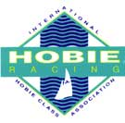

http://www.pdo.co.om/hseforcontractors/rahbc/Sailing/Sailraces/2005-Hobie-Nat.htm

