

Nawras Oman Hobie 16 National Sailing Championship

On the 5th anniversary of this event it was with great commitment and support that Nawras came to the fore and sponsored for the second time this dynamic and challenging sailing event, with the greatest numbers of Hobie 16 catamarans ever seen in the Sultanate, twenty seven teams fought to secure the Oman National Champion Title over the weekend. The Hobie Nationals race committee where also wonderful supported by Nomad Tours, Lorna Messeder who kindly provided the start committee boat, Shamsa 1 and her captain and crew for the whole weekend, the race committee where truly in the lap of luxury.

Three Omani Teams from the Ministry of Sports Affairs proved that the current sailing training program for Omani sailors has really taken off with a very impressive final placing of 9th Overall for Suleiman Khamis Al Wahaibi & Abdul Latif Al Wahaibi. With a real mix of sailors from Dubai with five teams, from Abu Dhabi two teams, from the Castaways of Oman with two teams and the host sailing club PDO Recreation Club making the balance of teams, with 54 international sailors on the water the racing was sure to be extremely competitive.

With a schedule of nine races over the two days, spirits where high amongst the teams with the anticipation of the forecasted Easterly wind of 12 knots expected to hold for the two days of the Championship.

Day one saw the fleet settling down to some very impressive starts especially from the local team of Tony Van Thiel and son Paul Henri with numerous port starts across the fleet to take the days’ advantage of tide / current / wind with the inshore route into the PDO bay. The rest of the local Oman fleet approached the line with accuracy and speed but even with this local knowledge available, it couldn’t stop Malcolm & Sue MacGregor being the over night leader, followed closely PDO Team Pascal Richard & Ines Duclairoir. With such a large fleet in each race their where constant challenges throughout the fleet at every mark rounding and finish, with several teams finishing within seconds of each other after 45 minutes of racing.

Day two started with a North Westerly wind of around 10 knots, however due to local knowledge of this type of wind this early in the day the race committee knew that they had to wait for the swing to the East around lunchtime as the heat builds up over the impressive Hajar mountains and the Sumail gap, sure enough as though some one had flicked a switch, at 13:00 hours the wind swung and settled into a steady 15 knots with gusts of a few knots more, perfect sailing conditions for these exciting twin wire catamarans. As the fleet headed out to the start line they all knew that this would be tough afternoon on the water of three possibly four races all back to back.

The fleet had many challenges, with a slightly altered course from the previous day, the downwind gate became a dilemma, should you go left or go right back up the beat, the offshore gate buoy was closer to the windward mark, the inshore buoy was on the inshore bay favoured course line but further away from the windward buoy, this challenge saw 50 / 50 splits in the fleet as teams chose their route back up to the windward mark, with the majority of races being 3 laps, each judgement call made a difference.

With strong performances from the top teams especially from Barnaby Houk and Helen Morgan with 2 first places in row, the eighth race and potentially last race of the regatta was the race for all secure their positions in the final ranking. As the race committee commenced their countdown for the start it was very apparent that the teams where really fired up and eager to make their start count, with a tight start line and twenty seven boats all trying to hit the line dead on the gun at full speed this was what it was all about, a real all on National Championship level race.

With all the cats away cleanly the fleet clawed their way up the windward beat, places changed with different tactics, offshore or onshore routes, out of the mayhem one boat managed to get away and achieve clean air, Barnaby and Helen where in control, they held onto their first place and where never challenged, as they went through the finish line they knew that they where in the hunt for the Championship title. However as time limit for regatta had been reached they saw that the race committee had not raised the back to back race flag and they could only compute themselves their final placing as they sailed back to the beach. With the rest of the fleet all trying to make the last race their best finish place, many challenges occurred at each mark rounding, tack for tack challenges, cries of port / starboard, windward boat keep clear, no over lap, could be heard on the course. As each team finished and passed behind the start boat you could see the smiles beaming back to the committee that everyone had a fantastic time on the water.

As the race committee ran their computations the fleet engulfed the beach with a wave of colour and in the midst of it all Nawras where there preparing for the prize giving ceremony. With results computed at 17:00 the competitors gathered around the Nawras Championship award table eager to see if their maths where correct or not. The Senior Race officer and Hobie Nationals Chairman, David Clark commenced the formalities with a warm welcome, an introduction and thank you to Mr Tore Solberg Marketing & Sales Director of Nawras as the Guest of Honour for the Championship. David expressed with very special gratitude and thanks to Nawras for so generously supporting the event for a second year, and to all the committee who had worked so hard to make it all happen and in particular to Mr Mac McCourt who provided constant and ever reliant assistance with the course laying / adjustment and rescue services. David also thanked all competitors for their excellent sportsmanship skills and invited them to network with all other clubs / competitors attend next year’s event, which surely will break the thirty boat entry threshold.

Mr Tore Solberg then presented Nawras trophies to the following teams:

Best placed Omani Team – Suleiman Khamis Al Wahaibi & Abdul Latif Al Wahaibi – Ministry of Sports Affairs

- 4th Place Pascal Richard & Ines Duclairoir – PDO
- 3rd Place Klaus Mueller & Jane Nicolson – PDO
- 2nd Place Barnaby Houk & Helen Morgan – Abu Dhabi
- 2008 Nawras Oman Hobie 16 Champions Malcolm & Sue MacGregor - Dubai

The full results, pictures and other details are available at the following web site:
http://www.rahbc.pdorc.com/Sailing/Sailraces/2008-Hobie-Nat.htm

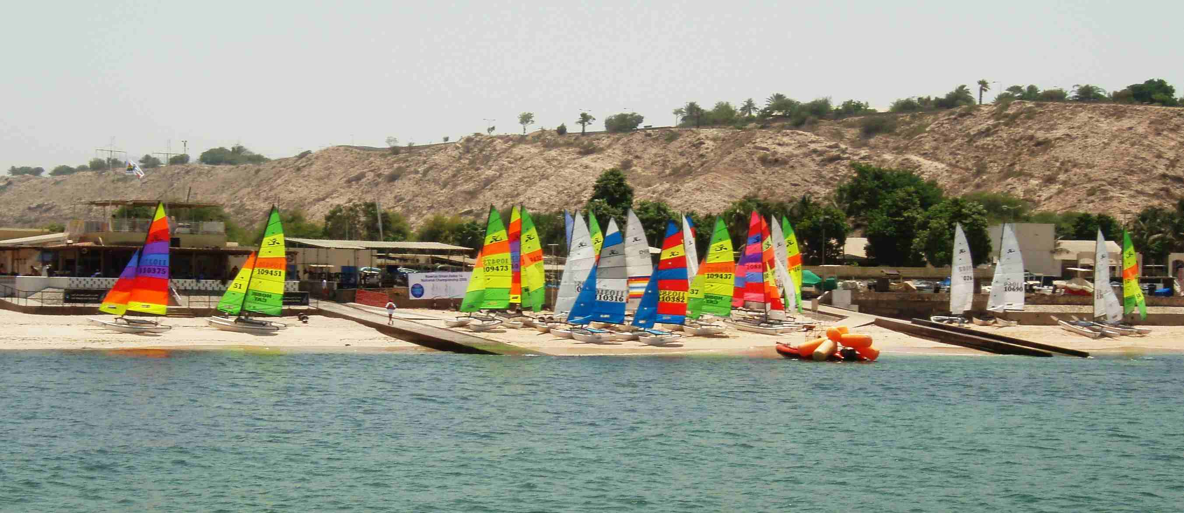
The Hobie 16 Fleet on The RAHBC beach
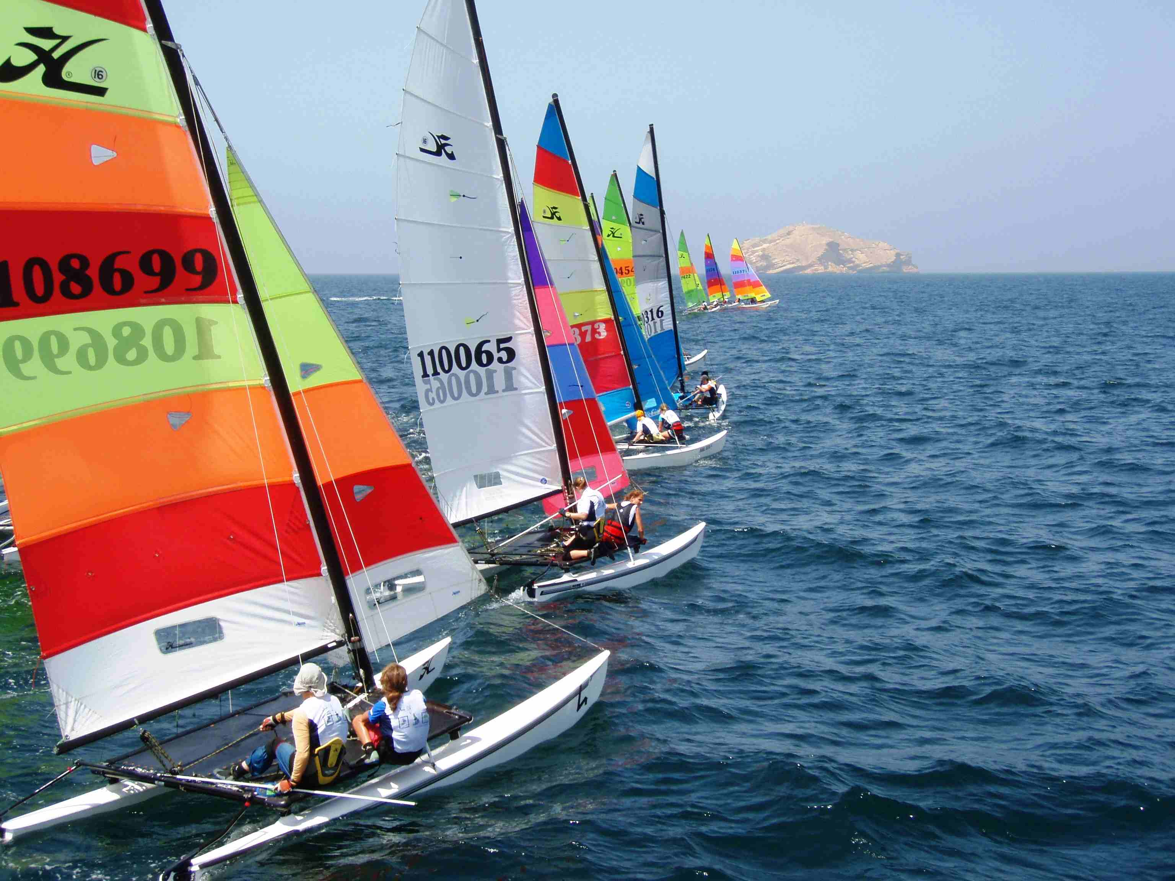
The start of one of the races. Note the last boat coming over port across the fleet.
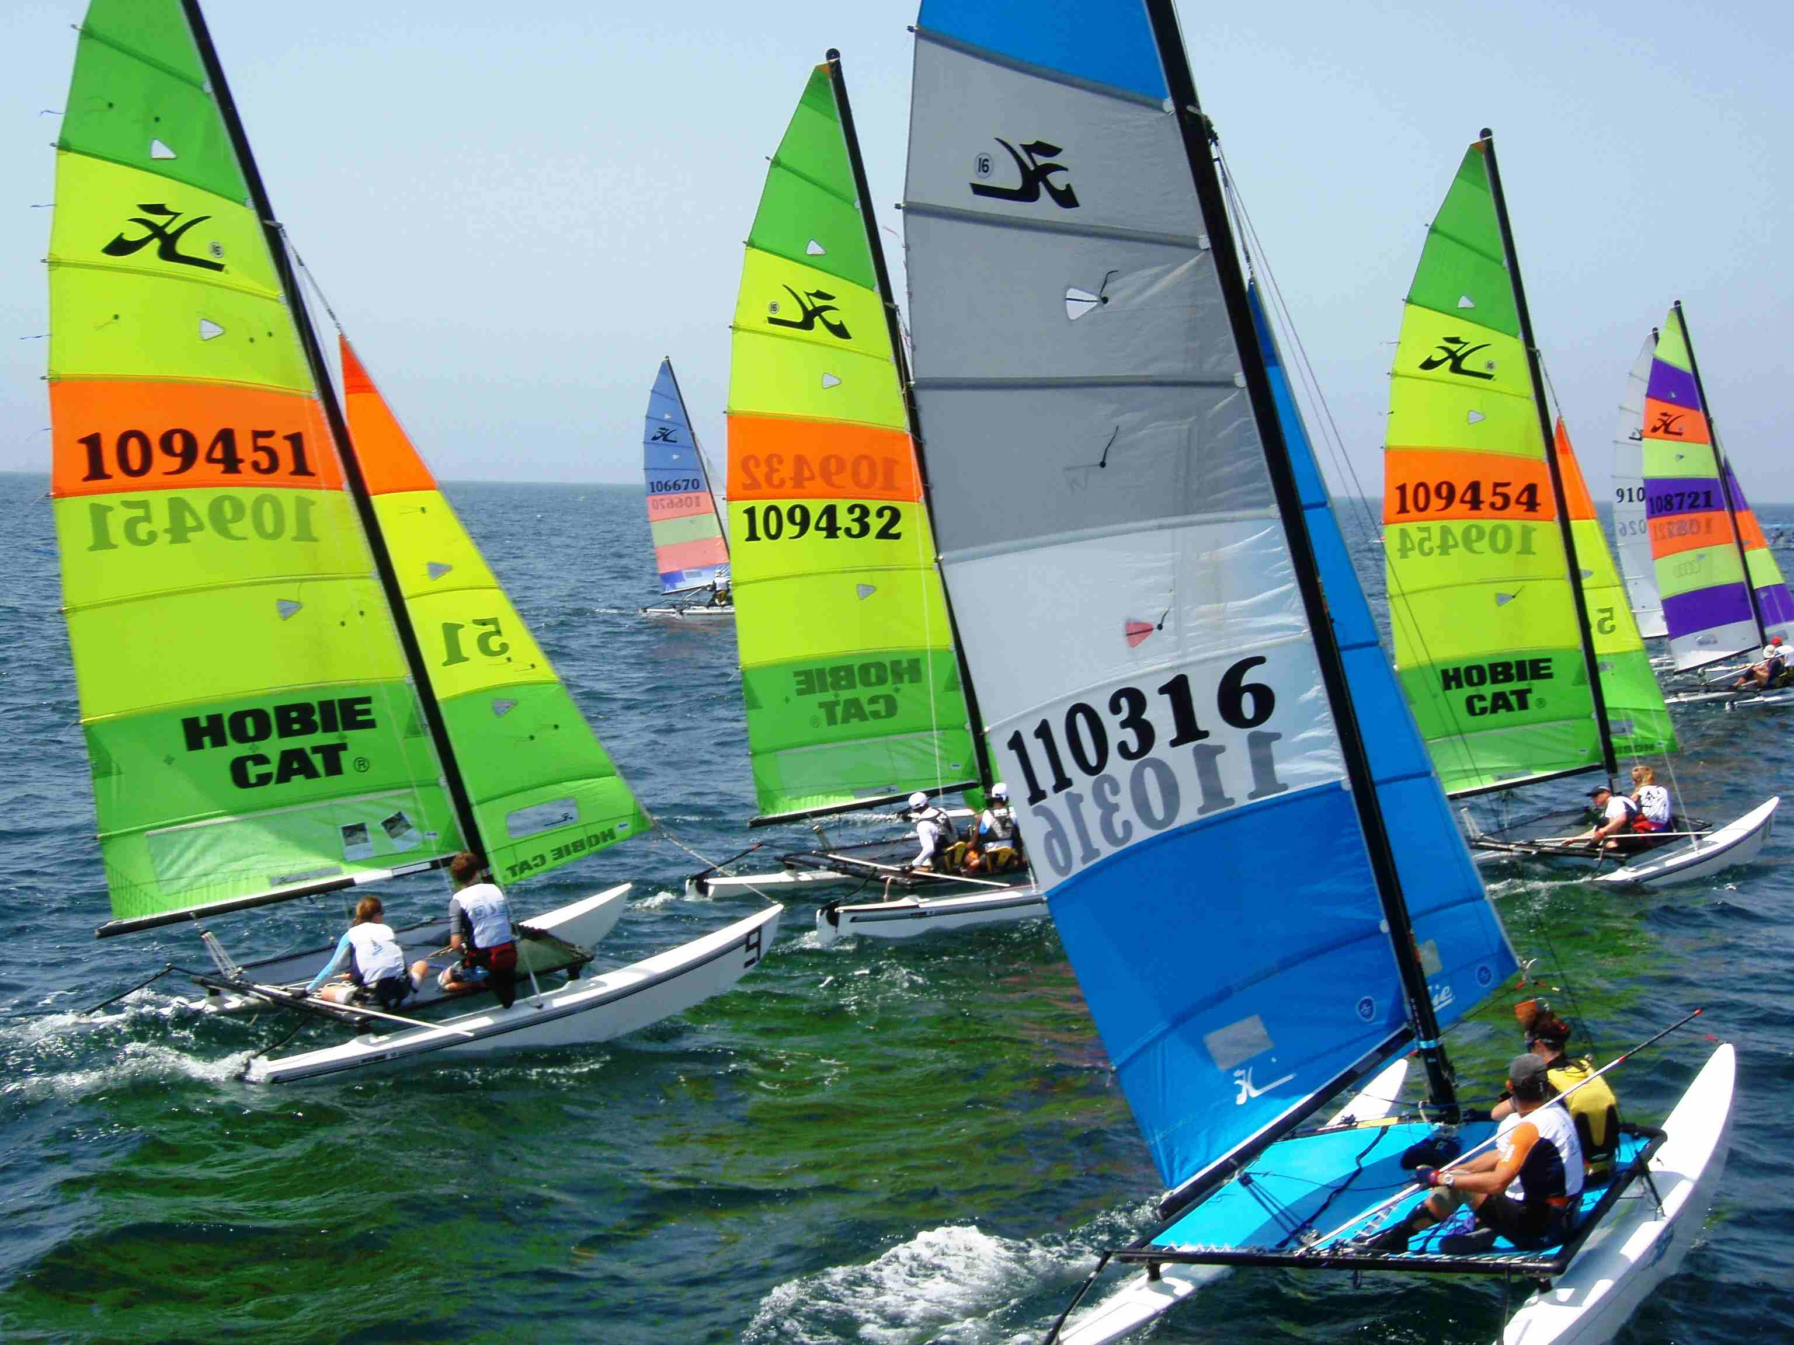
Just before the start. The boats are lining up for best position
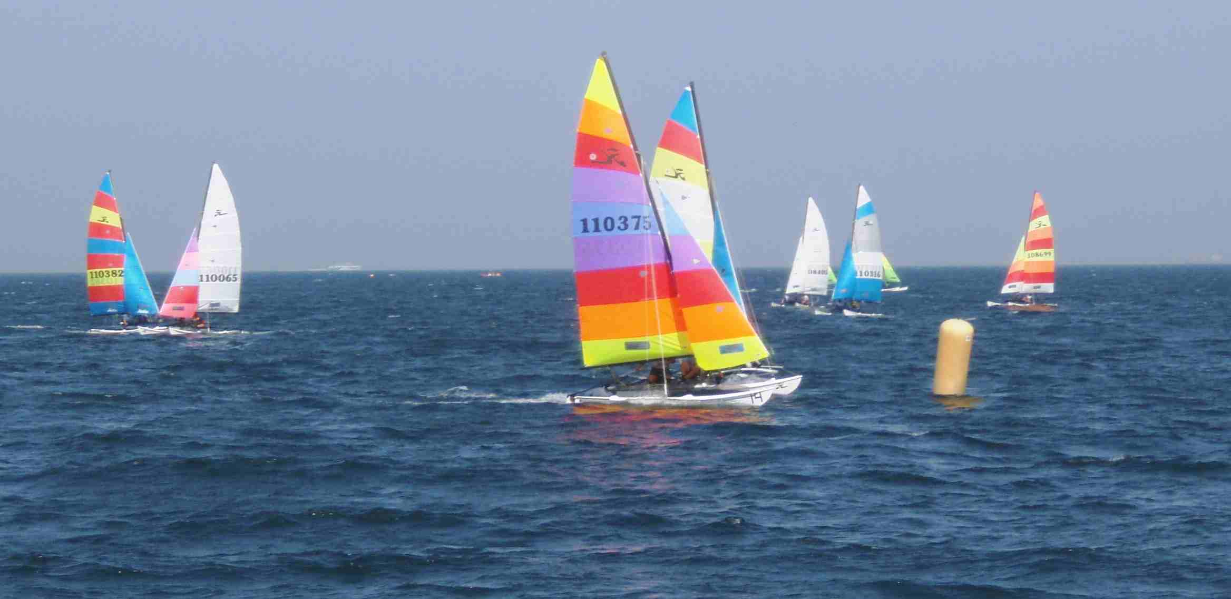
The fleet rounding one of the buoys of the gate

