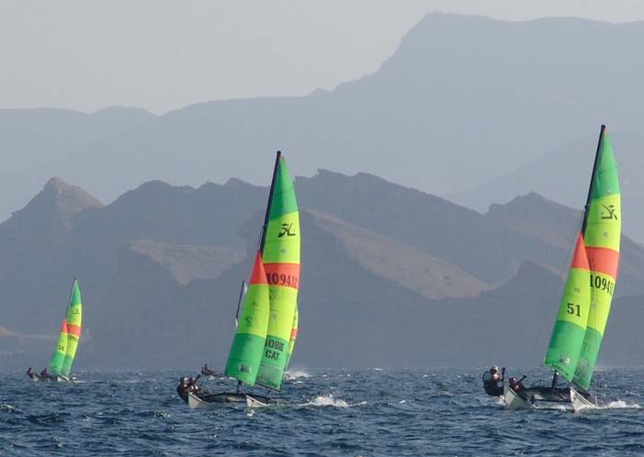
Notice of Race

PDO Prequalification Round

for the

2009 Oman Hobie 16 Open & Oman
Hobie 16 National Championship

- Organising Authority

This Prequalification Round will be organised by the Sailing Section of the Ras Al Hamra Boat Club (RAHBC), the Oman Hobie Fleet 938 and the appointed Race Committee.

This Notice of Race has been issued by the Sailing Section of the RAHBC.

- Dates, Venue & Principal Contact

Racing dates: 3rd & 4th September 2009

Venue: All racing will take place at the RAHBC, Muscat, Oman.

Enquiries shall be addressed to: David Clark – daveclarkoman@gmail.com

- Rules

The event will be governed by the ISAF RRS 2009-2012, this Notice of Race, the Sailing Instructions, the Hobie International Class Rules and any posted amendments on the official Notice Board,

This event is designated Category C as stated in Appendix 1 of the RRS 2009 – 2012.

- Eligibility & Fees

In accordance with the Hobie 16 International Class Rules.

Fees OMR 15/- per team

- Competing Class

Hobie 16 - without spinnaker class only.

- Registration

All teams shall complete their final registration between 08:15 & 09:15 on Thursday 3rd September.

- Participation notification

All entries are requested to send an email confirming their participation to, David Clark daveclarkoman@gmail.com , no later than 31st August 2009.

- Sailing Instructions

Copies of the Sailing Instructions will be available at registration and will be published on the event website: http://www.rahbc.pdorc.com/Sailing/Sailraces/2009-Hobie-Nat.htm

- Schedule of Events

The Prequalification Round will take place on:

Thursday 3rd September

08:15 – 09:15 Registration

09:15 Briefing

10:15 Start first race

Friday 4th September

10:15 Start first race

The final umber of races is dependant on the number of entrants

Race pools / boat allocation / race frequency for each team will be advised at the briefing

- Prizes

Trophies or prizes may be awarded for:

2009 PDO Prequalification Champion
2009 PDO Prequalification second and third place

For further information about this event, please contact the following.

David Clark, Tel: (968) 99732035 E-mail: daveclarkoman@gmail.com

