REGATTA 2006
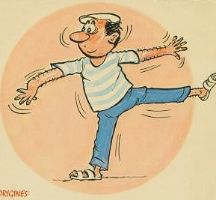
JEU DE BOULES

Each sailing team is entitled to enter more than one team in the “Jeu de Boules”.
Each team is made up of 3 players;
Each player uses two boules made of metal; boules will be provided, but if you wish, you may use your own boules.
All team players in action should wear a beret;

A draw for competition will be held on Wednesday evening (8th March) at the Boat Club;
Timing: Expect to start on Thursday morning at 10 a.m.;
Final will be played on Friday afternoon;
If sufficient teams are interested, a runner-up competition will also take place;

Each game is played up to 13 points (usually one game is finished within 30 minutes);
The final will be played up to 21 points;
If a team is not able to field 3 players, the team is allowed to find other players outside of their team;

Rules are currently being working out and will be a simplified version of the Official International Rules of the Game of Petanque, approved by the International Congress of the Fédération Internationale de Pétanque et Jeu Provençal held in Grenoble (France) on 3rd October 2002;

In the event of a dispute, the final adjudication on rules will be made by the resident International Boule Umpire: Alain Guidou.

A trophy and prize will be awarded to the winner.

Registration to Alain Guidou, by Monday 6th of March

