PDORC SAILING SECTION
2008 ANNUAL REGATTA

28th & 29th February 2008

Petroleum Development Oman
Ras Al Hamra Recreation Club
Muscat, Oman

Sailing Instructions Rev B

1.0 Rules

1.1 The Regatta is open to the Hobie 16, Laser, Topper and Optimist classes.

1.2 The event will be governed by the ISAF RRS 2005-2008.

1.3 The Hobie 16, Laser, Topper and Optimist Class Rules shall apply.

1.4 Advertising and Sponsorship

Advertising and sponsorship will only be allowed if approved by the Regatta Organising Committee. Early notification providing all appropriate details of advertising and sponsorship shall be made in writing to the Regatta Committee.

1.5 Eligibility and Entry

Entry is open only to members of PDORC, their guests and Invited Guest Teams.

1.6 All entrants for racing shall be a member of a team. A team shall consist of a minimum of 3 helms and 3 crew for Hobies, 2 helms for Lasers, 1 helm for Topper and 1 helm for the Optimist.

Age limits are as follows:

Hobie 16 Open age limit

Laser Open age limit

Topper helm(s) – up to and including 16 years as of 31st August 2008

Optimist helm(s) – up to and including 11 years as of 31st August 2008

1.7 Eligible Teams may enter by completing the attached form, in Appendix 1, and bringing it to the first team captains meeting.

1.8 Invited Guest Teams must use their own Hobie 16 unless previously agreed by the committee however, Laser, Topper or Optimists, can be made available as required from the club. Regular PDO Hobie 16 Teams will be allocated Hobie 16s, Lasers, Toppers, and Optimists.

1.9 Any team member under the age of 18 years must have their Parent or Legal Guardian sign the “Declaration” in Appendix A.

1.10 All persons shall sign the “Hold Harmless Disclaimer” in Appendix 2 prior to racing. There are no exceptions.

1.11 Racing Rules will be changed as follows: -

Rules 10, 11, 12 and 13 – right of way – All participating Hobie and Laser boats will give right of way to Optimists and Toppers on the water during the event.

Rule 14 – All boats shall avoid contact. Penalty will be applied to all boats that make contact causing damage or injury irrespective of right of way.

Rule 26 – Refer to Section 9 for alternative start sequence.

Rule 44 – Refer to Section 11 for alternative penalty

Rule 60 - Part 5, Section A, Rule 60. The right to protest, redress and hearing can be withdrawn for any individual protest or for the whole regatta at any time and for any reason by the OOD. The reason for withdrawal of Rule 60 need not be given by the OOD. The final position of the yachts in the race that the protest was made shall stand in the event that OOD exercises this right. Instruction to withdraw Rule 60 may be given verbally by the OOD at any time during the protest process without posting a Notice.

Clarification on withdrawal of Rule 60

The intention of this rule is to allow the OODs to manage the event within the time frame and not be constrained because of protesting. Teams should note that a fair protest will probably be heard and a judgment made.

Teams are expected to race in a fair manner and take a penalty turn as defined. If reasonable doubt exists that a rule infringement has occurred, then the infringing team should take the penalty turn. Similarly, a team that is clearly out sailing another team, in a particular race, should make a reasonable attempt to “sail round” a developing scenario that could lead to a rule infringement between them and a competitor.

1.12 A teams' helm and crew can sail in any role in any race but can not change roles during a race i.e. if a team member starts a race as a helm, they must finish that race as a helm. However if the roles are swapped during a race to assist another competitor in an emergency e.g. recovery of another team's "man over board", then this swap would not be considered detrimental to a claim for redress.

1.13 A team member that sails in a race shall not sail in any other Hobie race, in any capacity, until 2 further Hobie races have been completed by their team (rest period). Team members can only sail for the team that they are registered for and can not change teams. However, a team member may immediately sail its own team Laser or Topper or Optimist race after or before sailing a Hobie race without incurring a penalty.

1.14 The overall team fleet result on each day of the Laser races will be incorporated in the main event; it is planned (but not mandatory) to hold two Laser races per day raced back to back, no discards are allowed. Two different team members will be required to helm per team, i.e. one helm per day.

1.15 Topper races will be raced in fleets of 8 boats. A total of 6 Races are planned, each team will record 3 results, no discards are allowed. Races may be on, one day or two days at the discretion of the OOD.

1.16 Optimist races will be raced in fleets of 8 boats. A total 6 races are planned, each team will record 3 results, no discards are allowed. Races may be on, one day or two days at the discretion of the OOD.

1.17 A protest must be lodged with the OOD before the finish of the race following that in which the protest was made.

1.18 Where a conflict exists between the Sailing Instructions, salient point’s bulletin and the ISAF RRS 2005 – 2008, then the instructions in the Sailing Instructions shall take precedence.

2.0 Race Control

2.1 The Hobie 16 and Laser racing shall be managed by the OOD, Assistant OODs and 4 persons drawn from the teams on a rotational basis, to be stationed at the OOD table / bridge / rescue boat.

2.2 Topper and Optimist races will require at least one parent or acting parent per team to assist on the beach to launch / recover boats / rotate teams as required by the OOD.

2.3 Team helpers will assist as required i.e. assisting starts, recording finishing, registration, rescue boat duties and any other task required to run the race.

2.4 The race notice board, registration documents and finish line transits shall all be located at the OOD Station on the Boat Park Bridge. The race pennant flag pole is located to the East of the OOD Station beside the winch ramp.

2.5 All communication regarding race matters will be from the OOD station. The instruction for starting will be from the beach area at the start line.

2.5 Amendments to the Sailing Directions, courses and the results, will be posted on the race notice board.

2.6 Any information that affects the race shall be communicated to the competitors by hoisting code Flag L, one blast of the sound signal and the notice being posted on the race notice board.

3.0 Registration

3.1 All Hobie, Laser, Topper and Optimist teams must register before racing at the OOD station. Note Laser / Topper / Optimists can pre allocate their attendance schedule at time of registration or immediately prior to a race.

3.2 During racing each Hobie helm and crew shall sign in before each race and sign off after each race. Signing off must be done before the first boat finishes the following race. Failure to adhere to this requirement shall result in a 4 point penalty being applied to the team for the race that the infringement occurred on. Individual race sign in / off is not required for Lasers / Toppers / Optimists.

3.3 All sailors shall have signed the “Hold Harmless Disclaimer” prior to racing. Any team member under the age of 18 years must have their Parent or Legal Guardian sign the “Hold Harmless Disclaimer” prior to racing.

4.0 Fees

Payment of the regatta fee at 35 Omani Rials per team must be paid before a team will be allowed to race.

5.0 Schedule

5.1 At the first captains meeting PDO Club Boats will be made available to teams.

Teams at this juncture will be allowed to take ownership of their club allocated Hobie 16 Catamaran, Laser, Topper, and Optimist.
5.2 1st Team captains meeting. Administration matters discussed and advised, Social agenda advised, Yacht allocation, briefing on the Race Instructions issued, AOB and clarification issues noted for resolution by Email.

Lasers, Toppers and Optimists will be allocated by draw during the first captains meeting. Use of private Lasers, Toppers and Optimists is allowed as long as the organising committee are informed before the end of the first captains meeting.

5.3 PDO Club Hobies will have been previously inspected and serviced by the RAHBC Sailing Section, but teams are advised to inspect the boats in time to allow for any repairs. PDO Club Lasers, Toppers and Optimist are to be checked independently by the Teams.

5.4 Teams are encouraged to set up their “Team Camp" on the beach between at / near the playground on the beach (between Cafe Bar and the Western edge of the boat park). Team Areas will be allocated by the organising committee and advised at the first captains meeting.

5.5 2nd Team captains meeting. Weather forecast and tides, race format, race instructions clarifications defined and issued. OOD duty list and rescue boat duty list for weekend for the teams, distribution of pre ordered polo shirts.

  - 28th February 2008

5.6.1 Race Registration Day 1 8:00 – 9:00 Boat Park OOD Desk
Handout Lasers to teams 9:00 Boat Park
H16 races 9:30 +/- 30 minute laps
Optimist Races 10:00 +/- 20 minute races
Topper Races 10:00 +/- 30 minute races
Round The Island 1 14:00 (start time at OODs discretion)
Laser Race 1 and 2 14:00 (back to back)
Last Race Start not later than 17:30
End of Racing Day 1 18:30

Start times and race schedules are notional and can be changed at the OOD’s discretion

  - 29th February 2008

5.7.1 Race Registration Day 2 8:00 – 9:00 Boat Park OOD Desk
H16 races 9:30 +/- 30 minute laps
Optimist Races 10:00 +/- 20 minute races
Topper Races 10:00 +/- 30 minute races
Round The Island 2 12:00 (start time at OODs discretion)
Laser Race 3 and 4 12:00 (back to back)
Last Race Start not later than 15:30
End of Racing Day 2 16:00 approx.

Start times and race schedules are notional and can be changed at the OOD’s discretion

5.8 Prize Giving The Beach 16:30

6.0 The Venue

All Racing will take place at PDORC, Ras Al Hamra, Muscat, Oman. Racing will be conducted over the 2 days. The Racing Area will be in close proximity to and generally to the North of RAHBC, just clear of the bay. The round the Island race will be from RAHBC and around Al Fahal Island

7.0 Courses

7.1 The Hobie and Laser courses to be sailed will be one of the courses as defined in Appendix A “Courses”. The course to be sailed shall be advised on the day of the race. Courses to be sailed may change during the series.

7.2 The first Hobie course of the day to be sailed shall be displayed on the Race Notice board before 09:00 each day.

7.3 If the Hobie or Laser course changes Code Flag “L” shall be flown, followed by 2 short blast of the horn, 10 minutes before the start. The new course will be posted on the race Notice Board.

7.4 The Topper and Optimists fleets will sail a different course from the Hobie 16 / Laser fleet. The skippers will be verbally briefed by the race officer on the course, start and finish procedure at the beach launch area, prior to the start of each race or set of races.

8.0 Start Sequence Hobie Fleet – First Race on Day 1

For the first race on day 1, the following start procedure will be used:

8.1 The start will be on the water

8.2 Start Signals

8.2.1 Signals will be made from the Race Committee boat stationed at the starboard end of the line or from The Shore Bridge should weather conditions dictate. Changes to Committee Start location and revised Courses will be advised on the official notice board.

8.2.2 The start line will be between a staff displaying a Red flag on the Race Committee boat at the starboard end and a mark at the port end.

8.2.3 The start sequence shall be as follows

1. Warning Flag “H” up Sound Signal 5 minutes to start
2. Preparatory Flag “P”, “I”, or Black flag up Sound Signal 4 minutes to start
3. Preparatory Flag down Sound Signal 1 minute to start
4. Warning Flag “H” down Sound Signal Start

8.2.4 If in any start there are premature starters, Flag X will be displayed on the Race Committee boat immediately following the start signal and one sound signal will be made. It will be the responsibility of each yacht to determine whether she has started correctly.

8.2.5 Flag X will be lowered when all premature starters have returned correctly to the pre-start side of the line or four minutes after start signal, whichever is the earlier.

9.0 Start Sequence Hobie Fleet – All Except the First Race on Day 1

Except for the first race on day 1 the following start procedure will be followed:

9.1 The start will be on the beach

9.2 The start line is between two marks on the beach approximately one boat length from the waters edge to form a starting box area.

9.3 Boats will be lined up on the start line prior to the Warning Flag. The warning Flag will be the Flag H.

9.4 The start sequence shall be as follows

1. Sound signal: approx 2 minutes warning
2. At 30 seconds verbal warning for 1st team from OOD
3. At 0 seconds start verbal instruction from OOD to go

9.5 Boats will start in the reversed finishing order of the previous race (Refer to Chapter 10).

9.6 At the discretion of the OOD, thirty seconds before the start the OOD (or assistant OOD) shall announce the Team Name At this point the team may position the boat in the water directly in front of their slot such that the stern of the boat is just clear of the beach. At the “go” signal a boat may be propelled into deeper water by human assisted endeavours only, i.e. by manually pushing; no outside assisted mechanism may be employed. It is not allowed to move boats laterally along the beach during the start unless the OOD chooses to start the race in accordance with para 9.8.

9.7 If a start is made in accordance with 9.6 at the start the first team shall commence racing around the course. Each other team shall then start at 30 second intervals as designated.

9.8 Or at the discretion of the OOD, sixty seconds before the start the OOD (or assistant OOD) shall announce the first to start Team Name and they will move their boat into the starting box area and then into the water directly in front of the starting box area such that the stern of the boat is just clear of the beach. At the “go” signal a boat may be propelled into deeper water by human assisted endeavours only, i.e. by manually pushing no outside assisted mechanism may be employed.

At this point the next starting team will move their boat into the starting box area and all subsequent teams will be moved laterally along the beach by physically lifting or the use of trolleys to enable the next starting team to enter the starting box as the starting boat starts.

9.9 If a start is made in accordance with 9.8, after a team has started the next team may position their boat in the water directly in front of the starting box area such that the stern of the boat is just clear of the beach. The next boat will start 30 seconds after the verbal start signal given to the previous boat. Team names will be advised during the start sequence.

9.10 At all beach / start box starts the time interval may be adjusted at the OODs discretion and will be verbally informed to all teams by the OOD on the start line.

10.0 Finishing and Preparation for the next Hobie race start

10.1 All races, except the First Hobie Race of The Fist Day, including the Round The Island Race and the start of day 2, will be started in reverse sequence of the preceding race team's position i.e. last in first out.

10.2 The finish line for all Hobie Races is a line between the boat park bridge and a coloured buoy towards the West cliff of the bay. Boats shall finish by leaving an inner distance mark (another coloured buoy) to port, located on or near the finish line. Boats will not be deemed as finished if they pass between the inner distance mark and the beach.

10.3 As boats finish the team is responsible for placing the boat onto the pre start line in order. Important note; at all times during the regatta all Hobies are to be stopped in the water and either a trolley utilised or manually lifted by team members to bring the boat up to and onto the beach into the pre start slot position, unless otherwise advised by the OOD.

10.4 The first Hobie finishing shall be placed at the Western end of the start line i.e. side furthest away from the OOD Station / Boat Park Bridge.

10.5 The second boat to finish shall be placed next to the first boat, the third boat next to the second boat etc etc, until the last boat is in or the race time limit has been reached. The final order on the line should reflect the finishing order of the preceding race.

10.6 The maximum time allowed between the first boat finishing and the start of the next race’s warning signal shall be 15 minutes. In the event that all boats are finished within the 15 minute period, the OOD may immediately commence the start sequence on arrival at the start line of the last boat in. However the OOD may extend the time limit as appropriate.

10.7 In the event that the next race starts while a boat is still completing the previous race, then this boat may pull up to the waters edge and crew change there without pulling the boat ashore. This boat shall remain clear of any boat starting.

10.8 Between the finish line and the start line boats shall be governed by ISF RSS 2005 to 2008, Racing Rules of Sailing. However, collision between boats after they finish and on their way to the start line shall be penalised 2 extra points.

11.0 Start & Finish Sequence Laser, Topper, Optimist Fleets

11.1 The start will be on the water

11.2 Start Signals

11.2.1 Signals will be made from the Race Committee boat stationed at the starboard end of the line or from The Shore Bridge should weather conditions dictate. Changes to Committee Start location and revised Courses will be advised on the official notice board.

11.2.2 The start line will be between a staff displaying a Red flag on the Race Committee boat at the starboard end and a mark at the port end.

11.2.3 The start sequence shall be as follows

Lasers

1. Warning Flag Laser Logo up Sound Signal 5 minutes to start
2. Preparatory Flag P, I, or Black flag up Sound Signal 4 minutes to start
3. Preparatory Flag down Sound Signal 1 minute to start
4. Warning Flag Laser Logo down Sound Signal Start

Toppers

1. Warning Flag T up Sound Signal 3 minutes to start
2. Preparatory Flag P, I, or Black flag up Sound Signal 2 minutes to start
3. Preparatory Flag down Sound Signal 1 minute to start
4. Warning Flag T down Sound Signal Start

Optimists

1. Warning Flag O up Sound Signal 3 minutes to start
2. Preparatory Flag P, I, or Black flag up Sound Signal 2 minutes to start
3. Preparatory Flag down Sound Signal 1 minute to start
4. Warning Flag O down Sound Signal Start

11.2.4 If in any start there are premature starters, Flag X will be displayed on the Race Committee boat immediately following the start signal and one sound signal will be made. It will be the responsibility of each yacht to determine whether she has started correctly.

11.2.5 Flag X will be lowered when all premature starters have returned correctly to the pre-start side of the line or four minutes after start signal, whichever is the earlier.

11.3 General Recall

11.3.1 A General Recall will be indicated by the display of Flag 1st Substitute and two sound signals. After the removal of Flag 1st Substitute and one sound signal the warning signal will be made one minute later.

11.4. Shortened Course

11.4.1. The shorten course signal, Flag S, will be flown on an official boat at or near a rounding mark. The finish will be between the nearby mark and the staff displaying this flag.

11.4.2 If a course is shortened at a gate, an official boat near the gate will display Flag S and boats shall finish by sailing through the gate from the direction of the previous mark. The finishing line will be between the gate marks. This changes race signal S.

11.4.3 When crossing a shortened course finish line, the onus is on the boat to decide whether or not it has completed the shortened course.

11.5. Finish

11.5.1 The finish line for all Laser Races is a line between the boat park bridge and a coloured buoy towards the West cliff of the bay (Outer Distance Mark). Boats shall finish by leaving an Inner Distance Mark (another coloured buoy) to port, located on or near the finish line. Boats will not be deemed as finished if they pass between the inner distance mark and the beach.

11.5.2 The finish line for all Toppers and Optimists will be between a staff displaying a Blue Flag on the Race Committee boat and the adjacent mark. Finishing boats must pass inside the Committee Boat and the mark forming the finishing line.

12.0 Penalty System

12.1 The Penalty System in Rule 44.2 will apply i.e. The 2 Turns Penalty

12.2 For the Hobie 16 class, Rules 44.1 and 44.2 are changed so that only one turn, including 1 tack and 1 Gybe, is required.

12.3 Boats that infringe Rule 14 as amended shall be disqualified from that race. Disqualification shall be applied to all boats that have made contact, which causes damage or injury, irrespective of right of way. However, redress may be granted for extenuating circumstances e.g. a boat that had lost steerage due to equipment failure and was subsequently involved in a collision. A boat stuck head to wind will not be given redress.

12.4 A team that does not show up for OOD Duties or Rescue Boat Duties shall be penalised 2 extra points onto the score for the race underway that the infringement is detected. Team members on duty to assist the OOD shall go to the OOD table at the Boat Park Bridge and wait.

12.5 A team that does not place their boat in the correct start slot after finishing a race shall be penalised 2 extra points onto the score of the previous race.

13.0 Scoring System

13.1 The scoring system will be the Low Points System except that before the start of any Hobie race a team may present a “Joker” card which will reduce the points allocated for that race by 50%. The “Joker” card can only be used on a Hobie race. This “Joker” card can only be utilised once during the entire regatta.

13.2 Laser results will be computed from the result of each days racing to be able to rank all the teams per day after the races held that day. This day result will be used for the final computation of a teams score.

13.3 Topper and Optimist races will be computed to rank all the teams into one overall result per category. This overall result for both classes will be used for the final computation of a teams score.

13.4 A team's final score will be the sum of all the scores for that team based on:

All Hobie team races sailed in the regatta less the Joker card submittal
Laser team result 28th February
Laser team result 29th February
Topper team result under 16
Optimist team result under 11

I.e. all the Hobie team races plus 4 dinghy team results

13.5 The team that sails with the best fancy dress on day one, in any Hobie race, for one race only, shall have 5 points deducted from their final score. The second placed team shall have 3 points deducted and the third placed team shall have 1 point deducted from their final score. The best fancy dress shall be determined by a method. However, effort, ridiculousness and ‘intactness’ of the fancy dress at the end of the race shall all weigh heavily in the final OOD’s decision.

13.6 In the event of a tie the Fancy Dress competition may be used to determine the overall winning team.

14.0 Support Boats

14.1 No Team Support boats are allowed

15.0 Radio Communication and Electronic Aids to Navigation

15.1 The use of any communication device or positioning system (i.e. GPS) on a yacht that is racing is prohibited, except in an Emergency.

16.0 Prizes

  - Annual Regatta Prizes will be awarded for the following race positions:

- Overall Annual Sailing Regatta 1st, 2nd, 3rd, & 4th
- Fastest Round The Island Race (Hobie 16) – 1st place
- Best Fancy Dress (Hobie 16)
- Wooden Spoon

16.2 Individual class prizes maybe awarded at the discretion of the Race Committee for:

- Hobie 16 1st
- Laser 1st,
- Topper 1st 2nd 3rd place
- Optimist 1st, 2nd, 3rd place

17.0 Disclaimer and Liability

17.1 Competitors participate in the regatta entirely at their own risk. See rule 4, Decision to Race. The organizing authority will not accept any liability for material damage or personal injury or death sustained in conjunction with or prior to, during, or after the regatta.

17.2 All entrants shall indemnify Petroleum Development Oman, PDORC and the Organising Committee for any loss, damage, death or personal injury howsoever caused.

18.0 Insurance

18.1 All private yachts participating shall have adequate 3rd party insurance valid for this regatta.

19.0 Further Information

19.1 Race Committee

Albert Whitley OOD

Mac McCourt Assistant OOD

Rob Nieuwenhuijs Hobies
Robbert.Nieuwenhuijs@pdo.co.om

Dave Clark Lasers / Toppers / Optimists
daveclarkoman@gmail.com

19.2 Regatta Committee

Cees van Eden Chairman
cve@mac.com

Rob Mink Treasurer
Rob.mink@pdo.co.om

Rob Nieuwenhuijs Member
Robbert.Nieuwenhuijs@pdo.co.om

Victoria Grainger Member
vicoman@omantel.net.om

Dave Clark Member
daveclarkoman@gmail.com

Mary McCauley Member

Andrew Faulkner Member

Martin /Khalifa /Maurelli Boat Repairs / Rescue Services

Appendix A Registration Form

If there are more than 16 team members then please use an additional form

Team Name
Team Captain
Vice Captain
Boat Type / Class
Helms
1
2
3
4
5
6
7
8
Crews
9
10
11
12
13
14
15
16

Appendix B - Courses

The following four courses have been defined.
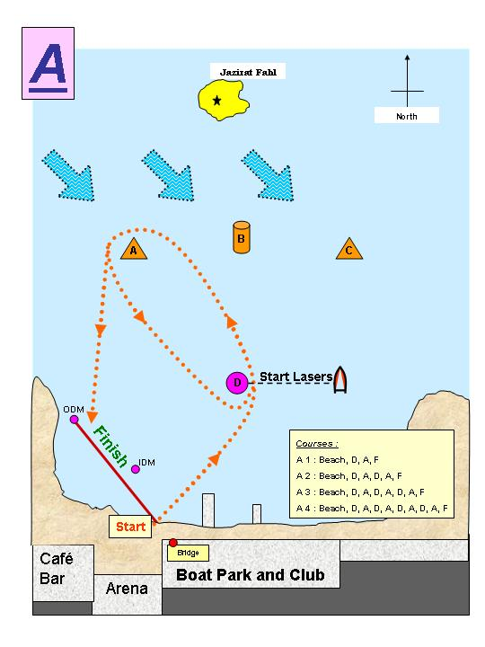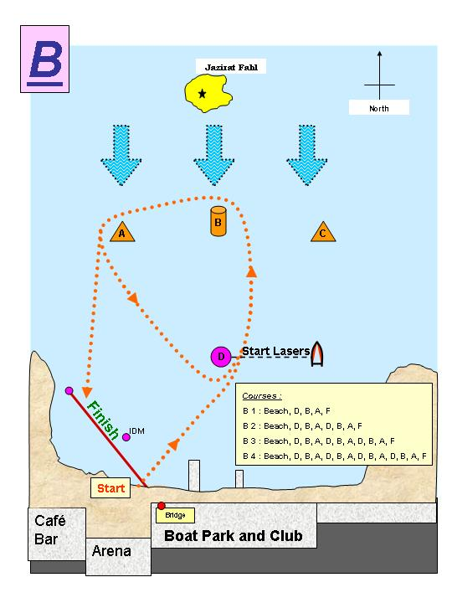
& 1st Hobie
Race
& 1st Hobie
Race
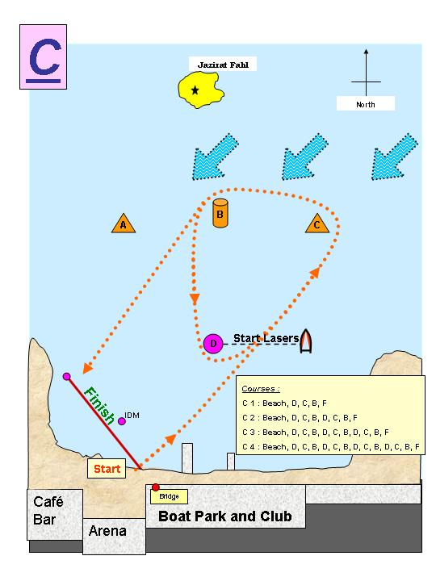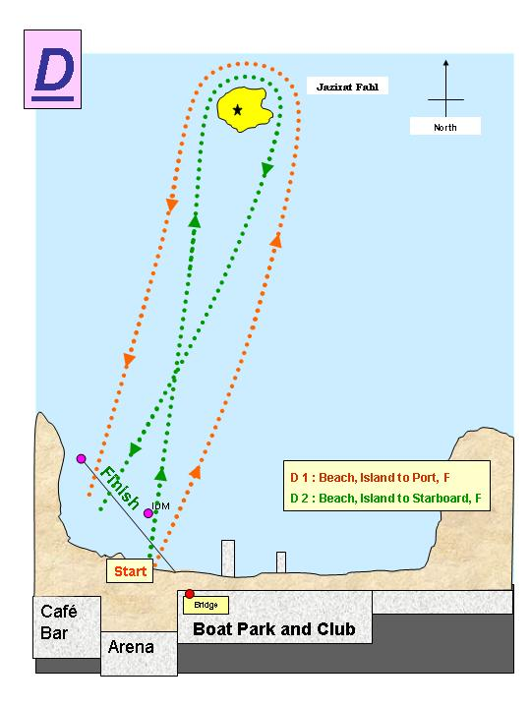
& 1st Hobie
Race
Appendix C - PDO Club Boat Allocation

