REGATTA 2008
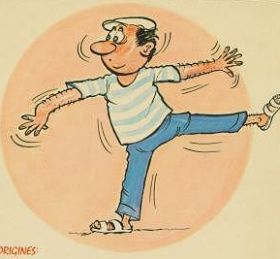
JEU DE BOULES/
PETANQUE

Each sailing team is entitled to enter more than one team in the “Jeu de Boules”.
Each team is made up of 3 players;
Team consisting of kids only will not be allowed to enter the competition; at least one adult has to be member of a team;
Each player uses two boules made of metal; boules will be provided, but if you wish, you may use your own boules.
All team players in action should wear a beret.

Timing: Expect to start on Thursday morning at 10 a.m.;
Final will be played on Friday afternoon;
If sufficient teams are interested, a runner-up competition will also take place;

Each game is played up to 13 points (usually one game is finished within 30 minutes);
The final will be played up to 21 points, if time permitted;
If a team is not able to field 3 players, the team is allowed to find other players outside of their team.

These rules is a very simplified version of the Official International Rules of the Game of Petanque, approved by the International Congress of the Fédération Internationale de Pétanque et Jeu Provençal held in Grenoble (France) on 3rd October 2002. Official rules can be found in Internet at en.wikipedia.org/wiki/Pétanque

In the event of a dispute, the final adjudication on rules will be made by the resident International Boule Umpire: Alain Guidou.

A trophy and numerous prizes will be awarded.

