REGATTA 2009
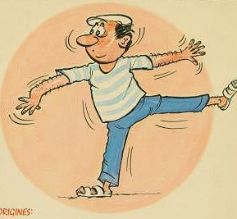
JEU DE BOULES

Bonjour Team Captains!

The time has come to prepare for a fun event, our annual Regatta Jeu de Boules Tournament!
At the last Regatta we had to say Au Revoir to our dear French organisers, Alain and Danielle Guidou. We will certainly miss them this year.
Before they left they handed me their "heritage" of boules papers and when the Regatta Committee asked meto take over the organization I hesitated. but I guess speaking the language, loving Jeu de Boules and being friends of The Guidou's.and the offer of assistance of the Regatta Committee, made the choice easy and I hope to continue this great event in the spirit of Alain and Danielle!

So I would like to invite you to join the Jeu de Boules Tournement and enroll your teams no later then Sunday the 8th of March. We will be playing in the Sohar Garden on grass and the following rules will apply.

REGATTA JEU DE BOULES TOURNEMENT RULES 2009:

- Each Regatta Jeu de Boules team is entitled to enter more than one team;
- Each team is made up of 3 players(1 adult minimum);
- Each player uses 2 boules made of metal;
- Boules will be provided;
- If one of the players is unable to play due to a clash with sailing or volleyball,
- one of their own Regatta team members may replace them.
- If that Regatta team has enrolled more teams, the individual players can only play in their own team;
- Each game is played up to 13 points;
- The final is played up to 21 points;
- Starting time Thursday at 10.00 am;
- Semi finals Friday morning starting 10.00 am;
- Finals Friday starting 12.00 a.m;
- You will be provided with a copy of the basic rules;
- Final decisions will be made by undersigned organizer/appointed assistant.

So please register your teams(team name and individual team player names) as soon as possible(deadline 8th of March!!!) to ensure a place in this well desired Tournament!!!
Registration to: Jane van Lienden Dieters, email: lienden@omantel.net.om
If you have any questions please e-mail or call me on 99459651.

Allez les Boules!!!!
Salutations,

Jane van Lienden Dieters
Organiser Regatta Jeu de Boules Tournement

