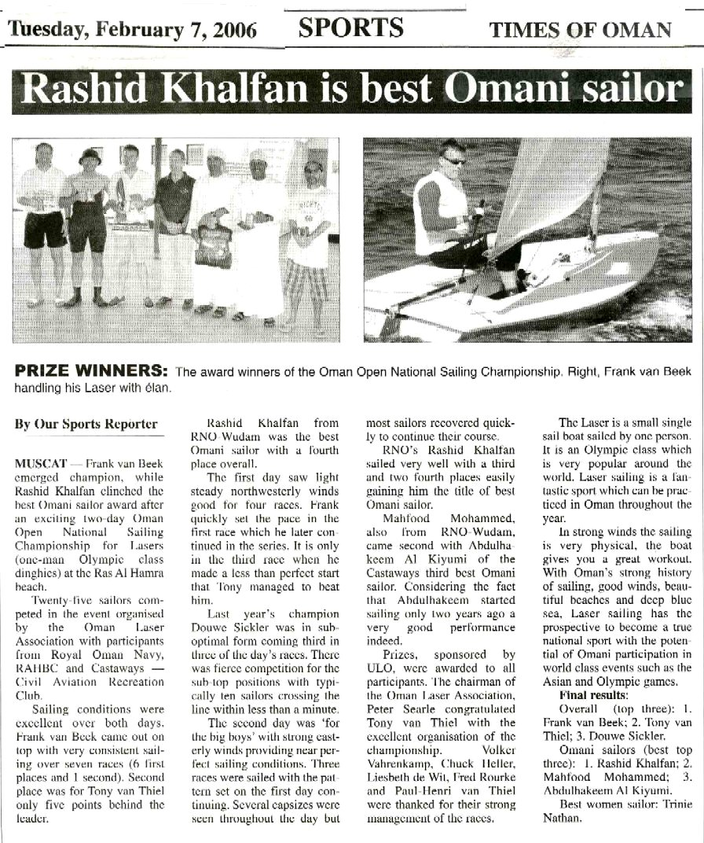

By Our Sports Reporter
MUSCAT — Frank van Beek emerged champion, while Rashid Khalfan clinched the best Omani sailor award after an exciting two-day Oman Open National Sailing Championship for Lasers (one-man Olympic class dinghies) at the Ras Al Hamra beach.
Twenty-five sailors competed in the event organised by the Oman Laser Association with participants from Royal Oman Navy, RAHBC and Castaways — Civil Aviation Recreation Club.
Sailing conditions were excellent over both days. Frank van Beek came out on top with very consistent sailing over seven races (6 first places and 1 second). Second place was for Tony van Thiel only five points behind the leader.
Rashid Khalfan from RNO-Wudam was the best Omani sailor with a fourth place overall.
The first day saw light steady northwesterly winds good for four races. Frank quickly set the pace in the first race which he later continued in the series. It is only in the third race when he made a less than perfect start that Tony managed to beat him.
Last year’s champion Douwe Sickler was in sub-optimal form coming third in three of the day’s races. There was fierce competition for the sub-top positions with typically ten sailors crossing the line within less than a minute.
The second day was ‘for the big boys’ with strong easterly winds providing near perfect sailing conditions. Three races were sailed with the pattern set on the first day continuing. Several capsizes were seen throughout the day but most sailors recovered quickly to continue their course.
RNO’s Rashid Khalfan sailed very well with a third and two fourth places easily gaining him the title of best Omani sailor.
Mahfood Mohammed, also from RNO-Wudam, came second with Abdulha-keem Al Kiyumi of the Castaways third best Omani sailor. Considering the fact that Abdulhakeem started sailing only two years ago a very good performance indeed.
Prizes, sponsored by ULO, were awarded to all participants. The chairman of the Oman Laser Association, Peter Searle congratulated Tony van Thiel with the excellent organisation of the championship. Volker Vahrenkamp, Chuck Heller, Liesbeth de Wit, Fred Rourke and Paul-Henri van Thiel were thanked for their strong management of the races.
The Laser is a small single sail boat sailed by one person. It is an Olympic class which is very popular around the world. Laser sailing is a fantastic sport which can be practiced in Oman throughout the year.
In strong winds the sailing is very physical, the boat gives you a great workout. With Oman’s strong history of sailing, good winds, beautiful beaches and deep blue sea, Laser sailing has the prospective to become a true national sport with the potential of Omani participation in world class events such as the Asian and Olympic games.
Final results:
Overall (top three): 1. Frank van Beek; 2. Tony van Thiel; 3. Douwe Sickler.
Omani sailors (best top three): 1. Rashid Khalfan; 2. Mahfood Mohammed; 3. Abdulhakeem Al Kiyumi.
Best women sailor: Trinie Nathan.

