
Press Release Oman Laser Association - 22 April 2007

Douwe Sickler new National Laser Sailing Champion
Rashid Khalfan best Omani Sailor

The Nawras sponsored 2007 Oman Open National championship for Lasers (one man Olympic class sailing dinghies) was sailed last weekend from the beach off the Ras al Hamra Boat Club. 24 Sailors competed in the event organised by the Oman Laser Association with participants from Royal Oman Navy, RAHBC, Castaways – Civil Aviation Recreation Club and 2 international entries from Qatar and France.

Douwe Sickler came out on top with 8 points, repeating his performances of 2003 and 2004. Second place was for Frank van Beek (last year’s winner) only 1 point behind the leader with Tony van Thiel following closely as third with 10 points.

Rashid Khalfan al Yahyai from RNO-Wudum was the best Omani sailor with a 6th place overall, an excellent performance. Rashid again showed that he is the best Omani Laser sailor a fact that was confirmed by his recent participation in the Asian games in Qatar. Abdulhakeem Al-Keyumi of the Castaways came second Best Omani Sailor, improving on his last years third place. 3rd Place was for RNO’s Sabah Saif Salim al Buraidi.

On Thursday the fleet of 24 boats went out in light winds. By the time they arrived on the start line the wind had died completely and races had to be abandoned for the day.

Friday saw light winds building up late morning and a decision was taken to start at 12 noon. All competitors lined up for the start but a strong current pushed half the fleet over the line before the start signal. The OOD (Officer Of the Day) wisely decided on a general recall and a restart. The second attempt went better and some very competitive racing developed. Henrik Norgaard (new to the Oman sailing scene) won the first race. The second race again saw the fleet starting too early twice with 2 general recalls. The third attempt was better and Douwe Sickler showed his old form of 2003 & 2004 and took first place. The fleet had a double surprise during this race. The second mark had floated away almost 2 miles with the current requiring some quick thinking of all sailors. On the long run back to the third buoy a humpback whale surfaced straight in the middle of the fleet, an awesome sight (especially when your sitting 10 cm of the water in a small boat!).
The third race of the day was just possible in very light winds requiring super concentration. Tony van Thiel got a first in this one. A fourth race was attempted but the wind stopped and all sailors returned to the beach for the calculation of the results and the price ceremony.

Prizes, kindly sponsored by NAWRAS and ULO, were awarded by Tore Solberg (Nawras Marketing Director) to all participants. The RAHBC sailing captain, Cees van Eden congratulated Tony van Thiel with the excellent organisation of the championship. OOD Barrie Wiltshire and his team of Chuck Heller, Nigel Burn, Fred Rourke and Bob Sambell were thanked for their strong management of the races. Tony finished by thanking NAWRAS and ULO for their sponsorship of the event. He also thanked Saif Said al Shebli of the Ministry of Sports Affairs for his presence at the ceremony and expressed his hope for the Ministry to materialise possible plans for a Youth Sailing Training Centre. This would give a strong impetus for Omani youth to participate in this excellent sport.

The Laser is a small single sail boat sailed by one person. It is an Olympic class which is very popular around the world. Laser sailing is a fantastic sport which can be practiced in Oman throughout the year. In strong winds the sailing is very physical, the boat gives you a great workout. With Oman’s strong history of sailing, good winds, beautiful beaches and deep blue sea, Laser sailing has the prospective to become a true national sport with the potential of Omani participation in world class events such as the Asian and Olympic games.

For full details and pictures of the event see: http://www.pdo.co.om/hseforcontractors/rahbc/Sailing/Sailraces/2007-OLA-Nationals.htm

Final results:

Place | Name | Points | Comment
1 | Douwe Sickler | 8 | Overall 1st Place (Winner 2003 & 2004)
2 | Frank van Beek | 9 | Overall 2nd Place (Winner 2005/06)
3 | Tony van Thiel | 10 | Overall 3rd Place (Winner 2002)
4 | Jan Wind | 14 | Entry from Qatar (Winner 2001)
5 | Henrik Norgaard | 15
6 | Rashid Khalfan al Yahyai (RNO) | 21 | Best Omani 1st Place
7 | Iain Hudson | 22
8 | Cees van Eden | 22
9 | Abdulhakeem Al-Keyumi | 33 | Best Omani 2nd Place
10 | Fred Park | 33
11 | Maxime Bayen | 39 | Entry from France
12 | Sabah Saif Salim al Buraidi (RNO) | 41 | Best Omani 3rd Place
13 | Yacoob Masood (RNO) | 42
14 | Rob Nieuwenhuis | 42
15 | Paul-Henri van Thiel | 42 | Youngest competitor (13 yrs)
16 | Dave Clark | 51
17 | Victoria Grainger | 52 | Best Lady
18 | Bob Gloyn | 53
19 | Paul Goedemoed | 54
20 | Glenn Perry | 57
21 | Jorgen Leiknes | 57
22 | Ernie Meili | 58
23 | Salah al Jabri (RNO) | 71
24 | Rodger Martin | 72 | Wooden Spoon

Pictures of the event

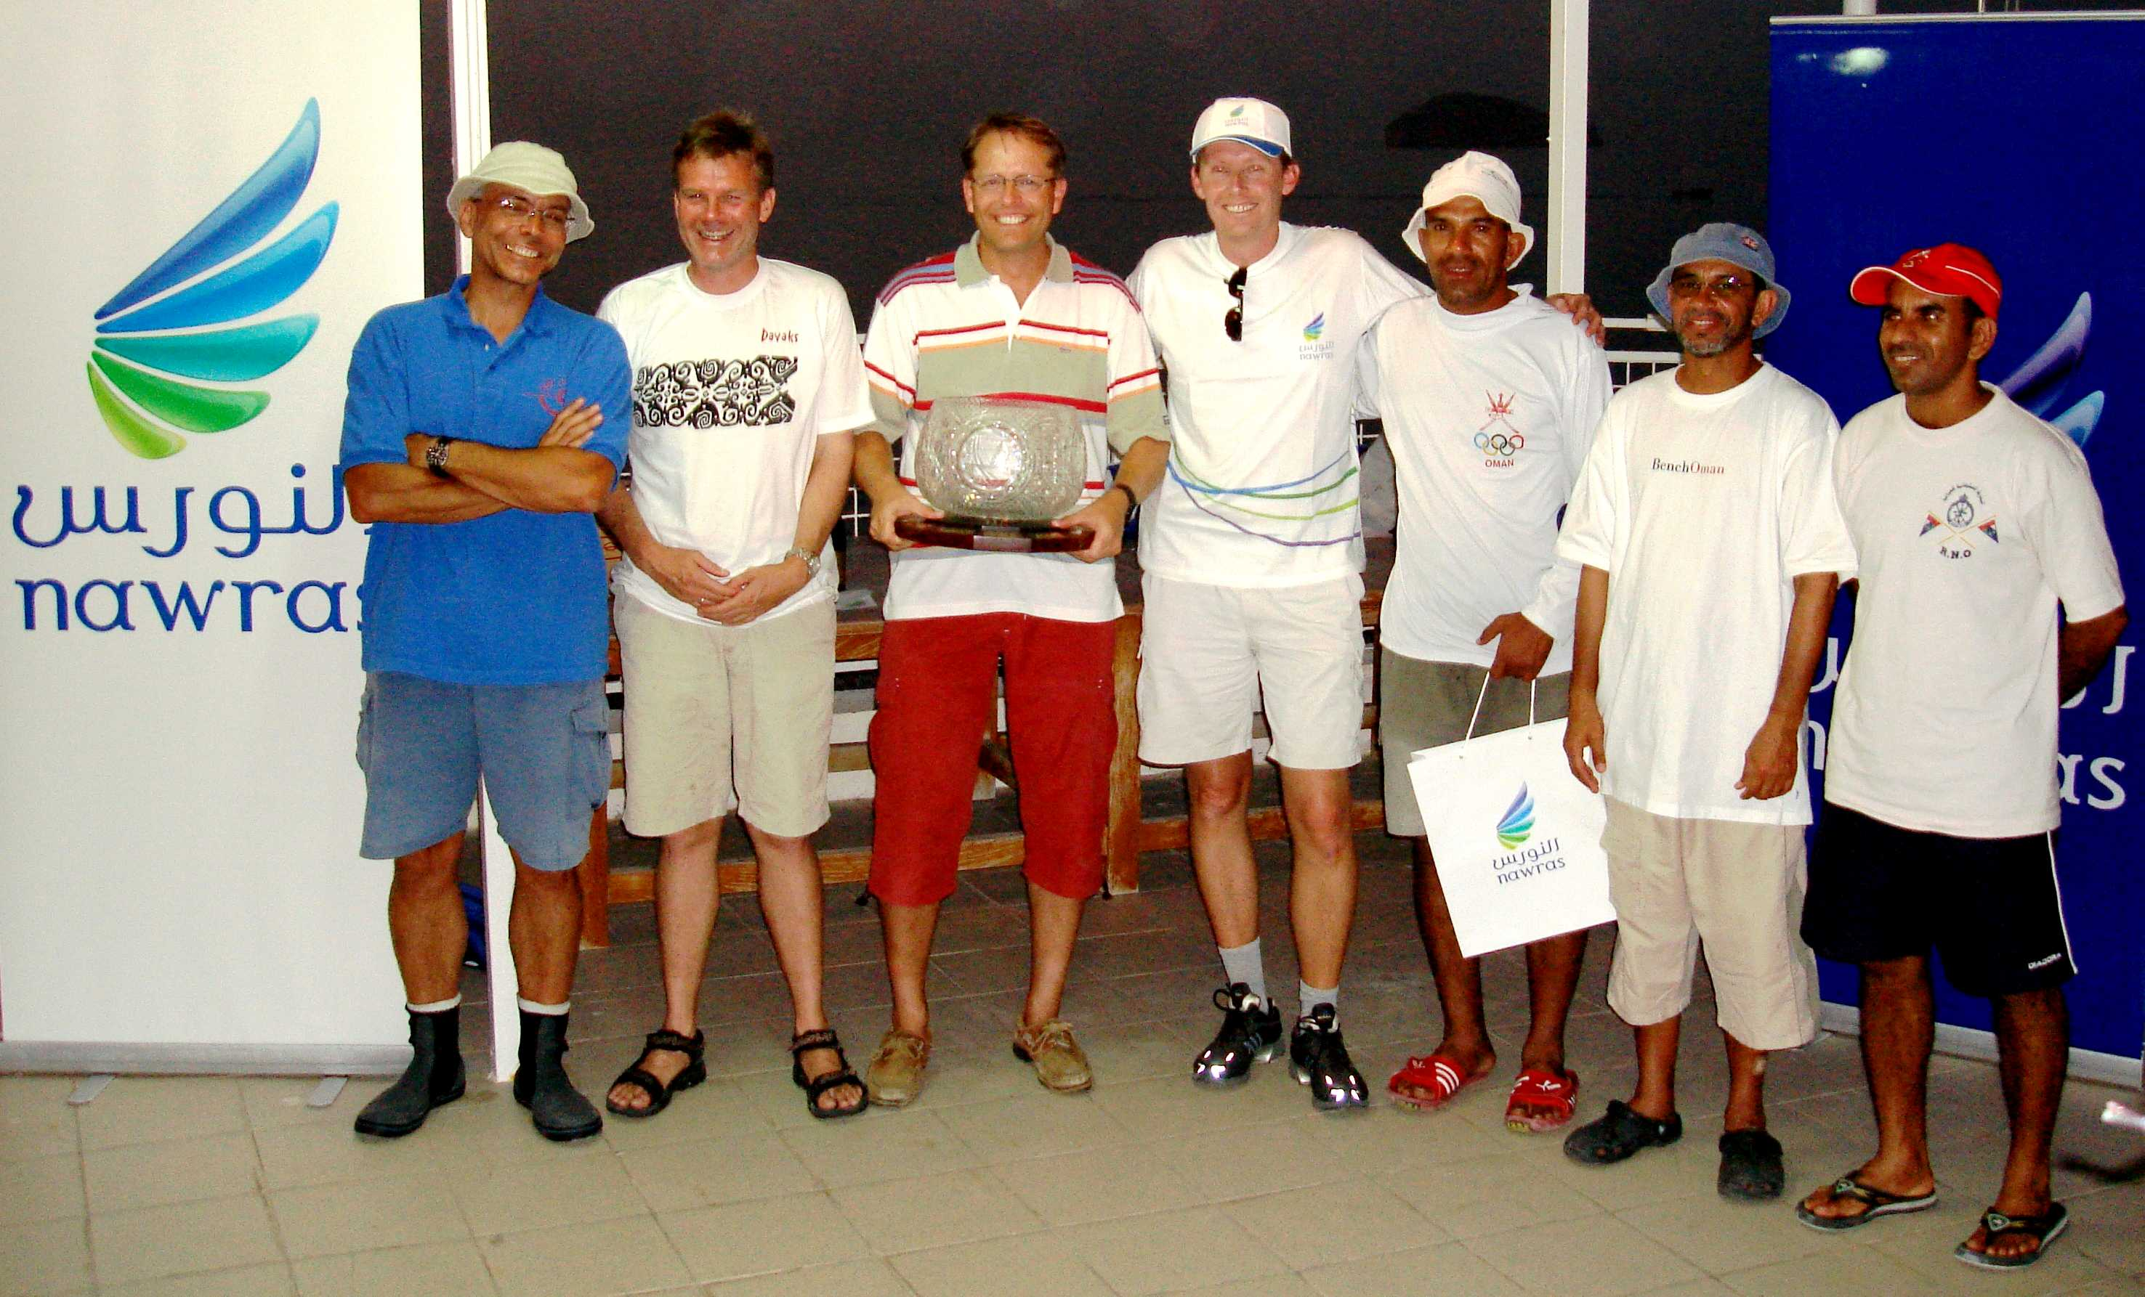

The winners (best Overall 3/2/1 on the left and best Omani 1/2/3 on the right) with Tore Solberg (Nawras) in the middle
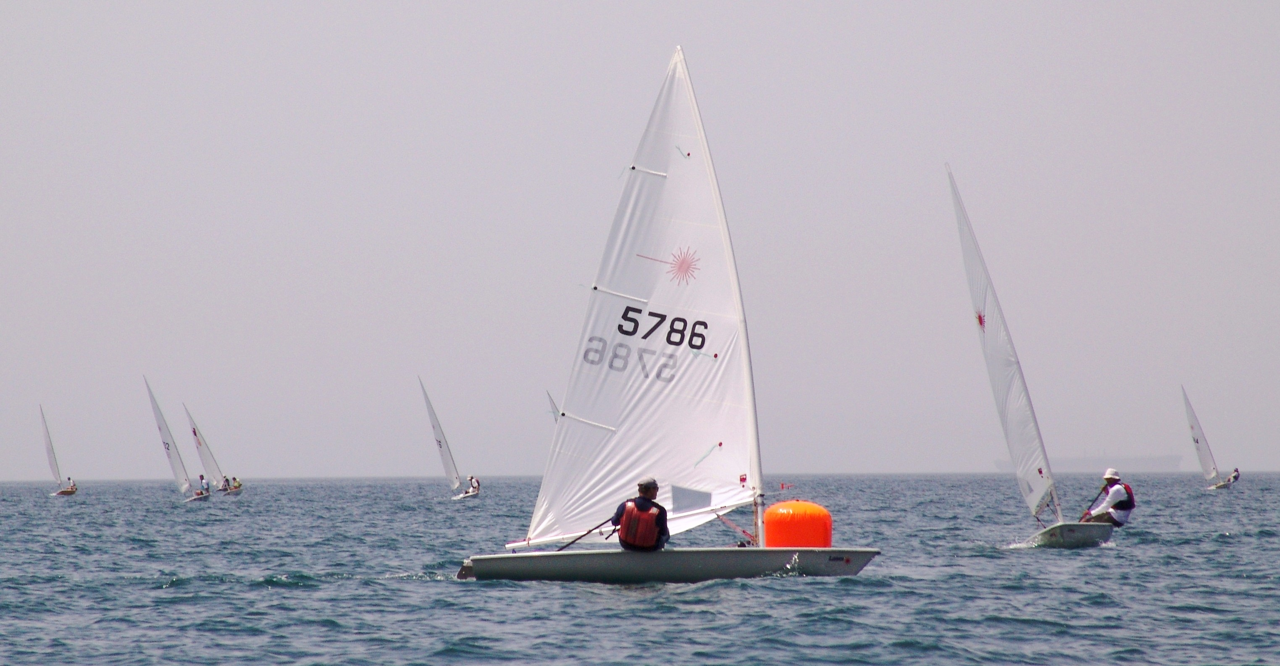

Winner Douwe Sickler Rounding the mark closely followed by Rashid Khalfan (on the right)
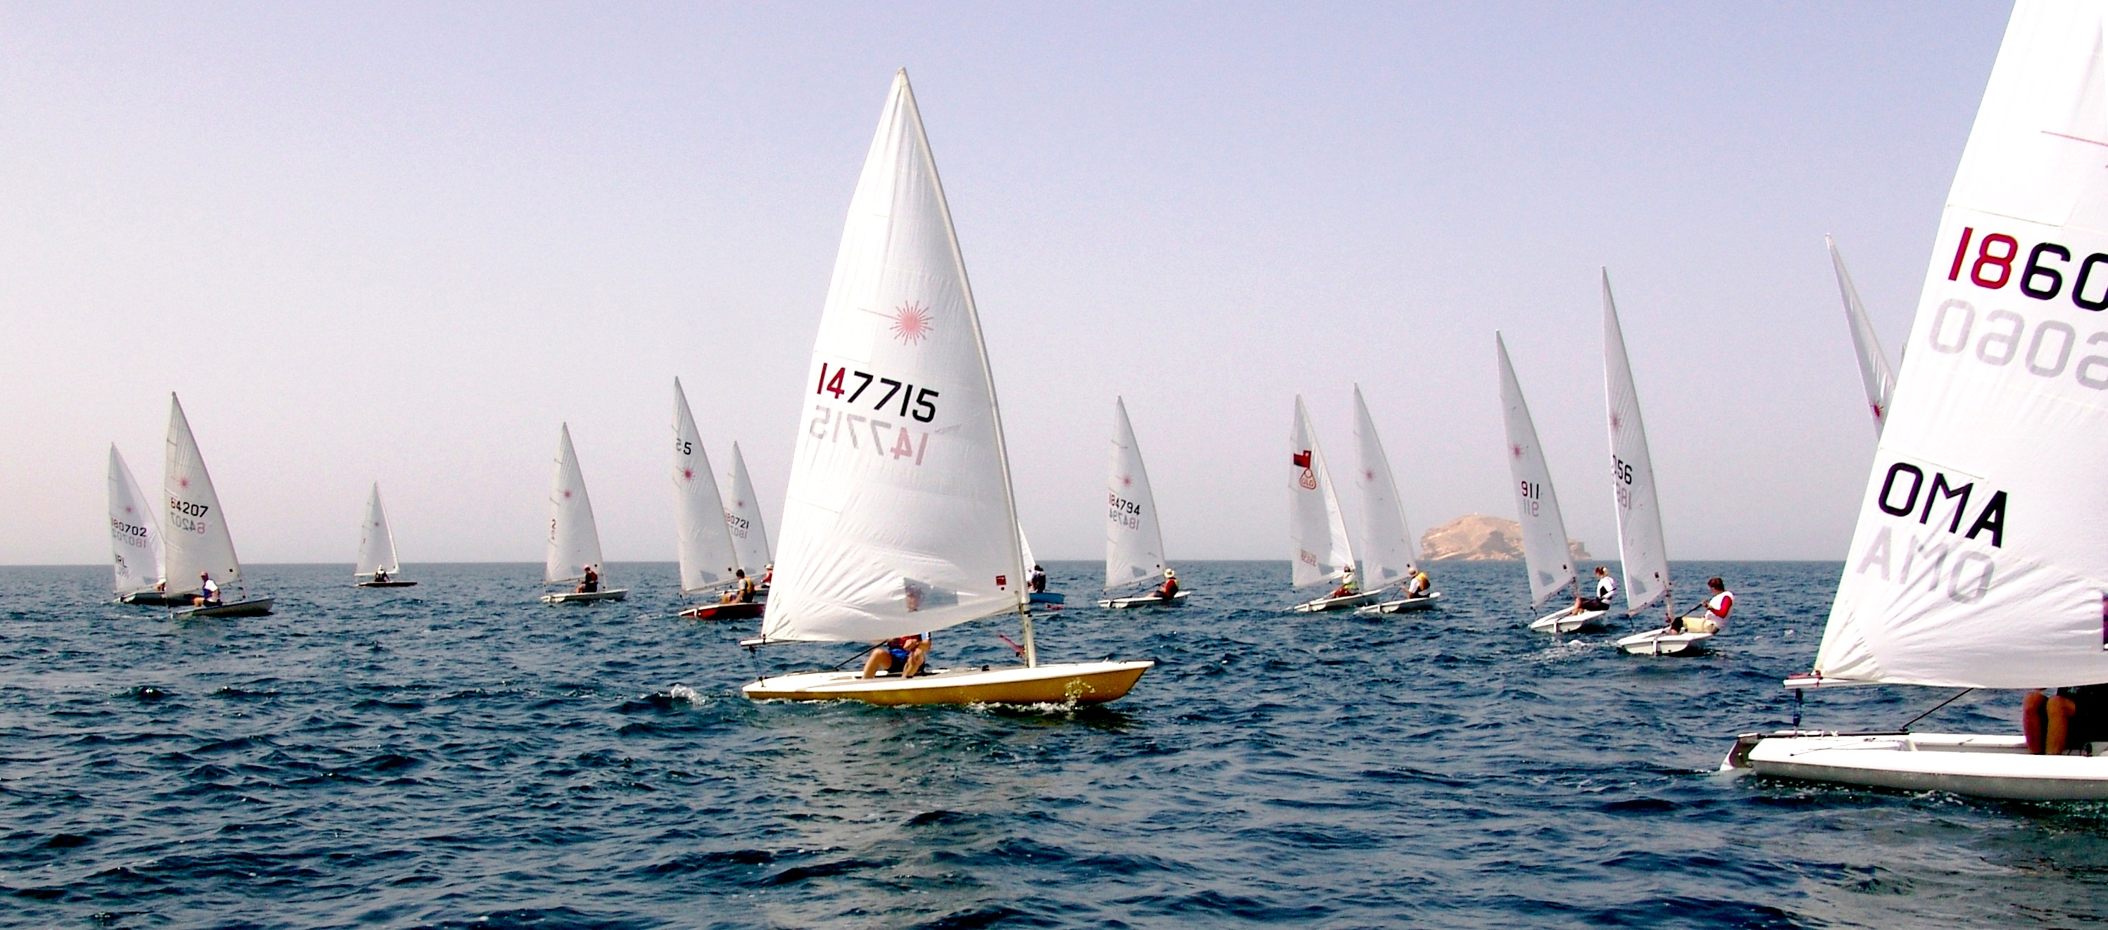

The fleet just after the second start (Al Fahal island in the background)
Winner Douwe Sickler executing a roll-tack
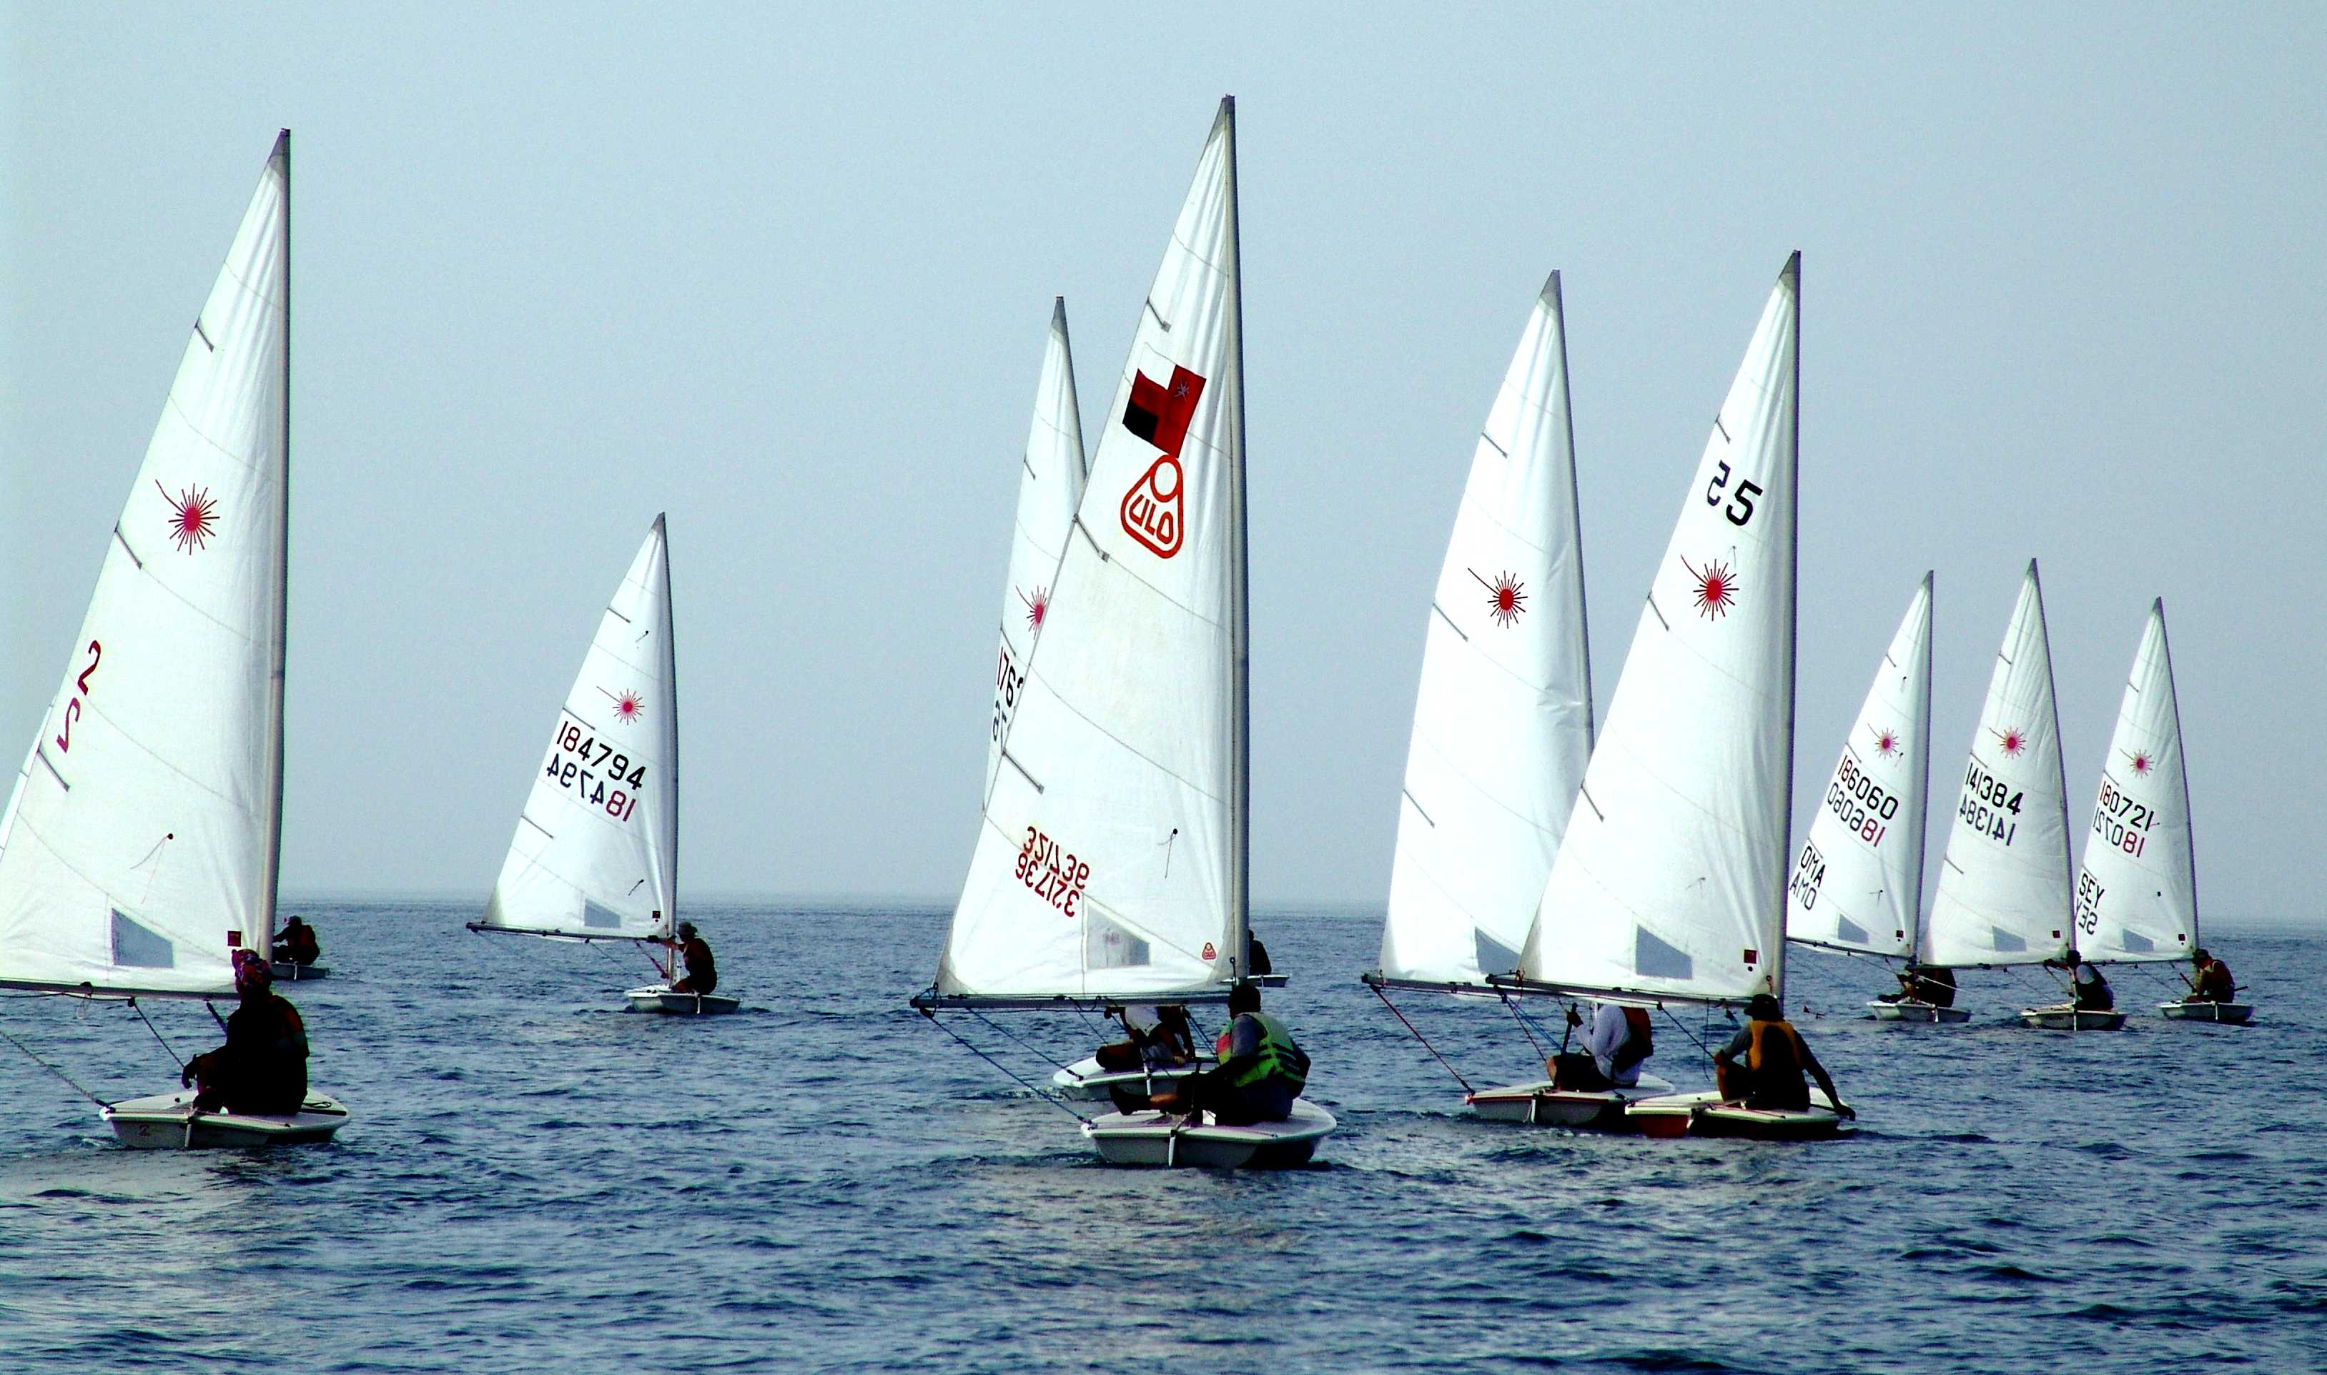

The fleet sailing downwind
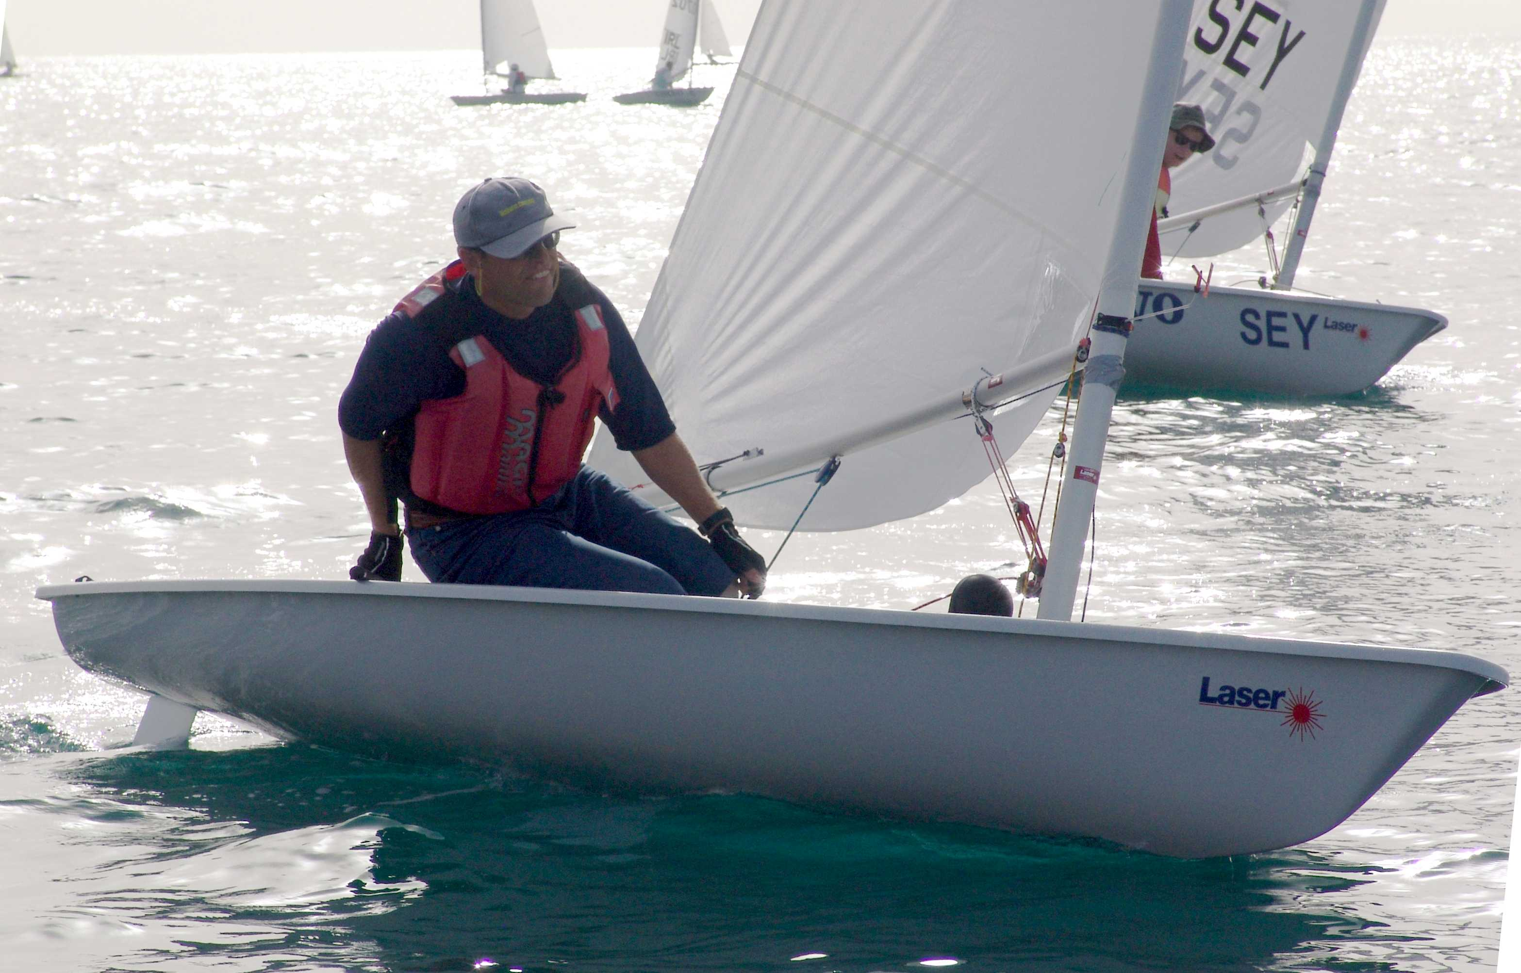

Winner Douwe Sickler executing a roll-tack

