
Press Release Oman Laser Association - 28 April 2008

VOLVO 2008 Oman National Laser Championship

Henrik Norgaard new National Champion Laser Sailing
Abdulhakeem Al-Keyumi best Omani Sailor

The VOLVO 2008 Oman National Championship for Lasers (one man Olympic class sailing dinghies) was sailed last weekend from the beach off the Ras al Hamra Boat Club (RAHBC). 26 Sailors competed in the event organised by the Oman Laser Association with participants from Royal Oman Navy, RAHBC, Castaways – Civil Aviation Recreation Club and one international entry from Denmark.

Henrik Norgaard came out on top with 5 points (out of 5 races with one discard), improving on his performance of 2007 (when he came 5th). Second place was for Frank van Beek (last year also no 2) only 1 point behind the leader with Douwe Sickler (last years winner) following closely as third with 12 points.

Abdulhakeem Al-Keyumi from Casteways was the best Omani sailor with a 11th place overall, an excellent performance. Abdulhakeen has improved consistently over the years finishing 3rd best Omani in 2005, 2nd in 2007 and now on the number one slot. Rashid Khalfan al Yahyai from RNO-Wudum came second this year after a first place in last year’s event. Rashid had 2 early starts which cost him dearly and pushed him back to second place. 3rd Place was for Suleiman al Waheiby a youngster taking part in the Ministry of Sports Affairs (MOSA).sailing training program. Suleiman’s performance is particularly impressive considering that he has only started sailing a few months ago. His cousin Abdullatif al Waheiby fished just behind him on a 4th place. Oman can have high sailing hopes with youngsters like these.

On Thursday the fleet of 26 boats sailed 3 races in generally light Easterly winds. The combination with a strong Westerly current made the starts particularly difficult with competitors being pushed over the start line by the current before the starting signal. Several general recalls were required. Frank won the first race with Henrik as second. They swapped positions in the second and the third race saw Frank again as number 1 with Henrik in 3rd place. The 2nd race saw Suleiman Waheiby finishing as 9th. Pretty good for such a young and novice sailor.

On Friday all participants were ready to start at midday but the wind left everyone waiting until 13.30 before sailing could start. The OOD (Officer Of the Day) wisely decided to execute all races back to back. Just before the start of the 3th race the wind died completely and everyone was send back to the beach to clean up the boats and get ready for the price ceremony. Henrik won both races with Frank in 2 & 4th respectively. A critical moment in the first race occurred at the start when the OOD identified Henrik as OCS (on the course side of the start or early start). This situation was reviewed in the protest committee and came out in Henrik’s favour: he kept his first place. A video of the start sequence also confirmed that he was in his rights.

Prizes, kindly sponsored by VOLVO – MHD, were awarded by Umesh Rao and Naresh Kadaba to all participants. Tony van Thiel (OLA Chair and event organiser) thanked the OOD’s Fred Rourke, Dave Clark, Rob and Michiel Nieuwenhuisen and Hans de Koning for the first rate management of the races. The RAHBC sailing captain, Cees van Eden congratulated Tony with the excellent organisation of the championship. Tony finished by thanking VOLVO-MHD for their sponsorship of the event. VOLVO has long and world wide history in their link with sailing.

Tony also thanked Saif Said al Shebli of the Ministry of Sports Affairs for his presence at the ceremony and expressed his hope for the Ministry to soon materialise the plans for a Youth Sailing Training Centre so that more young Omanies can enjoy this fantastic sport.

The Laser is a small single sail boat sailed by one person. It is an Olympic class which is very popular around the world. Laser sailing is a fantastic sport which can be practiced in Oman throughout the year. In strong winds the sailing is very physical, the boat gives you a great workout. With Oman’s strong history of sailing, good winds, beautiful beaches and deep blue sea, Laser sailing has the prospective to become a true national sport with the potential of Omani participation in world class events such as the Asian and Olympic games.

For full details and pictures of the event see: http://www.pdo.co.om/hseforcontractors/rahbc/Sailing/Sailraces/2008-OLA-Nationals.htm

Final results:

No | Name | Points | Comment
1 | Henrik Norgaard | 5 | Overall 1st Place
2 | Frank van Beek | 6 | Overall 2nd Place
3 | Douwe Sickler | 12 | Overall 3rd Place
4 | Tony van Thiel | 16
5 | Cees van Eden | 17
6 | Iain Hudson | 28
7 | Paul-Henri van Thiel | 31
8 | Morten Kristensen | 36
9 | Fred Park | 38
10 | Aly Brandenburg | 40 | Best Lady
11 | Abdulhakeem Al-Keyumi | 45 | Best Omani 1st Place
12 | Rashid Khalfan al Yahji | 48 | Best Omani 2nd Place
13 | Robert van Eden | 51 | Youngest: 13 years old
14 | Brian Stewart | 52
15 | Tony Males | 53
16 | Suleiman al Waheiby | 56 | Best Omani 3rd Place
17 | Jack Tarr | 57
18 | Abdullatif al Waheiby | 58
19 | Yacoob Masood | 62
20 | Torben Skov | 67
21 | Peter Evans | 72 | Senior: above 65
22 | Mariette Verdaasdonk | 76
23 | Mafoudh al Zurafi | 79
24 | Steve Williams | 89
25 | Ernie Meili | 90
26 | Bob Gloyn | 95 | Wooden Spoon

Pictures of the event

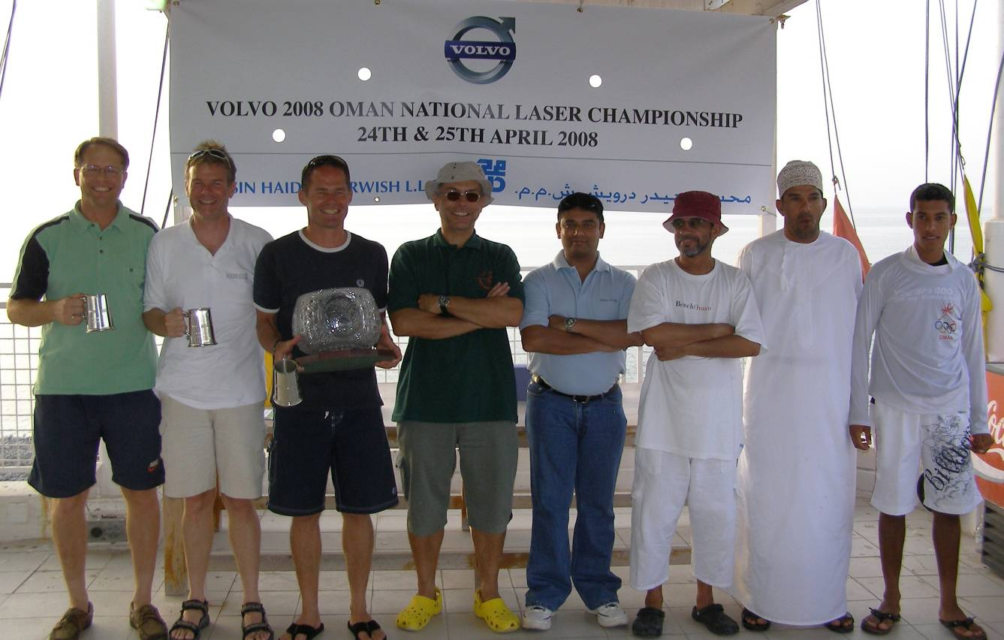

The winners (best Overall 3/2/1 on the left and best Omani 1/2/3 on the right) with Tony van Thiel (with hat) and Naresh Kadaba from VOLVO-MHD in the middle
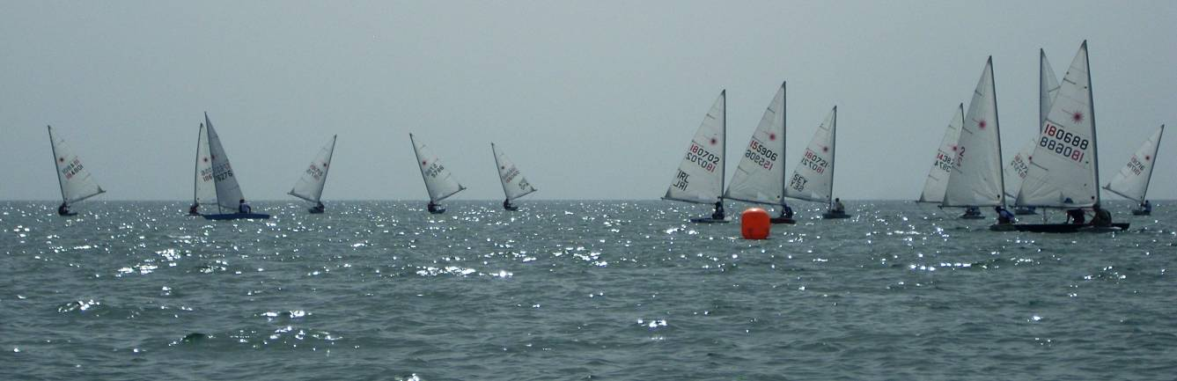

The fleet sailing downwind from the windward buoy to the finish line
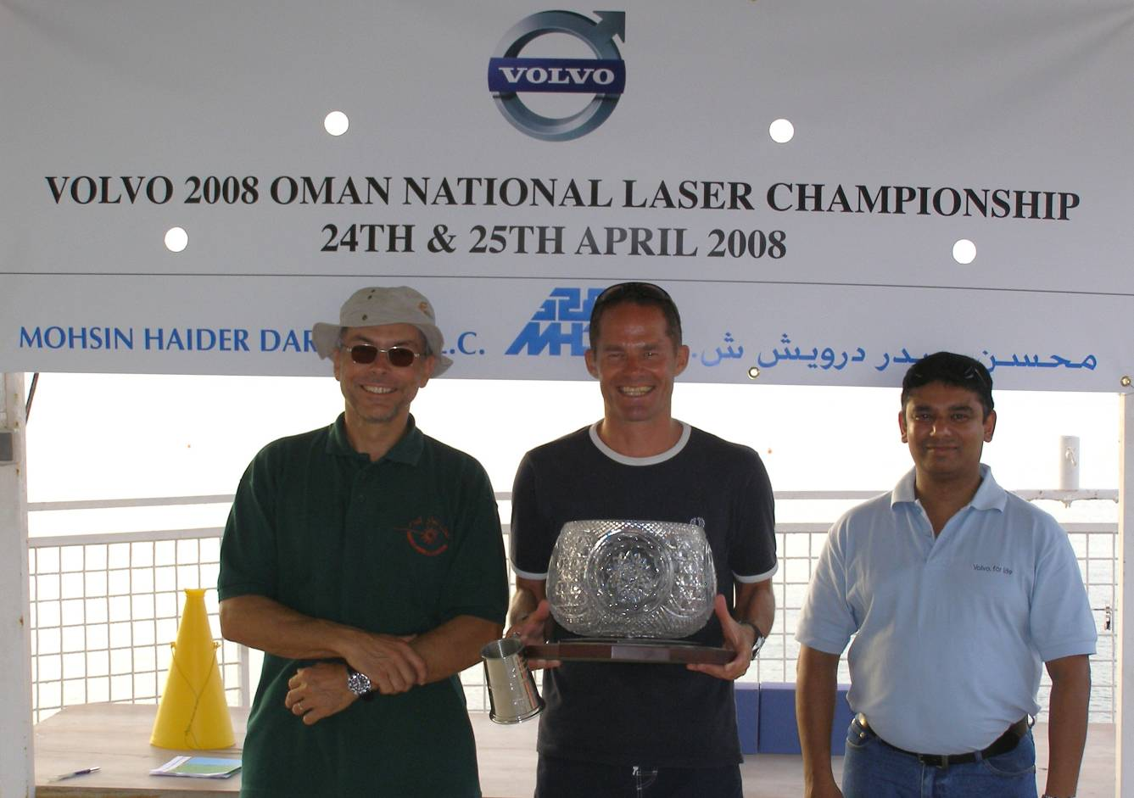

The new National Champion Henrik Norgaard with the trophy flanked by Tony van Thiel and Naresh Kadaba
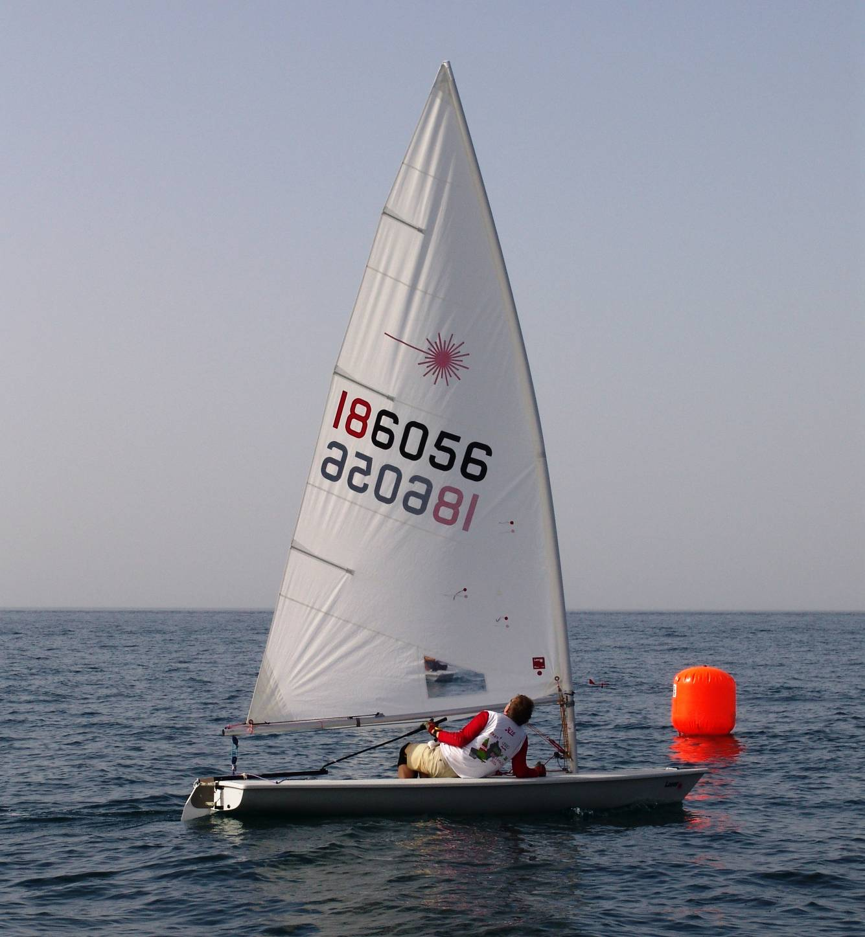

Frank van Beek rounding a buoy

