
Press Release Oman Laser Association - 18 April 2009

VOLVO 2009 Oman National Laser Championship
 | Douwe Sickler new National Champion  Rashid Khalfan al Yahyai best Omani Sailor | 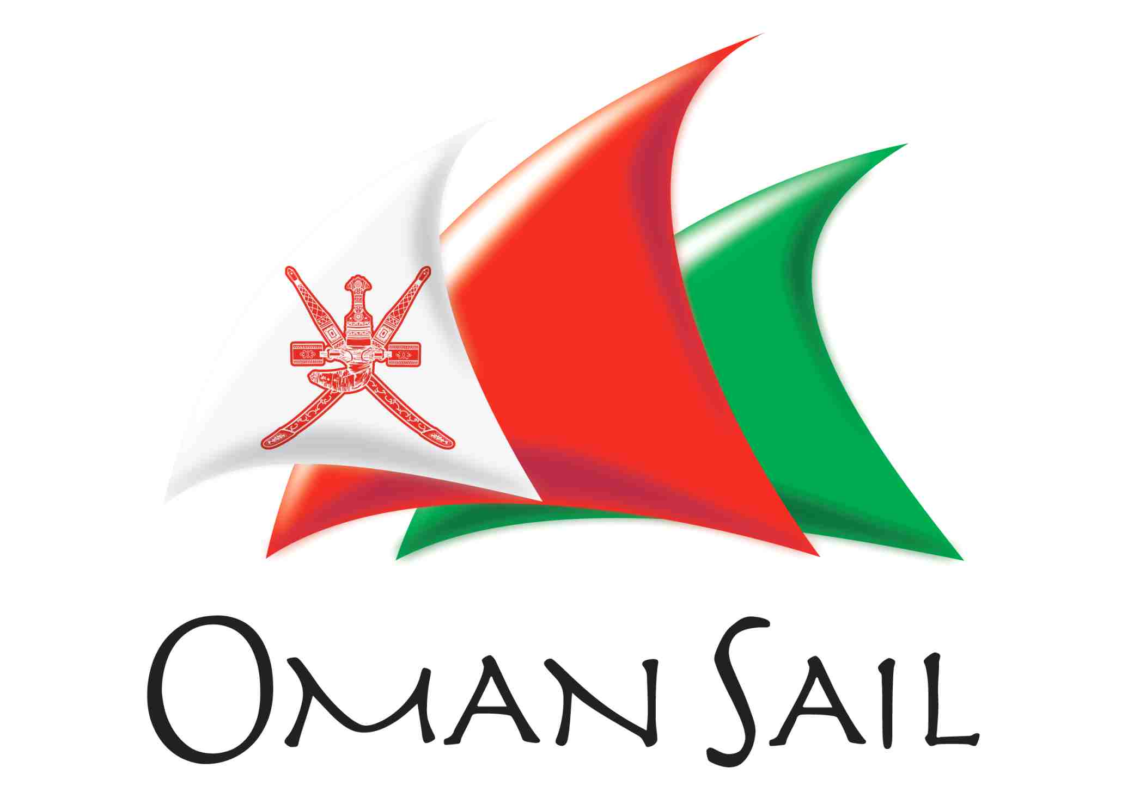

The VOLVO 2009 Oman National Championship for Lasers (one man Olympic class sailing dinghies) was sailed for the 27th time last weekend from the beach off the Ras al Hamra Recreation Centre. 24 Sailors competed in the event organised by the Oman Laser Association and Ras Al Hamra Boat Club (RAHBC) with participants from Royal Oman Navy, Castaways (Civil Aviation Recreation Club), Oman Sail and RAHBC.

Douwe Sickler came out on top with 9 points (out of 8 races with one discard). Second place was for Tony van Thiel (16 points) with Stephen Rice following closely as third with 19 points.

Rashid Khalfan al Yahyai from RNO-Wudum was the best Omani sailor with an 11th place overall, an excellent performance. It is the third time he takes this place. Abdulhakeem Al-Keyumi from Casteways came second. Last year they scored the opposite with Hakim on first and Rashid on second place. Mafoud al Zarafi from RNO-Wudum took the third place. He only sailed 2 races and would have gone on much stronger but hurt himself during a capsize after which he had to abandon further participation.

The first racing day saw very strong easterly winds throughout the day. Wind speeds up to 20 knots (force 5) created very demanding conditions which only part of the fleet could handle. The first race started with 22 sailors. Only 14 were able to complete the course. The number of finishers reduced in every race to only 7 in the fifth and final event of the day. Those that made that last race came back to the beach totally exhausted. Sailing a Laser in strong winds is physically demanding. One has to be very fit! At the end of day-1 Douwe had 2 wins and was already 3 points clear of Tony.

On Friday the wind was again blowing strong. Just a notch less power full than the day before, creating excellent sailing conditions which most of the fleet managed well. The lighter sailors wisely decided to use the smaller radial and 4.7 sails instead of the big standard sail. 3 races were held and Douwe won them all. A clear winner. A fierce battle for 2nd/3rd and 4th took place in every race between Tony, Stephen and Dave Clark. Tony ended up as second followed by Stephen and Dave.

It was good to see the participation of 4 youngsters aged 14 to 16 years. Alexander Rice (14) took the “Best Youth” ranking (7th overall). A remarkable feat considering he only sailed on the first day. Paul-Henri van Thiel (15) finished 9th, Tim Street (16) on 15th and Robert van Eden (14) on 17th position. Well done boys!

Prices kindly sponsored by VOLVO-MHD and Oman Sail, were awarded to all participants by Moshin al Busaidi (Oman Sail) and David Aziz of Volvo-MHD. Tony van Thiel (OLA Chair and event organiser) thanked the Officers Of the Day (OOD’s) Fred Rourke, Stephen Martin and Mariette Verdaasdonk for the first rate management of the races. The RAHBC sailing captain, Cees van Eden congratulated Tony with the excellent organisation of the championship. Tony finished by thanking VOLVO-MHD and Oman Sail for their sponsorship of the event.

VOLVO has long history in their link with sailing in the world and has been the title sponsor for this event for the second year. David Aziz thanked the organisation and expressed his commitment for further support next year.

Tony also thanked Oman Sail’s Moshin al Busaidi for his presence at the ceremony. Moshin recently became the first Arab sailor to sail non-stop around the world (in 76 days). Details of his epic journey can be found on the Oman Sail website: http://www.omansail.com

Oman Sail is an exciting new initiative, guided and supported by the Ministry of Tourism, whose aim is to rekindle Oman's long and glorious maritime heritage. The Oman Sail Academy has started training young Omanies and it is very likely that a strong National squad of Laser sailors will be competing in the Laser Nationals next year. The 2010 Asian Beach Games which will be held in Oman will also feature Lasers as one of the sailing events. Start training!

The Laser is a small single sail boat sailed by one person. It is an Olympic single design class which is very popular around the world. Laser sailing is a fantastic sport which can be practiced in Oman throughout the year. In strong winds the sailing is very physical; the boat gives you a great workout. With Oman’s strong history of sailing, good winds, beautiful beaches and deep blue sea, Laser sailing has the prospective to become a true national sport with the potential of Omani participation in world class events such as the Asian and Olympic games.

For full details and pictures of the event see:
http://www.rahbc.pdorc.com/Sailing/Sailraces/2009-OLA-Nationals.htm

Final results:

No | Name | Points | Comment
1 | Douwe Sickler | 9 | Overall 1st Place
2 | Tony van Thiel | 16 | Overall 2nd Place
3 | Stephen Rice | 19 | Overall 3rd Place
4 | Dave Clark | 25
5 | Tony Males | 44
6 | Gordon Whitley | 51
7 | Alexander Rice | 82 | Best Youth (14)
8 | Victoria Grainger | 85 | Best Lady
9 | Paul-Henri van Thiel | 92 | Youth: (15)
10 | Joost Bloemarts | 94
11 | Rashid Khalfan al Yahji | 95 | Best Omani 1st Place
12 | Steve Williams | 111
13 | Jack Tarr | 113
14 | Abdulhakeem Al-Kiyumi | 122 | Best Omani 2nd Place
15 | Tim Street | 126 | Youth: (16)
16 | Aly Brandenburg | 132
17 | Cees van Eden | 134
18 | Mafoud bin Mohd al Zarafi | 145 | Best Omani 3rd Place
19 | Robert van Eden | 155 | Youth: (14)
20 | Abdullah bin Said al Habsi | 159
21 | David Price | 163
22 | Peter Evans | 169 | Great Grand Master (over 65)
23 | Osman Bilal | 172 | Wooden Spoon
24 | Jamil bin Hassan al Hadrami | 172 | Wooden Spoon

Pictures of the event

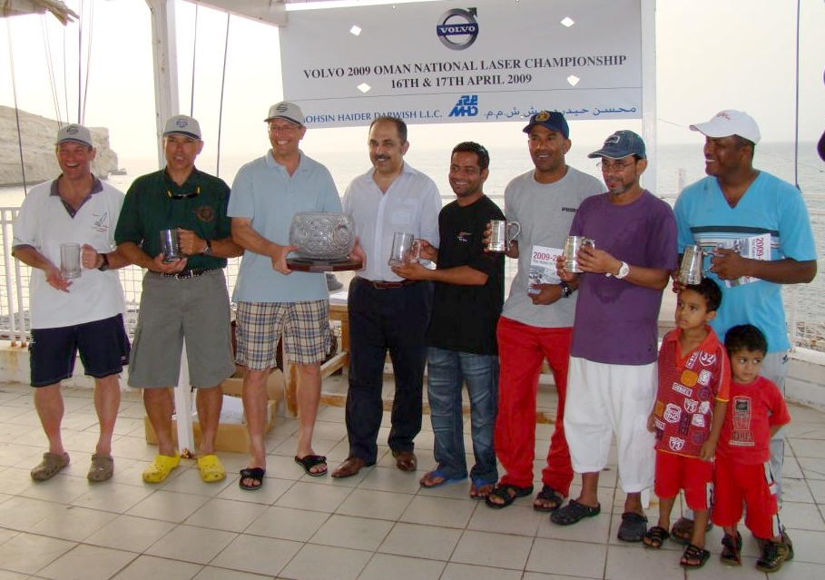

The winners (best Overall 3/2/1 on the left and best Omani 1/2/3 on the right)
with David Aziz from Volvo-MHD and Moshin al Busaidi from Oman Sail in the middle.
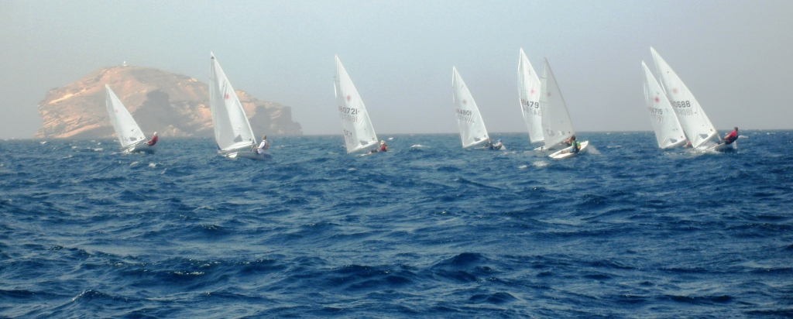

The fleet just after the start sailing towards the windward buoy in very strong wind

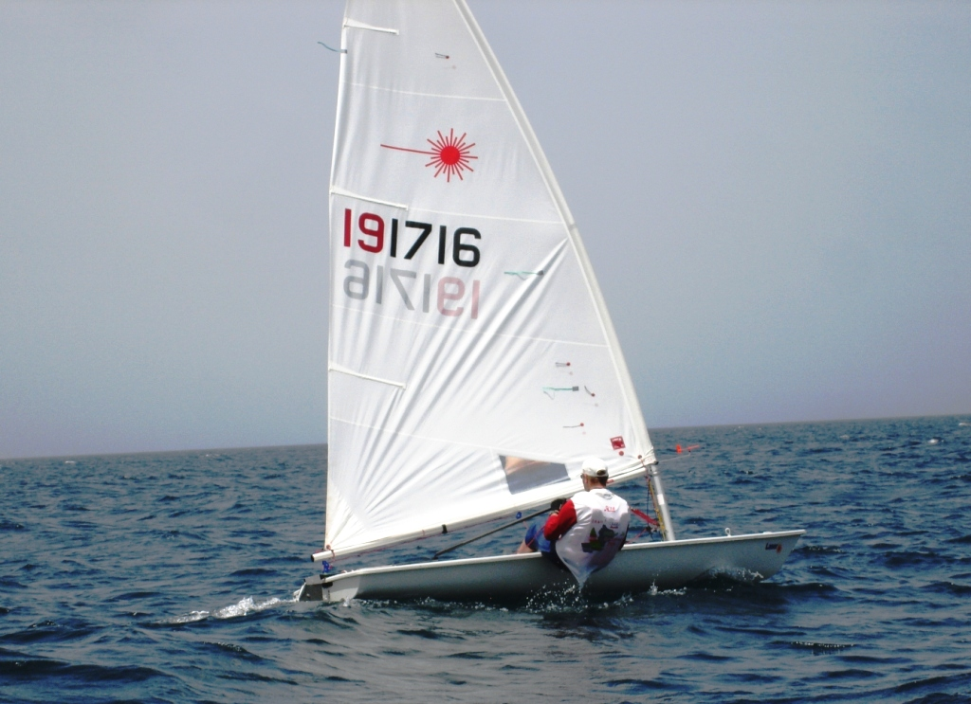

The new National Champion Douwe Sickler sailing close upwind
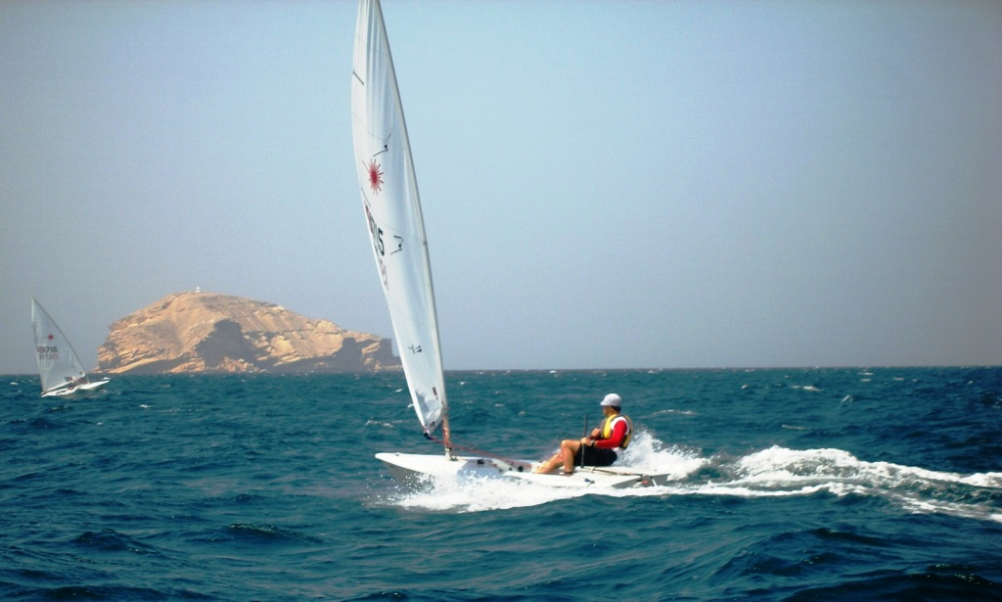

A Laser at full speed with Fahal island as a backdrop

